NZ Bridge

SCORER
AND

Report Tool

User Manual

The current version of Scorer is Scorer 22 (V22)
NOTE: Some functionality may not be available in older versions

Copyright BridgeNZ (2004) Limited
June 2011

Table of Contents
Introduction 6
1.1 News about Scorer 22 6
1.2 News about Scorer 20 6
1.3 Creating User Logon IDs and Security Levels 7
Start / Login to Scorer 8
2.1.1 Start Scorer using the Scorer icon 8
2.1.2 Start Scorer after starting BOS 8
2.1.3 Admin user with no Password 8
2.1.4 Admin has password OR no Admin user 8
2.1.5 Login screen appears with message 9
2.1.6 Request for NZB Player Update 9
Scorer Menu Functions -- the Ribbon Bar 10
3.1 Menu Structure 10
3.2 Scoring and Calendar 10
3.3 Administration 11
3.4 House Keeping 11
3.5 Advanced Options 12
3.6 Help and Support 12
Administration 14
4.1 Scorer Options 14
4.1.1 Club Details 14
4.1.2 Scoring Options 15
4.1.3 Sections 16
4.1.4 Windows 17
4.1.5 Handicap 17
4.1.6 Club Points 18
4.1.7 Files 18
4.1.8 FTP Options 19
4.1.9 Membership Details 20
4.2 Club Membership 21
4.2.1 Sorting Columns 21
4.2.2 Filters 22
4.2.3 Add/Edit Members (bottom tabs) 22
4.2.4 Payments View (bottom tabs) 23
4.3 Password Levels 25
4.4 Cashless Payments 25
4.5 NZB Player List 26
4.6 Non Members 27
4.7 Check for Updates 27
4.8 Release Notes 28
4.9 Redo Update 28
4.10 COPY CALENDAR 28
4.11 Print Calendar 29
4.12 Restore Event 29
4.13 DELETE HISTORY 30
House Keeping 31
5.1 Calculate Handicaps 31
5.2 Edit Handicaps 31
5.3 Backup or Restore 32
5.4 Individual Results 35
5.5 Club Points Ladder / C Points Ladder 36
5.6 All Results 37
Advanced Options 38
6.1 Set up Special Ladder 38
6.2 Run Special Ladder 38
6.3 Custom Teams Movement 39
6.4 New Custom Movements 40
6.4.1 Add Movement 40
HELP 42
7.1 Local Help 42
7.2 Documents 42
7.3 Remote Support 42
7.4 About 43
7.5 Reports 44
Scoring and Calendar 46
8.1 The CALENDAR 46
8.2 SCORE/LADDER 46
8.3 Edit Calendar 46
8.3.2 Ladders 49
8.4 Tournament Entries 53
8.4.1 Import from csv 54
8.4.2 Add Entry (Ctrl-E) 54
8.4.3 Delete Entry 54
8.4.4 Back Fill 54
8.4.5 Delete All Entries 54
8.4.6 Import from first round 55
8.4.7 Prize Groups 55
8.4.8 Reports 56
8.5 Patch Installation 57
Pairs Events Scoring 59
9.1 Pairs Section Setup 59
9.1.1 Mitchell Movement, ODD Number of Tables 60
9.1.2 Mitchell Movement, EVEN Number of Tables 61
9.1.3 ZigZag 61
9.1.4 Howell/Barometer Movement 61
9.1.5 New Custom Movements 61
9.1.6 Adding Sections 62
9.1.7 Start Remote Server 62
9.2 Manually Entering/Modifying Player Names 63
9.2.1 Entering Handicaps 64
9.3 Entering Scores Manually 65
9.4 Adjustments 66
9.4.1 Weighted scores 66
9.4.2 Changing Pair Numbers 66
9.4.3 Other functions 66
9.5 Generating Results 67
9.5.1 Calculate Results 67
9.5.2 Export / Import session 68
9.5.3 XML and the WEB 68
Individual Scoring 70
Teams Events Scoring 71
11.1 Swiss Teams 71
11.1.1 Set up the Event in the Calendar 71
11.1.2 Set up the Section 71
11.1.3 Enter team names and Players 72
11.1.4 Perform the Draw and Set up for the Round 73
11.1.5 Scoring the Round 74
11.1.6 Publish the Results (Print and Web Publishing) 77
11.1.7 OTHER OPTIONS from the sections screen: 77
11.1.8 RESULTS – SAVING to other formats 77
11.2 Round Robin Teams 78
11.3 Multiple Teams 79
Swiss Pairs Events Scoring 80
12.1 Pair Numbering 80
12.2 RESULTS – SAVING to other formats 80
12.3 Swiss Pairs Events and Masterpoints 80
Ghosting 81
List of Supplied Reports 83
14.1 System 83
14.2 Admin 84
14.3 Calendar 85
14.4 Pairs 85
14.5 Teams 85
14.6 Tournaments 86
14.7 Player Information 86
14.8 Director 86
REPORT LISTING 87
NZB Master Points System 91
16.1 Setup 91
APPENDIX 1 Running Multiple Events 92
17.1 Multiple Pairs Events 92
17.1.1 The Process 92
17.1.2 TEAMS 95
Appendix 2 - Using BridgeTab for Pairs 97
Appendix 3 - Using BridgeTab for Teams [Event already set up] 101
19.1 Round Robin Teams 105
Appendix 4 – Starting the SQL Server Service 106
Appendix 5 – Overview of scoring tables 107
Appendix 6 – Real Bridge USEBIO imports 108

Background
Scorer is written to cope with Tournament Scoring, Club Scoring and simple Club administration.
To this extent, there are facilities to run virtually any movement for Pairs, fundamental Round Robin, Swiss Teams, Multiple Teams and Individual movements. The Handicapping system has been improved to support Handicapping based on results from multiple session times and even weighted if the user requires, Import from a csv file from the user along with the standard handicaping by session time with the ability to manually enter or adjust handicaps to allow for specific instances.
Scorer’s administration module manages Subscriptions, Receipting, Mail Labels, Membership Lists and other membership related club requirements for your Club. Theere are reports available from the reporting system to give comparisom of table numbers between years and detect members who have not been playing for followup.
Scorer 11 represented a significant enhancement on previous versions; functionality and stability enhancements have continued to the current version.
BridgeNZ has and will continue to work with Clubs to ensure that we maintain our world class programme.
BridgeNZ offers support for the application in the form of email and telephone support and online connection to your computer using Team Viewer. Documentation is in this manual and in the new Help file structure. Clubs are able to insert their own documentation to be available to their users. Support for users at the current level will be at no cost for scorer related issues [charges may apply for training issues, user generated problems and problems caused by external issues]. Support is also offered for the immediately previous version of Scorer (for work-arounds but not development) and for other technical issues, including system structure and setup and use of WindowsTM and other applications. This work is chargeable at reasonable rates.
In V19 Scorer has moved away from using files for Howell/Barometer and custom movements. Standard Mitchell movements are still available as usual but the other movements have been moved to the database and streamlined so it is easy for users to filter by the number of tables and select the appropriate movement. These new custom movements also enable the dynamic production of a movement overview and guidecards.
Each version of Scorer requires a new licence key (purchased from BridgeNZ) which is based on your club name and club number. If either “Club Name” or “Club Number” is changed in the Options screen, you will NOT be able to access your programme without a new license key (or BridgeNZ reverting the names back to the original). From Scorer 15 the licence key is installed automatically on update, so no manual intervention is required.
If you have feedback that is constructive, then please email to: pat@bridgenz.co.nz
If you are reporting a suspected bug, then please ensure that you have written down all the steps involved in producing the situation. BridgeNZ will endeavor to remedy bugs!

Disclaimer
The diagrams (screen shots) in this document may reflect an earlier version of Scorer. They have only been updated where this was necessary to document a new feature or function.

Thanks to Maureen Pratchett of Wellington for her contribution to the manual and to tidying up the BoardMove folder delivered as “BoardMove_Clean” for versions 16 to 18.
From v19 the BoardMove_clean will no longer be delivered – A series of csv files will be available online at bridgenz.co.nz.
From V22 USEBIO imports from RealBridge can add to you rsessions, and cashless payments can be used for your members to pay to your bank account.
From V22.2 integrated cashless payments are available.

Martin Oyston
Director
BridgeNZ (2004) Limited

Introduction

News about Scorer 22
With changing times, RealBridge has provided a haven which is as close as we can get to face-to-face bridge. NZB has permitted MasterPoints to be allocated on RealBridge sessions replacing Club sessions. Thus with V22, there is a button in the Pairs events and Teams events which allow for the import of RealBridge sessions to be included with your playing calendar. The details on this are shown later.
With no requirement for players to be on premise at the club, the cashless payment system will allow the club to keep track of member’s credits and charge them for played sessions without the requirement to collect cash.
We have had a request for gender options, and to this extent have added 3 alternatives to M (Male), and F (Female); these are D (Diverse), N (Non-Specified), O (Other). When we look up gender, we find that there are over 60 gender types and feel that this is too much to add and too complicated to implement for clubs, so unless there is a specific requirement we will use D, F, M, N and O as the gerder availeble for members.

News about Scorer 20
Scorer 20 (V20) continues the trend to putting all information in the database and make scoring a session as easy as possible.
BridgeNZ is very much aware that there are natural complications to scoring when players do unusual things, or the laws dictate that scores should be handled in a certain way. We have tried to mitigate the awkward situations where such things as Pair numbers require changing or weighted scores need to be applied, without moving too far from the path that scorers have become accustomed to.
In this release, when the user calls up a Pairs session for the first time, the section defaults to the top section in the list and the cursor focuses to the number of tables. This saves some confusion and pointless setting of rooms and sections which occurred in the past. The Room has now been deprecated and there is only the Section and a Letter to be associated with it.
The user will notice a significant change in this version with setting up sections if using Howell or custom movements but the process has been simplified, and the dynamic production of an overview of the movement that is actually in use and the table guide cards ensure that nobody has guide cards that don’t actually match the movement being used.
The method of changing pair numbers has been improved so that the user cannot change pair numbers in a way that will have a pair shown twice. The validation is done before the final step can be taken to confirm the pair change.
Some dramatic changes have been made ‘under the hood’ with converting all frequencies and match points to decimals in order to follow the WBF suggestions for weighted adjusted scores. The user now has the option to enter several scores with weightings they see fit and scorer will assign the weighted match points from this.
With many clubs being small and security is not that big an issue with Scorer, it appears that the majority of clubs’ use “Admin” as the login with no password. As this seems pointless, from V20 if a club uses Admin with no password to access scorer then NO LOGIN SCREEN will appear UNLESS there is an issue with the version of scorer compared with that in the database (usually due to an incomplete update).
If Admin has a password OR is not a valid user, then the login screen will appear as previously.
When Master Points are sent, the files are named using the Letter rather than the session name, and the section name in the file will be the Letter used for the section. This avoids any undesirable complications where the user has named the section with characters not acceptable to the NZB Master Point system.

Creating User Logon IDs and Security Levels
The Membership table (bridmem) in the database stores the names of all your club members. These are entered through the Club Administration screens discussed later. Each of these members has a “UserLogin” associated with them.
For each member there is the ability to assign (amongst other information):
- UserLogin Name
- Password
- Scoring Security Level (1-9) [NOT CURRENTLY USED]
- Admin Security Level (1-9)
The AdminSecurity Level determines what icons the user has access to, and this is set by the local manager in the security settings.
The original method of using the “KnownAs” field for the login caused many issues due to the fact tht a club is likely to have a number of users with the same first name (e.g. John). From V19 the UserLogin must be assigned to at least one user.
If no user has admin privileges on update to V19 then:
If there is a userlogin “admin” then it will be assigned level 9 Admin security level
If there is no level 9 user and no Admin user then the user Admin will be added to the membership

It is recommended that there be a member type “_Z” created which is to be used for each administrative user login not associated with a playing member.
Leave the Subscription field BLANK for this member type.
NOTE: Do NOT put 0 for subscription – 0 is NOT blank

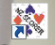
Start / Login to Scorer
Scorer icon Reports icon
There are two distinct scenarios:

Start Scorer using the Scorer icon
This method will be used by clubs who use BridgePads or no electronic scoring.
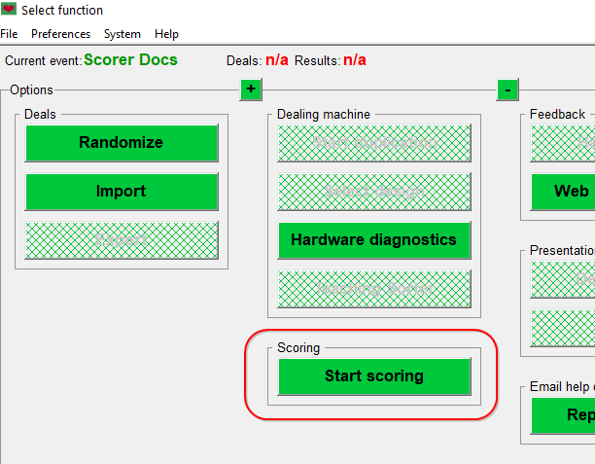
The icon will usually be on the desktop and/or in the Quick Launch bar. Talk to your local PC administrator to get advice on how the club computer is configured.
Figure 1 BOS Event Screen

Start Scorer after starting BOS
BOSscreen from which to start Scorer
After starting BOS and entering the new event (or Opening Old Event) there is a button to “Start Scoring”. If BOS is set up correctly then this should start Scorer.

In BOTH cases above, scorer should be started from a batch file.
This allows for any drive mapping or any custom requirements.

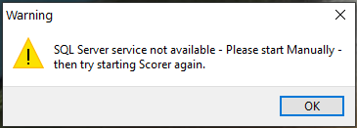
Scorer requires access to the SQL Server database. If the “SQL Server Service Not available” screen appears then it is likely that the SQL Server service on the computer has not yet started. This may happen for several reasons including pending Windows updates or possibly the computer has not yet been on for long enough for the service to start. See 0 for starting this service.
Figure 2 No SQL Service

Admin user with no Password
If Scorer is set up with the UserLogin Admin and no password, the Enter Password screen will NOT show unless there is a requirement because of a versioning problem (i.e. an update has not been completed.)
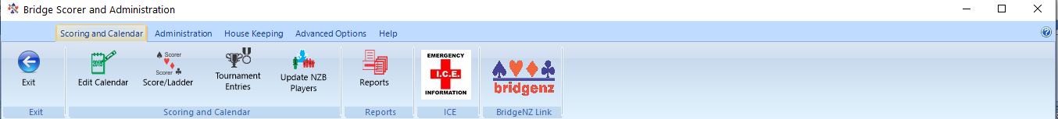
If all is good then the Ribbon bar will open and Scorer will be ready to use.

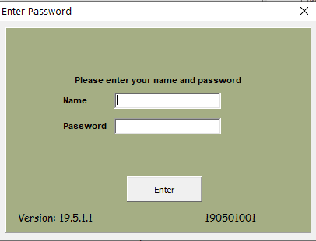
Admin has password OR no Admin user
Figure 3 Standard Login Screen
NOTE: This screen displays the programme version and the database version for quick reference.
When Scorer starts, the first screen that shows is the “Splash Screen” which shows the version of Scorer that you are running. When this disappears the Login screen appears:
This “Enter Password” window (also referred to as “Scorer Login Window”) will appear over other windows on screen, but if the user has clicked on another application then the focus will not be on this window, so it may be necessary to click in the Name field before starting to type the login name.
In the Scorer Login Window the user types the login name assigned to them (OR Admin if Admin has a password), and the password associated with that.
e.g. John Brown may have the username “johnab” with a password of “Batman”. (This has been assigned to him in the Club administration screens – see later)
Firstly, John CAN sign in as JohnAB or johnab or any other mix of upper & lower case letters.
The password MUST be in the same case as the original, so “batman” will NOT work.
Scorer allows the password to be blank.
Once logged in, the functions permitted with the user’s security level will be available to the user:

Login screen appears with message
Figure 4 Login with incorrect version
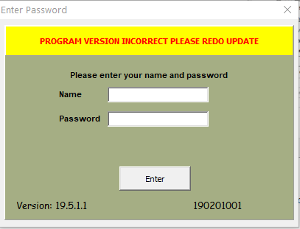
Scorer makes use of the four parts to the version as follows:
For version 19.4.3.2
- 19 = Major version usually based on year of release.
- 4 = Changes to Scorer.exe for enhancements.
- 3 = Changes to other files associated with Scorer. These may be reports or other associated files, but the version of the Scorer programme does not change.
- 2 = SQL update only. This only involves changes to the database and does not require downloading and installing of any programmes or ancilary files.
When the user logs in, the Scorer version will be compared with the available release on the web and the user will be advised if an update is available.
If the SQL update is done but the programme updates are not completed then the user is informed that the programme version is inconsistent with the database version and is asked to redo the update. Scorer will still work, but results are unpredictable. The “Redo Update” can be run from the administration tab in the ribbin bar.

Request for NZB Player Update
Scorer will check if the NZB Player update has been done within the last 14 days. If not, then it will ask if the user would like to do the update when logging in.
If the computer is on the internet then it is recommended to do the update, otherwise it is recommended that the user does the player update at the earliest convenient time after the session.

Scorer Menu Functions -- the Ribbon Bar
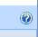
PLEASE NOTE: A Help page showing the following information is available from the icon at the top right of the ribbon bar.

Menu Structure
The ribbon bar is separated into tabs.
Scoring and Calendar / Administration / House Keeping / Advanced Options / Help and Support
Select the appropriate tab to see the ribbon with the available options.

Every tab has the “Exit” option on the left and the link to BridgeNZ on the right.
The Exit option requires the user to confirm that they actually intended to exit.
The link to BridgeNZ takes the user to our Home page – https://bridgenz.co.nz

Scoring and Calendar

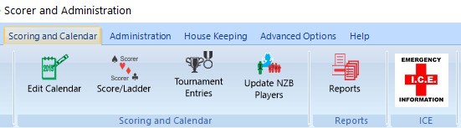
- Exit: Close Scorer
- Edit Calendar: Open calendar to add/delete or search for events – shows all days by default.
- Score/Ladder: Open calendar filtered to the current day ready to score. The ladder button is available on the calendar screen allowing the default ladder for any selected event to be run.
- Tournament Entries: Show Tournament Entry screen to enter/modify/report entries for Tournaments. NOTE: Event must be set up as a Tournament to show in this screen.
- Update NZB Players: Users are NOT asked on every login if they wish to update the NZB player list. It is now a conscious choice to do so. PLEASE DO THIS ON A WEEKLY BASIS.
- Reports: Start Reporting Tool.
- Emergency Information: This runs a report which displays information out into the ICE field in the member database. It is used to store emergency contact details or special medical information relevant to the players so that this information is available in an emergency.
- BridgeNZ Link: This takes the user directly to the https://bridgenz.co.nz
- Help screen for the Ribbon bar.

Administration

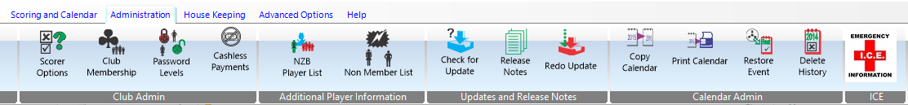
- Exit: Close Scorer
- Scorer Options: This opens the Options screen to allow for your local configuration.
- Club Membership: Add/Edit membership.
- Password Levels: These allows for the restriction of specific user access to specific icons on the ribbon bar.
- Cashless Payments: This will display the documentation for the integrated Scorer Cashless Payments.
- NZB Player List: This is the member list from NZ Bridge supplied to BridgeNZ for updated membership.
- Non Member List: Entries in this list are used for players that are not NZB members OR members of the club, but may be playing for a number of sessions. These names are available to electronic scoring systems.
- Check for Updates: This option requires internet access. The process checks the BridgeNZ website to see if the site database version is the same as that of the latest update .
NOTE: this does NOT check if the programme has been installed correctly.
- Release Notes: Shows the release notes for updates that have been completed. These notes are not necessarily full and complete but a useful indication of what has been added/modified.
- Redo Update: This will redo the latest update. This may be necessary if the second part of the update was not completed or if files (such as reports) have been accidently deleted. This option requires internet access.
- Copy Calendar: Copy the entire calendar from one year to the next.
- Print Calendar: Brings up the calendar with reports print option – far better not to use this but use the Reports Calendar options directly.
- Restore Event: The user may recover an event or session accidentally deleted from the calendar.
- Delete History: Deletes all calendar entries and underlying scoring files from the selected year and prior. PLEASE ENSURE YOU HAVE A BACKUP BEFORE USING THIS. This function will not delete the current year or the immediately prior year sessions from the calendar.
- Emergency Information and BridgeNZ Link: See above

House Keeping

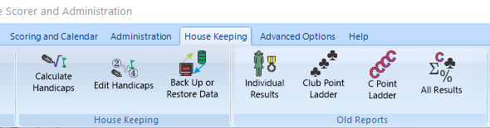
- Exit: Close Scorer
- Calculate Handicaps: Run the Handicap calculations. No existing handicaps are changed until this is run. Handicaps are calculated by session time, unless a custom or external handicap procedures have been implemented for the club. There is now options:
  - Custom Handicaps: BridgeNZ can write a handicap procedure to your specifications. Please email for further information.
  - External Handicaps: Handicaps may be calculated externally and a csv file with Computer number and handicap used to load the handicaps via the Scorer options screen handicaps tab.
- Edit Handicaps: AFTER running the handicap calculations, this may be used to make manual changes. Running the Calculate handicaps again will overwrite any changes made here. Manual handicapping as a separate item has been deprecated, as the use of Edit Handicaps without calculating handicaps achieves the desired goal of manual handicapping. [Edit Manual Handicaps: has been removed]
- Back Up or Restore Data: Standard backup that by default does the MSSQL Server database, Scoring folder for the current year and the files in the Scorer root folder. Optionally other folders can be backed up at the same time.
NOTE: Only the current year’s scoring files are backed up but database for historic sessions is retained.
- Individual Results: Show all results for one player.
- Club Point Ladder: Show ladder of club points for individual session or group of sessions.
- C Point ladder: Show ladder of C points earned for individual session or group of sessions.
- All Results: Show all results for all players for one session or a group of sessions.
- Emergency Information and BridgeNZ Link: See above

Advanced Options
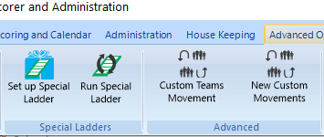
- Exit: Close Scorer
- Set up Special Ladders: Set up special ladder for sessions not in one event.
- Run Special Ladder: Run a ladder previously set up as a Special Ladder.
This now uses the database and reports.
- Custom Teams Movement: Create a teams movement with fixed format. NOTE: The numbers that are used in here are the SEEDING number of the team, NOT the team number.
- New Custom Movements: This allows for any movement to be generated and run easily. Most web and Bowman-Ewing movements are able to be generated automatically, and custom movements can be imported from csv or entered directly.
The Options Custom Movements and Create Howell have been deprecated in favour of the new easier to use and far more versatile” New Custom Movements”
- Emergency Information and BridgeNZ Link: See above

Help and Support
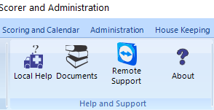
- Exit: Close Scorer
- Local Help: The file in the help folder directly below the Scorer root directory (usually C:\NZB Scorer\Help) called LocalHelp.pdf should be created by the local club with the important local information for users. A Microsoft Word document is also supplied for ease of editing, but to be seen in the Local Help this needs to be converted to PDF format.
Neither of these files are overwritten with updates so the content will be the default or whatever the club enters.
- Documents: These are documents supplied by BridgeNZ such as the Scorer User Manual, the Fast Reports Manuals, References on how to run events etc.. The club may add documents to the Documents folder as pdf files or avi files so that they are available to users.
- Remote Support: If the club computer does not have the Team Viewer host set up to run automatically, this provides single-time access to support from BridgeNZ.
- About: This gives the current version of the Scorer programme.
- Emergency Information and BridgeNZ Link: See above

Administration

Scorer Options
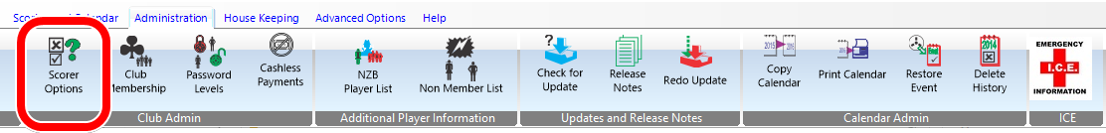
If changes are made in the Options menu, the SAVE button is required for some of the changes to take effect, however some changes are automatically saved. CANCEL will not necessarily undo all the changes made in the options screens.
Some options do not take effect unless Scorer is closed and restarted. These options write information to the scorer.ini text file which is read on startup.
SAVE: This is required to save some information to the start-up files.
CANCEL: This cancels changes made in the Options screens EXCEPT membership screen. When membership types are added they take effect immediately.

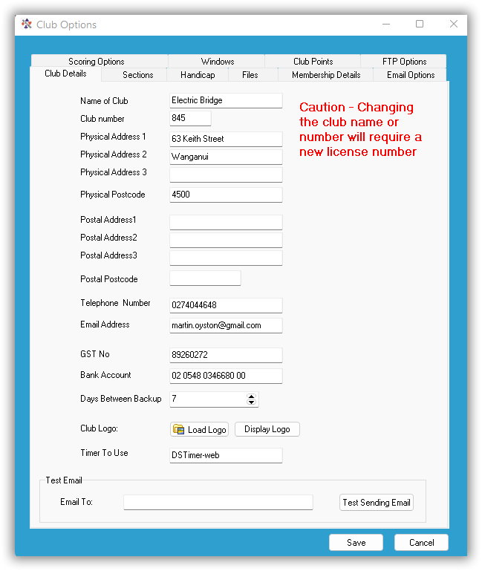
Club Details
Figure 5 Scorer Options Club Details
The details on this screen are used for club administration notices such as subscription notices.
It is strongly recommended that the information on this screen be completed so that it is available for reporting. The Name of the Club and the Club number are used in the licencing and should not be changed.
Email Address: Is able to be used in reports – future releases may use this as “From” address or “Reply To” address.
GST No: is available for reports and is used on the subscription notices.
Bank Account: is available for reports and is used on the subscription notices.
Days Between Backup: Allows the user to determine how often Scorer asks if you want to back up when exiting Scorer. The default is 1 but 14 would not be unreasonable for smaller clubs.
Once the backup is done the backup request for backup on exit will not show again until the number of days set here has passed.
Club Logo: A club logo may be imported using “Load Logo”. Logo field is designed for png file with print size 60mm wide x 35mm deep. Please note that larger logos may not show correctly in the reports.
NOTE: The logo is stored in the database so any changes to the original will NOT be reflected in Scorer unless the file is reloaded.
Display Logo: This is a report for the user to confirm the logo is correct.
Timer to Use: Entering “DSTimer-web” in the field will use Davis Stephens timer from the web for the timer (instead of the BridgeNZ Timer).
Entering “DSTimer-local” in the field will use a local version of David’s Timer which is useful if the club does not have internet access.
Test email allows the user to test that the email configuration is correct. (V22.2)

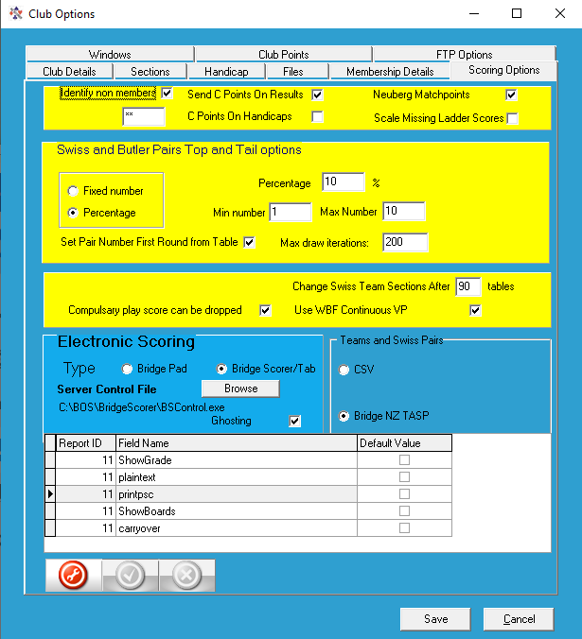
Scoring Options
Figure 6 Scorer options - Scoring Options
Identify Non Members: Players who are not in the club member list (bridmem table) will be identified in entry lists and results.
Scale Missing Ladder Scores: Allowed ladders to count more sessions for a player than actually played (e.g. 2 sessions to qualify and 3 to count will give players the average of all sessions played.)
Neuberg Matchpoints: This is a fairer system of adjusting Match Points if some boards are played a different number of times to other boards. This can happen when there is a phantom and the session is stopped short; or if there is an adjustment on a board.
Send C-points on Results: This is for the new master Points system whereby C-point files are sent to NZB every time the Results button is pressed.
C-points on Handicap: The C-point files will contain handicap results and rankings and C-points will be allocated based on these. This is likely to be phased out if NZB regulate against it but still valid as at December 2019.
Swiss & Butler Pairs Top & Tail options determines how many results are discarded from top & bottom in theory to remove extraneous results.
Change Swiss Team Section after nn tables: This is used if there are a very large number of teams to overcome the restriction that with BridgePad you cannot enter a table number greater than 99. The initial nn tables are set to section A tables 1 to nn, then the next table is set to section B table 1 and incrementally from there. If the number of tables is greater than 2 x nn then section C will be created starting with Section C Table 1 and incrementally from there.
Compulsory play scores can be dropped: If this is not ticked then any session of an event that is marked as compulsory must be played by anyone qualifying for the event. This means a player will be disqualified if they do not play that session.
Use WBF Continuous VP: If this is ticked then Teams and Swiss Pairs events will use the 2013 WBF official continuous scales which has been mandated by NZB for club and tournament events. It also enables a box in Teams scoring to allocate non-balancing adjustments. If this is not ticked, a standard discrete scale is used based around a 10VP draw and 20VP maximum points.
Electronic Scoring:
Bridge Pad - Bridge Scorer/Tab: These buttons select which remote scoring device is being used. It is important that the corrret program is started with these – please seek advise from BridgeNZ if altering these settings. The Bridge Scorer option includes BridgeTab. Due to the template requirements for the different device types, it is important that the correct scoring device is selected BEFORE creating the first section in any session.
NOTE: The path to the controlling programmes for each device should be the same on each computer. This is most important for BridgePads which install by default under C:\Program Files but there is a problem with different computers running 32-bit or 64-bit operating systems. It is highly recommended that the BridgePad software be installed in C:\bridgenz and referenced from there.
For BridgeTab the default programme is usually C:\BOS\BridgeSscorer\BSControl.exe
For BridgePads the default programme is usually C:\bridgenz\BridgePad\BridgePad.exe
Ghosting: This feature allows for an underlying electronic scoring database to be replicated and run independently. It means that the same event may be run using two computers and two receivers (for BridgePads) with the names and results being uploaded to the one event.
CSV: This is for future use and should not be used currently.
Bridge NZ TASP: This enables a subscription service offered by BridgeNZ for publishing Teams and Swiss Pairs round-by-round results to the web. This service requires the installation of a SQL database. Examples may be seen at tasp.bridgenz.co.nz
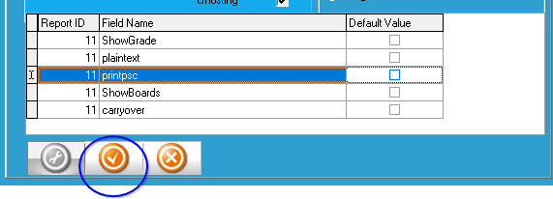
Figure 7 Report Defaults for Pairs
Default Values for Pairs Results: This allows the user to set which boxes are ticked when the results button is clicked for Pairs sessions. E.g. if “ShowGrade” is unticked and saved (with the green tick below the grid” then the “Show Grade option will automatically be UNTICKED when running the results.
NOTE: Please click on the green tick after the final option change or the last option will not be changed

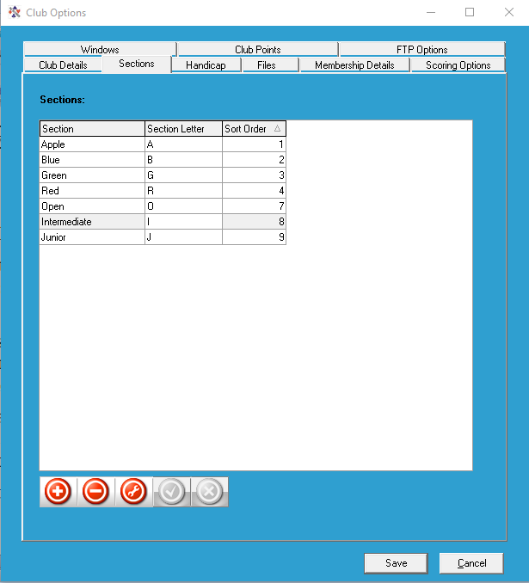
Sections
Figure 8 Section
The use of these fields has changed over the evolution of scoring.
The “Section” is the description for the players. It is useful if there are more than one section to distinguish by colour (usually the colour of the table cloths or table numbers)
The “Letter” is used by the scoring device. It is usually useful if this reflects the section (e.g. R for Red and G for Green) or the natural reason for different sections (e.g. O for Open and J for Junior)
The Section and letter are paired in the ScorerSection table in the databse. The section text can be accessed from the Section setup screen in Pairs (see later in this document). The sort order is also defined in the Section tab. This is the order they will be sorted in the dropdown menu in the Section Setup screen.
Section Letter Sort Order
Blue B 1
Red R 2
White W 3
Open O 4
Junior J 5
BridgePads can be pre-set to sections of a single letter A to L. Please choose the “Letter” accordingly.
BridgeTabs may be pre-set to single letters A to Z (there are other options here but not relevant).
For Multi-section tournaments it is recommended that the devices are set to a section and table, and the “Letter” in Scorer will match the Section on the scoring device. (see recommendation above for section settings).
Sections in Scorer are usually given a colour. This is historical and was initially used to reflect the colour of the score sheets associated with that section or the colour of the table covers. It is still useful to use this in tournaments to assist players in finding the correct section as many of them are still able to distinguish colours.
ADVICE:
- Avoid using the same letter twice
- Do not use the letter “R” as this may conflict with a RealBridge section. Please change R to another letter (we suggest “D”)

Windows
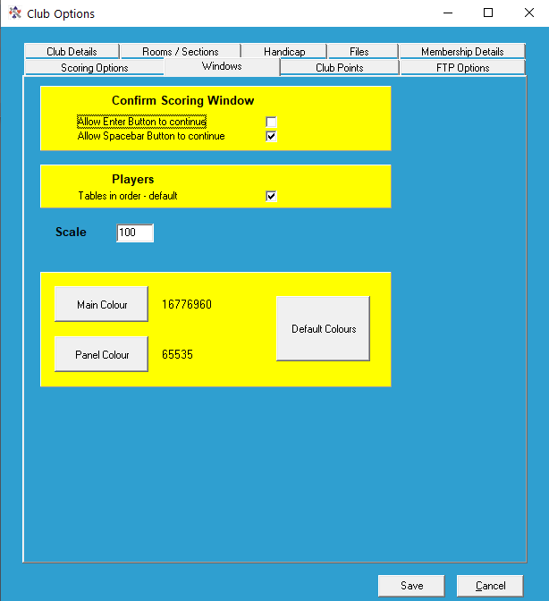
This allows the user to set the colour scheme for some of the Scorer screens
Confirm Scoring Window options allow the user to set the use of the space bar to confirm scores (as well as use the mouse to click on the “Yes” button) and/or use the Enter button for this. [Allow Spacebar option is recommended]
Players “Tables in order” is a useful default when entering names from entry slips, as your entry slips are usually in table order.
Scale : This is a scale factor and should allow for scaling of most screens.
Because of the tools used and the nature of scaling it may not work effectively if the user has more than one monitor.
Any previous scale factor which is greater than 150 will be reset to 100 when Scorer 19 starts.
Main Colour / Panel Colour : These allow the user to set colours – maybe for a test instance of Scorer or maybe just because they like the colours and don’t like Blue.

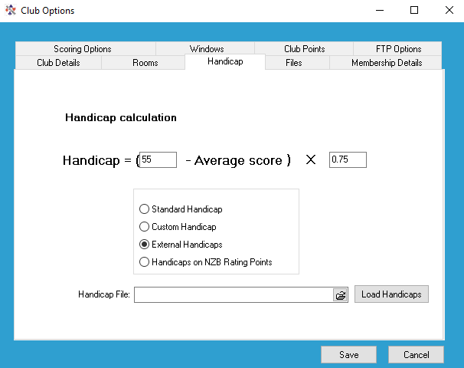
Handicap
Figure 9 Club Options Handicap
The type of handicapping to be used and parameters for the Standard Handicaps are set in this screen.
Standard Handicaps: With Standard Handicaps, the two parameters are used in the calculation. The first number is the “Zero”.
If a player’s average score is this “Zero” figure then their handicap will be 0.
The second number is the “compression”.
This allows the range of handicaps to be expanded or compressed.
Example of handicap calculations:
With “Zero” parameter set to 53 and “compression” set to 0.75
Player Andy averages 57% over the timesacle selected, player Gerry averages 45% over the date range selected whilst player June averages 53%.
The handicap for Andy is (53 – 57) x 0.75 = -4 x 0.75 = -3 (MINUS 3)
The handicap for Gerry is (53 – 45) x 0.75 = +8 x 0.75 = +6 (PLUS 6)
The handicap for June is (53 – 53) x 0.75 = 0 x 0.75 = 0

NOTE that if the compression had been 1 then Andy would have had a handicap of -4 and Gerry a handicap of +8.
Note also that handicaps are not all whole numbers, they have just been used in this example for clarity.
Standard Handicaps are calculated only on request (see menu item Housekeeping/Calculate Handicaps) and manual adjustments can be made for exceptions after they have been calculated (see menu item Housekeeping/Edit Handicaps).
Custom Handicaps: There is the option of using a custom handicap calculation. Please contact BridgeNZ if custom handicap calculations are required. These will not be overwritten in updates, and can include calculations involving several session times and weightings if required. The calculations may use any session related data (e.g. use multiple sessions of play .. say Monday evening, Wednesday afternoon and Thursday evening) and also may use any combination of local and NZB generated gradings, Master Points, A/B/C-points in the calculation. This allows handicaps to be calculated over multiple sessions of play and borders to be imposed for say players who have more than 100 A-Points.
External Handicaps: These are imported from a csv file and assigned to the players when imported. The handicaps may be generated in any manner the user sees fit, but remembering that there is a clause in the regulations about having an established handicap system. Please refer to ppE8-9 of the NZB Manual 2016.
Using external files, the club should set a location for the file and update the handicap file as required, then import from the options handicap screen.
Handicaps on NZB Rating Points: When the Handicap calculations are calculated they will be based on the member’s current NZB Rating Points.

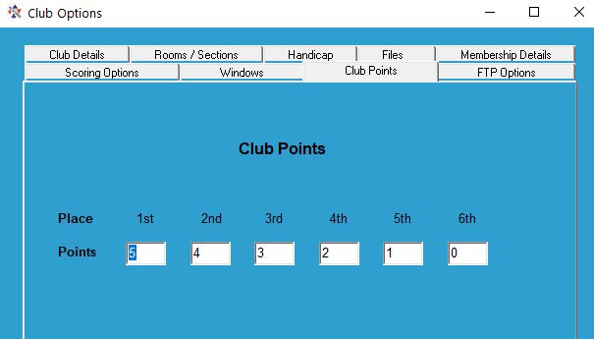
Club Points
Figure 10 Options Club Points
These are used solely within the club, and this option is used to allocate points to players for their placings in club sessions. The club points are allocated based on the player’s placing within a session and are not altered by the number of tables or pairs playing in the session.
This has two important ramifications:
- Playing a 6 table Mitchell will have two pairs getting maximum club points, two pairs getting second and so forth. Playing a Howell one gets a fairer result for the session but only the top pair gets top club points, next is second … so only half the number of club points are allocated.
- If there are 6 tables then it is possible for pairs to get maybe 2 or even 3 club points whilst scoring below 50% whilst when the number of tables is up to 18 or more players with 55% may struggle to get any club points.
These are NOT intended as comments to dissuade clubs using Club Points, merely advising that the club should be mindful of these factors when setting up or allocating the Club Points.

Files
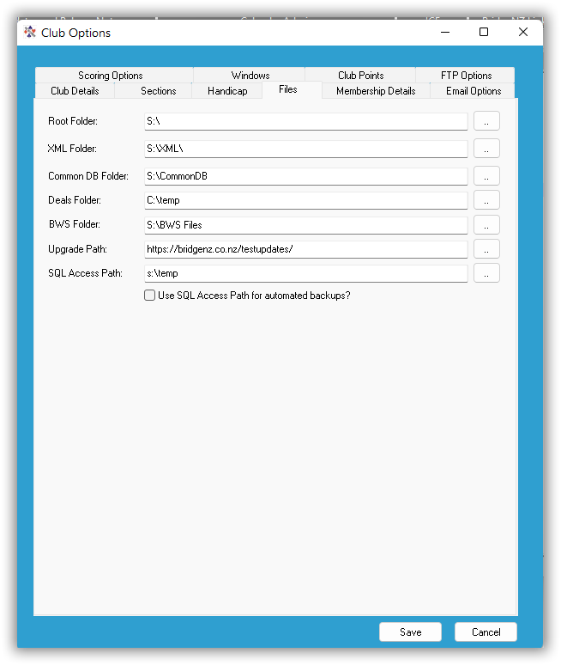
These specify the file locations that Scorer will use for its various processes.
Figure 11 Club Options - Files
Root Folder: This is used for backup purposes. It is the location of all files required to run Scorer (executables, ini files and dat files). If users delete dat files from this folder they may find they no longer have access to Scorer.
XML Folder: This is where XML files are placed ready to be sent to the web or displayed on screen. These are generally temporary files except for some formatting files located in that directory for display purposes.
Common DB Folder: This is the default folder used to share data for concurrently running multiple events using electronic scoring.
Deals Folder: This sets the default location that will open when searching for dealing files to attach to a session. This is the default location that will be opened when searching for a dealing file.
- EasyDealer users should change this at the end of each year to reflect the location of the new year’s dealing files – usually something like “C:\EasyDealer\EasyDealer Files 2020”.
- Users generating files in BOS should have this parameter set to something like “C:\BOS\Events”.
- In some instances the dealing folder is mapped for convenient use by multiple computers and will be something like “X:\”.
BWS Folder: This will be the default folder for saving bws files that are being used for electronic scoring.
Update Path: This is the location on the web that Scorer uses to search for updates. Basically there are two paths that can be used here: “ https://bridgenz.co.nz/scorerupdates/” is the standard path.
“https://bridgenz.co.nz/testupdates/” is the path for TEST versions only.
SQL Access Path: This is the location that is used to store the downloaded NZB member data for import into Scorer. This path needs to be accessible from all computers using Scorer. Most clubs can use a path like “C:\temp” if only using one computer, but more complex systems may use a UNC path. The important principle here is that the computer with the SQL Server installed and hosting the Scorer database (bridgenz) MUST be able to access the path typed into this field.
Use SQL Access Path for automated backups?: This allows the system to backup from a different computer and have the database backup sent to the BridgeNZ server. The user must still select “Yes” to the Backup on exit opiton when they close Scorer, and must not close the computer down until the process is complete. The computer must be on the internet for the backup transfer to take place.

FTP Options
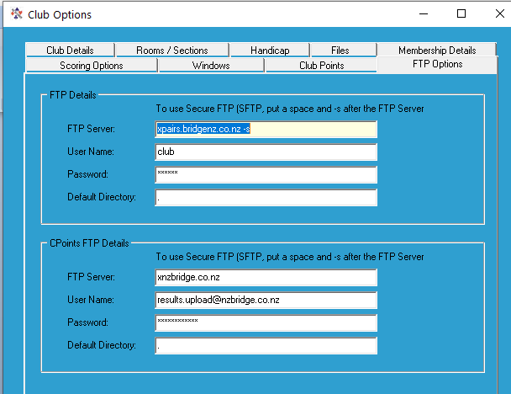
This allows the user to set the ftp site to which results will be sent. The results from pairs sessions can be automatically sent to the site in XML format, along with the hand records.
Figure 12 Club Options - FTP Options
For hand records to be sent a .txt, .edr or .pbn file must be available and linked to the session from the sections screen.
[Strongly recommended and best option is a pbn file].
Details for the BridgeNZ web result hosting site will be provided by BridgeNZ.
Please note that a secure FTP (sftp) option is available and preferred. To use Secure FTP:
- ensure that the “FTP Server” field ends with “–s” (ensure there is a space before the dash and no space between the dash and the s).
- Send a set of results to the web from a pairs event (by clicking the XML button).
- In Windows explorer, browse to S:\ (or C:\NZB Scorer if no S: drive) and double-click FTPStart.bat
- In the DOS window which appears it will ask if you want to store the encryption key – type Y [ENTER]
- The window should complete it’s actions and close
The system is now using Secure FTP, but ensure this is done on each computer as the encryption key is stored in the registry of each computer and is the means of the computer knowing that the web site is not harmful.

C-Point FTP Details: These details allow the sending of C-points directly to the NZB site (no relation to BridgeNZ). If the club changes these details (except as below) then their results will not be received by NZB and C-points will not be allocated.
It is possible for the C-point file to be routed through the BridgeNZ server using sftp. This overcomes any firewall/antivirus issues with using FTP which is known to be a less secure protocol and is usually blocked by default.
To do this the C-Point FTP Details should be set exactly as per the FTP Details except for the “Default Directory” which should be set to “./cptfiles”. NOTE: the ./cptfiles IS case sensitive so ./Cptfiles will NOT WORK.

Membership Details
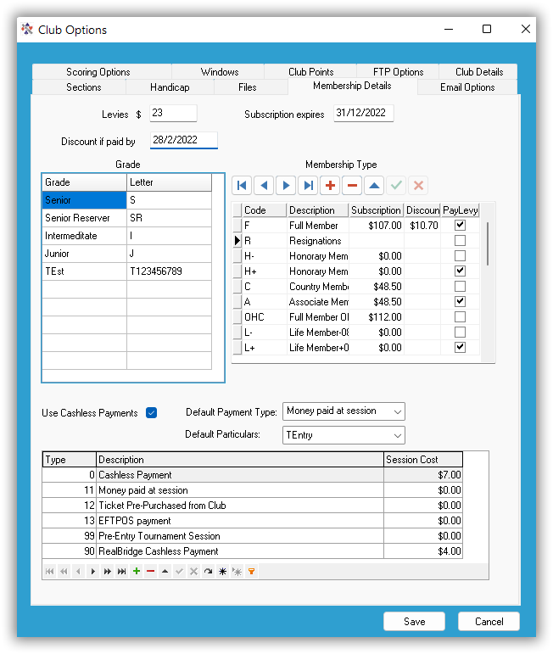
This is where invoice information, membership classes and local grades are entered. All levy and subscription amounts entered should be inclusive of GST.
Figure 13 - Member Details and Scorer CP Options
RECOMMENDATION: Add a member type “_Z” “Administrative user” and leave the Subscription and discount fields blank. This allows for an administrative user to be in the membership but not be picked up in the financial reporting. It may be useful to have another member type “X” for members that have resigned but the club wish to follow up at some point. Once again leave the subscription and discount columns blank.
Levies: This is the Annual NZ Bridge Levy which includes a regional levy. This is set by NZ Bridge each year and will need to be updated as notice is received from NZ Bridge.
Subscription Expires: Usually end of the club’s financial year.
Discount date: To allow discount for early payment if the club chooses to do so.
Grade: For local grades. Note that these are NOT the NZB Ranking or Grading, but allow the club to have its own internal grading.
Membership Type: This is unlimited, and clubs are free to add different types with appropriate subscriptions and discounts. Please note, at the time of this manual, NZB levies are only payable at one club per player. This is designated as the player's Home Club.
The subscription that the members pay is
- NZB Levy + Club subscription if “Pay Levy” box is ticked OR
- Club subscription only if the “Pay Levy” box is not ticked.
- Both these are less the applicable discount if before the Discount Date.
If a club wishes to accept subscription amounts from players joining part way through a year, they should set up a new member type with the appropriate subscription amount and change the member type for these players at the start of the next financial year.
Example in Figure 13,
- A Code “F” member will pay $23 Levy + $107 subscription = $130 (less $10.70 if paid by 28/2/22)
- A Code “C” member will pay $48.50 subscription with no levy (box not ticked).
- A Code “H+” member sill pay no subscription, but will pay $23 NZB Levy. [IMPORTANT sub=$0.00]
- A Code “H-” member will have an invoice generated for $0.00
- A Code “R” member will have no invoice generated (sub and discount columns are blank)

The Cashless Payments section is described in the document “Scorer Cashless Payments”. Please refer to this document.

Club Membership
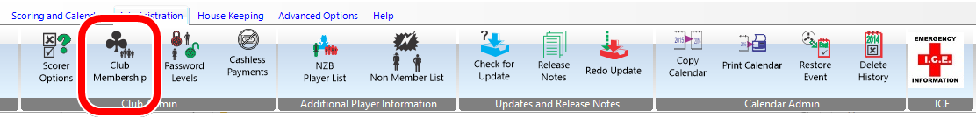
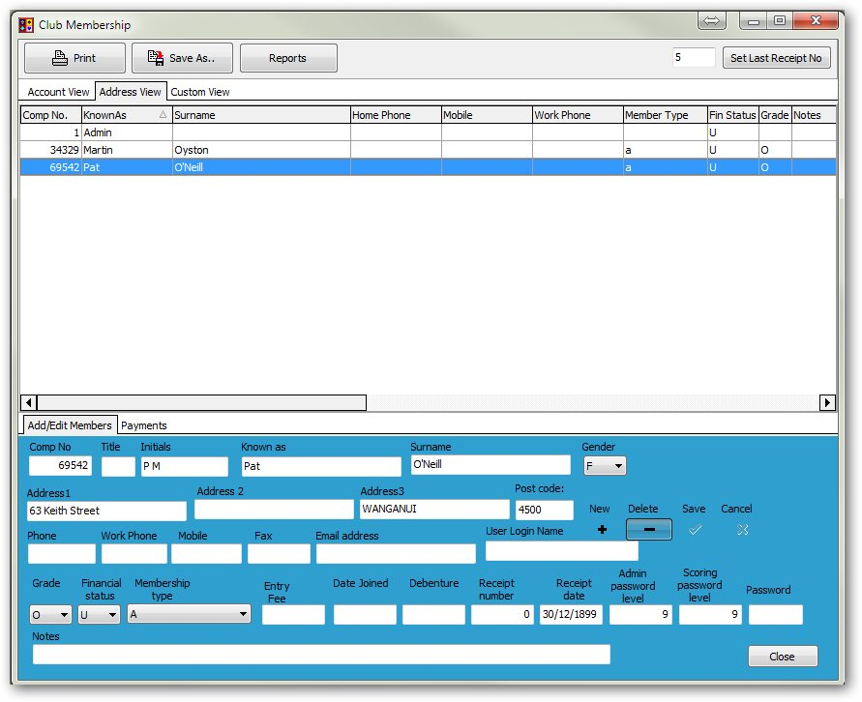
Columns in each tab can be dragged to show in the sequence the user chooses.
Column headings with sort & filter options
Tabs to move to different views

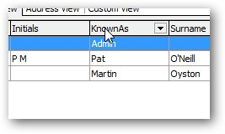
Sorting Columns

When you click on one of the field headings with the mouse, the records are automatically sorted by that field. If you click again on the same heading it sorts them in the opposite order.

Filters
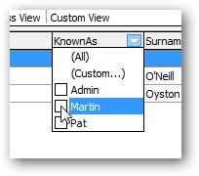
When the mouse is put over a heading, a small arrow appears at the right end of the field. Click on that arrow and a filter box displays. This allows for filtering to one or more specific entries.

This option is particularly useful if, for example, only Un-financial members, or maybe only Junior players are to be displayed. Ticking any of the boxes will display only those entries.
The action may be cancelled by going to the filter box again and clicking on (All).

When a filter is set, there is notice of it at the bottom left of the grid. The filter may also be cancelled by clicking on the X next to the filter description.

More complex filters may be added using the (custom) options, but that is beyond the scope of this document.

Add/Edit Members (bottom tabs)
Figure 14 Add new member
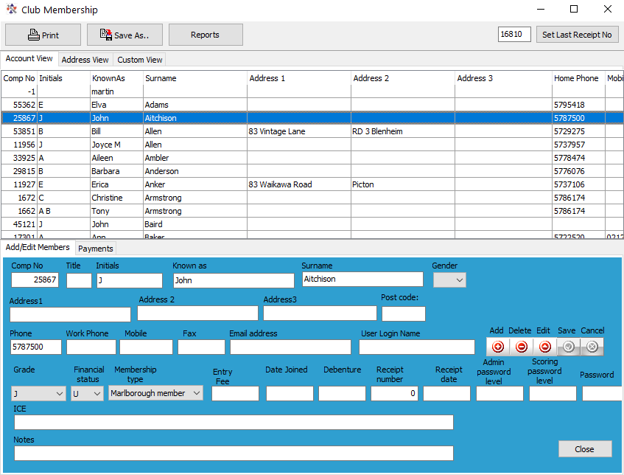
This screen allows the user to add members, edit details of a member or delete the member. Filters can be applied to any field, (this IS case sensitive) but there is no general search facility.
To ADD a new member
- click the “+” under “New” in the bottom panel.
A new blank line will open up and you can enter details in the BOTTOM section of the screen.
- The Comp No (required field) can not be blank and can not be duplicated.
- The email address will take up to 60 characters.
- The Gender is a drop-down that will only be M or F (should you require other types please advise).
- Grade is the LOCAL grade (see Options Membership Details). Choose from the dropdown.
- Membership Type (Required Field) is a lookup from those entered in the Options screen (see Options Membership Details)
- Financial Status is U (Unfinancial), F (Financial) or D (Debenture Holder).
- Click the tick under “Save”
- The Financial status of the new member is automatically calculated and set to ‘U’ or ‘F’
NOTE: If the club has a part year subscription (for players joining part way through the year) OR for new members from lessons then another Member Type (in the OPTIONS screen) should be set up with the appropriate charges. At the end of the financial year the Member Type can then change before producing new accounts.
User Login Name can be set to anything, and is used for the user to access Scorer. If the user is not doing Scoring or Administration for the club then nothing need be entered in this field. If a User Login Name is entered, then Admin and Scoring Password Levels should also be entered, and a password for the user to give them appropriate access to the menus required.
A user cannot change any password (including their own) unless they have admin privileges to this screen.
The highest access level is 9, and other access levels can be customised – see later in this document.
When Member's details have been completed, then click on the Tick under “Save” in the lower panel.
PLEASE ensure that some members have User Login Names and Passwords AND level 9 access before removing the ADMIN user (deliberately or inadvertently).

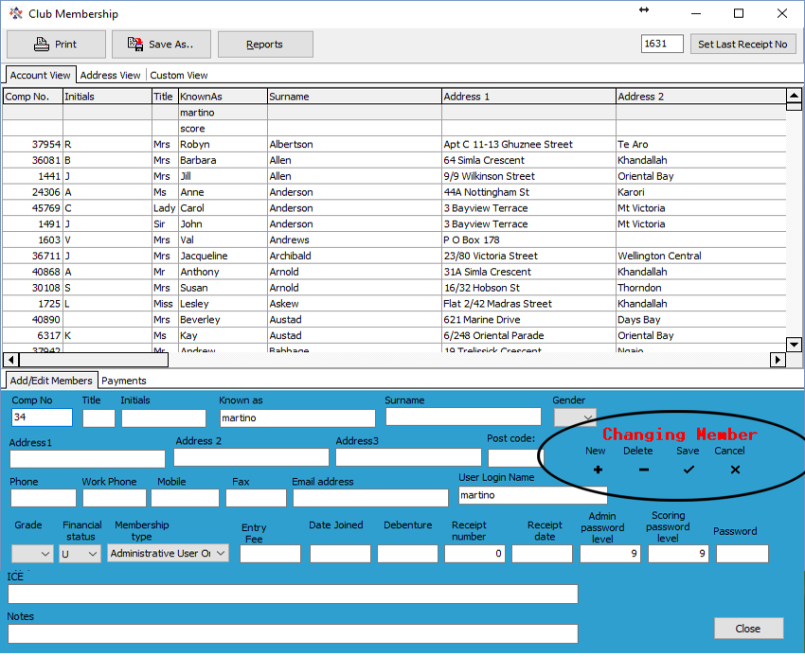
To change a member's details
Figure 15 CHANGE Member Details
Select the member, change the detail required in the bottom panel, then click the tick under “Save”.
A common error is changing an existing member details instead of adding a new member. From Version 16, if a current member details are being changed then a red highlighted message appears above the control boxes to indicate a record is being changed rather than added.
If this is an accident then the user may click Cancel then Add the new record as intended.

Computer Numbers: Please enter computer numbers allocated by NZ Bridge Inc. to your new members’ records. No member can be entered without a computer number. An error message will be generated if another member is found with the same number as that entered.
Notes: This is a free-text field that allows entry of any relevant notes. Any special medical conditions, Contact person, Next of kin etc. should probably be put in the ICE field – see below.
“REPORTS” REPORTS button on screen to access member information in a nicely presented manner. Reports may be added or modified according to the needs of the club, or the club may request reports to be written specifically to requirements.
The “Save” and “Print” buttons will be depricated
ICE (In Case of Emergency) Emergency contact information and important medical details should be stored here for easy reference if the player requires urgent medical attention.

Payments View (bottom tabs)
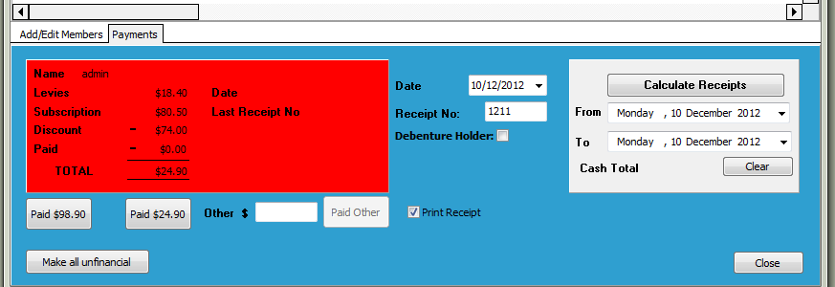

The following processes are managed in the Payments tab:
- Make all members unfinancial – as done at the end of the financial year
- See the status of a member – (the payment box is Green for members that are financial and Red for those members that have outstanding balances. Debenture holders will show with a Yellow background)
- Receipt payments – if the “Print Receipt” tickbox is ticked, a receipt will be printed using a pre-determined report ("ReceiptPayment” in the system reports which the club can change).
If the “Print Receipt” box is unticked, there will be no physical receipt printed but the receipt numbers and amounts will be accumulated in the database.
- The Date and Receipt Number fields show the date and receipt number that will be applied to the payment when the “Paid” button is pressed. These fields may be changed if required (e.g. to enter a historic receipt)
- There are two automatic payment buttons – one with early payment discount and one without the discount. If some different amount is paid, enter the amount in the ‘Other’ box and click “Paid Other”
- When receipts have accumulated, receipts can be calculated over a date range and the data used for banking or analysis
- The “Calculate Receipts” button will give a list of payments between given dates..
- When the payment buttons are clicked, the receipt number will be allocated, and the receipt number automatically incremented.
- NOTE: The recommended procedure for setting the receipt number is, at the start of the process (when you make members un-financial), to change the number in the box that says “Set Last Receipt Number” to YY000 (e.g. 15000 for 2015) then click “Set Last Receipt Number”.
This will then allocate all your receipts to 15001, 15002, …
Similarly, for the next year start at 16000. This format will give a quick count on how many payments have been made.
- When a member does not owe you money, the system automatically sets them to Financial, and the rectangle shows green.
REMEMBER: The Reports button allows reports to be run. Sorts and filters are also available from the grid.

SUBSCRIPTION PROCESS
The following is a recommended procedure for Subscription setting and receipting.
- From the reporting tool, Admin folder, run the report “Member_by_Type” to check that Membership Types are defined. Assign member types to all members with no type assigned.
- Set the NZB Levy and your subscriptions, discounts, Subscription Due Date and Discount date in the “Options” Screen, “Membership Details” tab. Save.
[Please remember that NZB Levy is NOT considered part of the subs. The payment from members is made up of NZB Levy + Club Sub]
- Go to Club Administration, payments tab
- Click the button “Make All Unfinancial”.
…Now all your members are made Unfinancial.
NOTE: This process may take a little time.
- Set the Last Receipt Number to YY000 – where YY is the year (e.g. 15000 for 2015)
- If any members have already made payments toward their subscription, then enter these payments now.
The payment date can be amended to receipt these against the correct date.
- Subscription Notices can be run from the Reports:
Click the Reports button
- Click on “Subscription Notice”
- Click on “Preview”
- The notices are designed to print on A5 paper. Most printers will manage this (or alternatively an A4 version may be produced either by the user or by BridgeNZ).
The subscription notices can now be printed. These will be in alphabetical order of Surname, and will not include any record with no surname (e.g. Admin). They will also not be printed for any member of class “X”. This has been reserved for members who have lapsed and have been flagged to enable follow up in other ways.
NOTE: If you would like a report to print two invoices per page, that can be arranged, or most printers these days will have settings to print 2 per page when printing A5 to A4.
- To generate Labels for posting out, a report is available. These may be customised by a local person or BridgeNZ can alter to your specifications for a small charge. Any size label can be accommodated.
- When Subscriptions are paid, enter the payments on the Membership Payments screen. Receipt numbers are now allocated automatically.
NOTE: Players remain unfinancial until full payment has been made.
IMPORTANT NOTE: BridgeNZ delivers a report “Subscription Notice BridgeNZ” which can be used as a template for the club’s own notice. When the club completes it’s own notice, please ensure it is saved under Reports\Admin to be accessable.
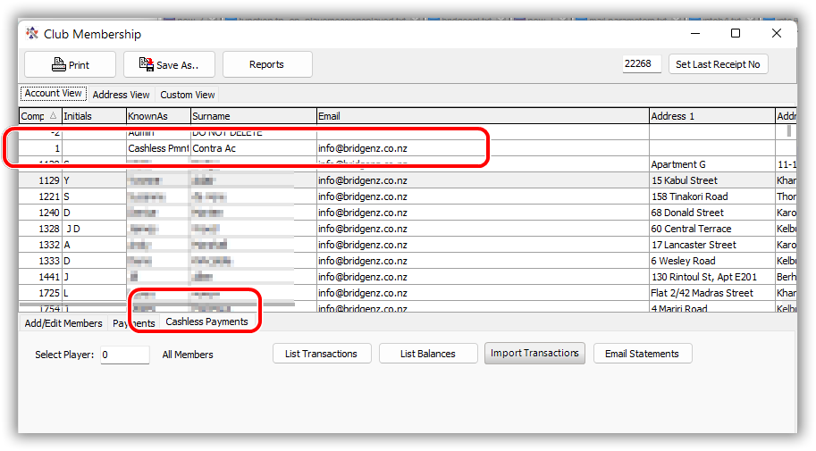
From V22.2 there is a “Cashless Payments tab in the membership window.
Please refer to the Scorer Cashless Payments documentation for a full description.
Note that the “member” with computer number 1 is the cashless payments contra account and should be created if not there.
Also please note that the cashless payments allows for receipt of subs and automatically assigns a receipt number if imported this way.

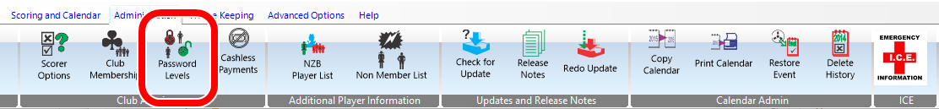
Password Levels
This allows the administrator to set which icons on the ribbon bar are available to specific users by setting the access levels for the icons and the users.
There are four groups – one for each tab in the ribbon bar except for HELP.
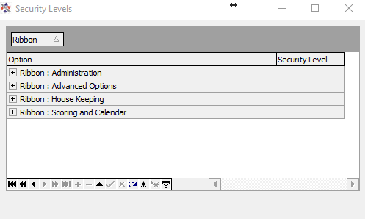
When each of these groups is expanded, there is a level associated with each icon on the ribbon bar. If the security level associated with the user (Admin Password Level) is greater than or equal to that assigned to the icon then it will be accessable to the user.
Example:
The Scoring level access to “Administration”, “Club Membership” is set to 7, so a user with admin level 7, 8 or 9 will be able to edit the club membership whilst other users will not.
Scoring level access is not relevant at this time.
SPECIAL NOTE: The “Edit Received Data” option in pairs is only available to users with Admin level 9 access

Cashless Payments
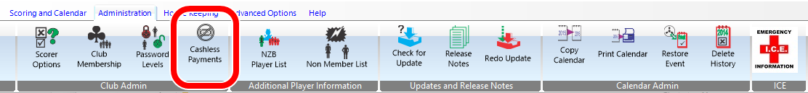
This should bring up the document :Scorer Cashless Payments

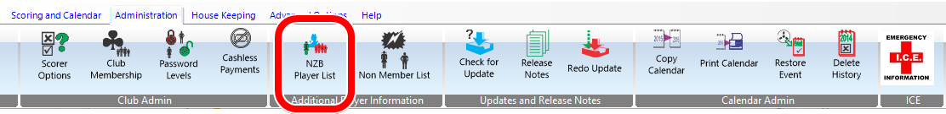
NZB Player List
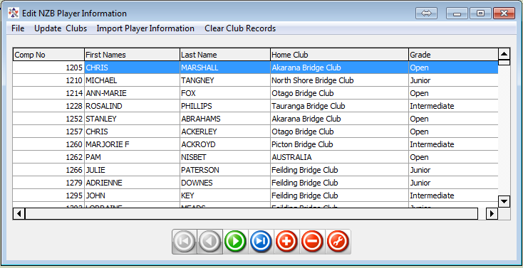
Although This screen allows the user to download information about NZ Bridge registered players in reality the “Update NZB Players” option does all that is necessary here. The screen can be used to filter down by club or grade or name etc. to check players, but the user will rarely access this screen.
NOTE: There is an “Update NZB Players” icon on the ribbon bar at login which should be used at least weekly. The process takes a very short time.
The player list is provided by NZB and BridgeNZ copy the file every hour to make it available to users. The “Update NZB Players” option brings in the latest list available which may be several hours out of date but should be no more than 3 hours in general. This means if the club adds a member in the NZB system then within a few hours their number is available to all clubs in the NZB Player list.
IMPORTANT NOTES:
When the player information is imported, the computer numbers are looked up in the club membership list and the “FirstNames” and “Lastname” are replaced with “KnownAs” and “Surname” from the club membership list. Also any members in your membership which are NOT yet in the NZB list will be added. This is to allow for a complete list of numbers and names when scoring electronically.
Any numbers which do not appear in your local member database will appear as they have originated from NZ Bridge.
In general this has the ramifications:
- If the club information is incorrect then the incorrect information will be shown on reports and electronic scoring systems for the local club but if the player plays at another club the information will show correctly.
- If the NZB information is incorrect then the correct information will be displayed at the local club but incorrect information will be displayed at other clubs.
After the NZB Player Update is run, the report (under the Admin section of Reports)
“Player Mismatch with NZB”
Should be run and any anomalies sorted between the club and NZB.

Non Members
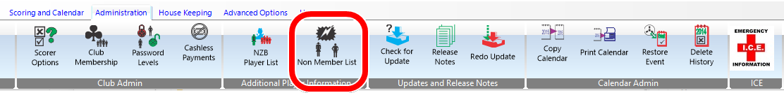
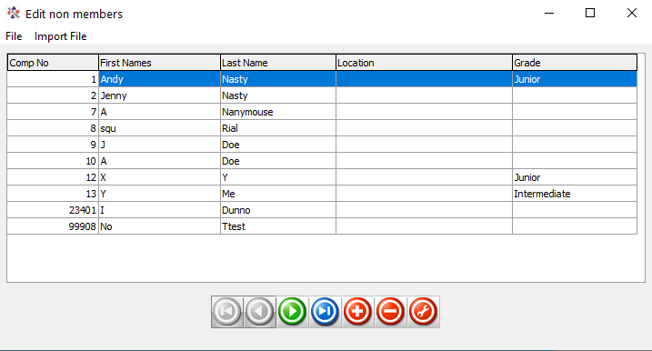
Non-members are added when a user enters a computer number in the scoring system and the number is not in either the club membership OR NZB membership. The user has the option to add this user to the non-members, and this used to be a useful function when newer players had to wait for NZB numbers.
The table is not of great value now, and should definitely be checked on a regular basis and cleared out.
The worst case is when a user adds the number of a player who has entered an incorrect number, then the player’s incorrect number will be sent for Master Points and the player will not receive their Master Points.

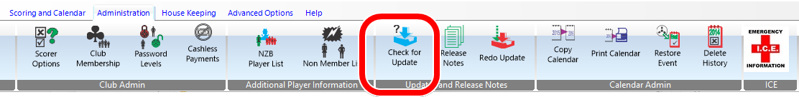
Check for Updates
This will check to see if there is a later version of Scorer available on the web. It requires internet access.
The option is automatically run if the computer is connected to the internet and Scorer is started.
If there are updates available then the user has the option of installing immediately or not installing.

In general if the user is about to start a session then DO NOT do the update, but do the update after the session is completed.

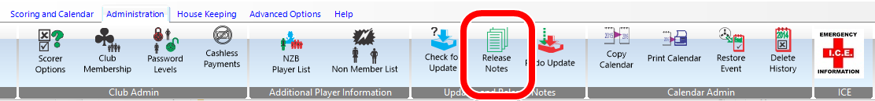
Release Notes
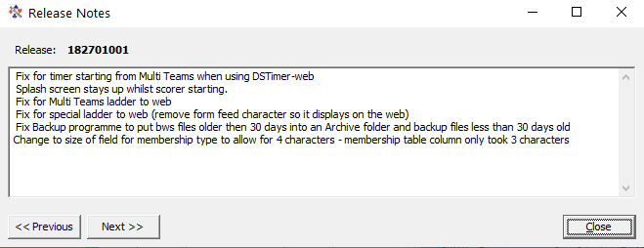
The release notes are included in the database so they are easily accessible.
They are not always updated but BridgeNZ tries to make notes on features which have been deprecated, modified or added to the patch when the patch is released.

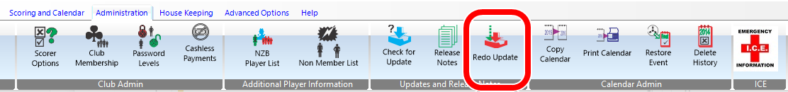
Redo Update
This option will re-apply the latest update(s). In practise it sets the version number to the next lower version which ensures that the scorer programme, associated files and SQL updates are all processed.
In the updates any necessary folders under the scorer root directory are automatically created if they are missing.

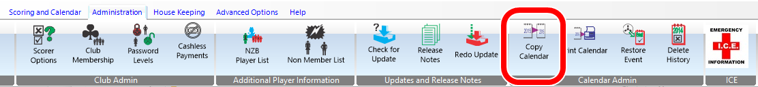
COPY CALENDAR
PLEASE TAKE A BACKUP BEFORE USING THIS FACILITY
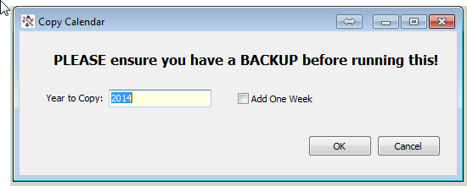
Year to Copy is the current year in the calendar. [i.e. It is NOT an option to copy the 2018 calendar to 2020!]
Add One Week means that when the year drifts back (as there is always 1 or 2 days more than 52 weeks in a year) then when the club starts a week later to align with the calendar this movement can be done automatically.
Any events named with the year e.g. “Champ Pairs 2014” will be automatically renamed to the next year e.g. “Champ Pairs 2015”

After copying the calendar, fine adjustments can be done using the calendar tools in Calendar Edit and adjust Tournament dates, session dates, event names etc using the tool (see below)

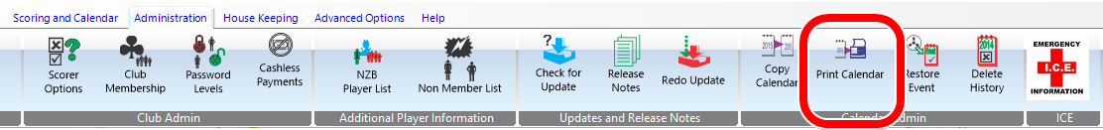
Print Calendar
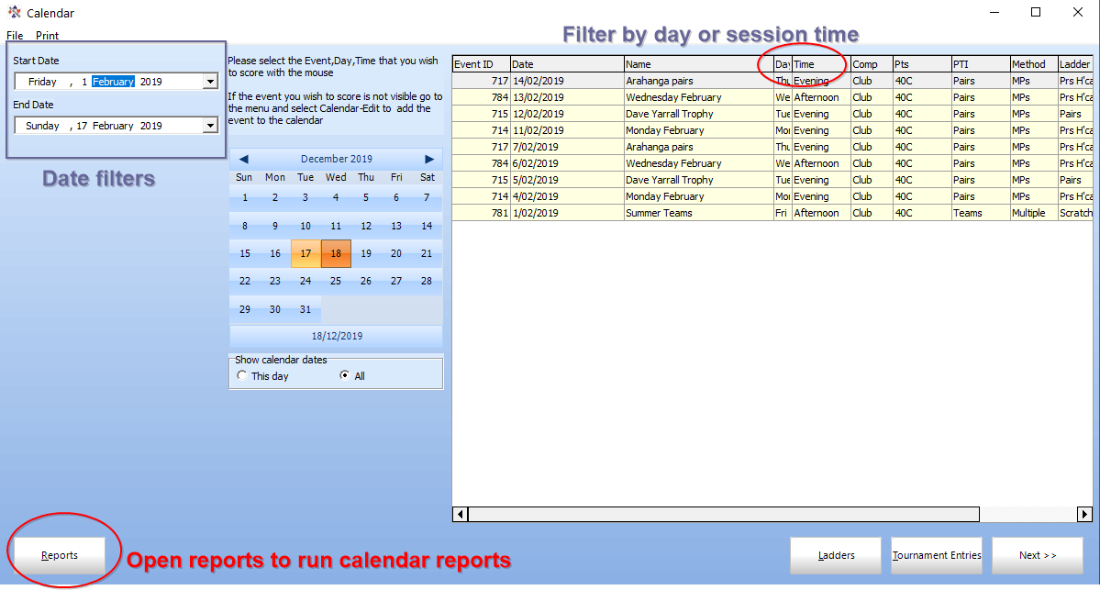
The Print Calendar allows the user to filter by date as well as by session time and day in order to check that the calendar is consistent with the next year’s programme.
The Reports button opens the Reports programme filtered to the Calendar Printing reports, which allow the calendar entries to be printed by session time in chronological order or alphabetical order of events.

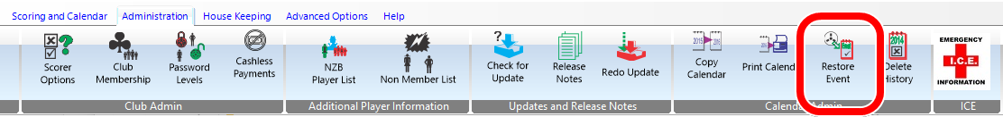
Restore Event
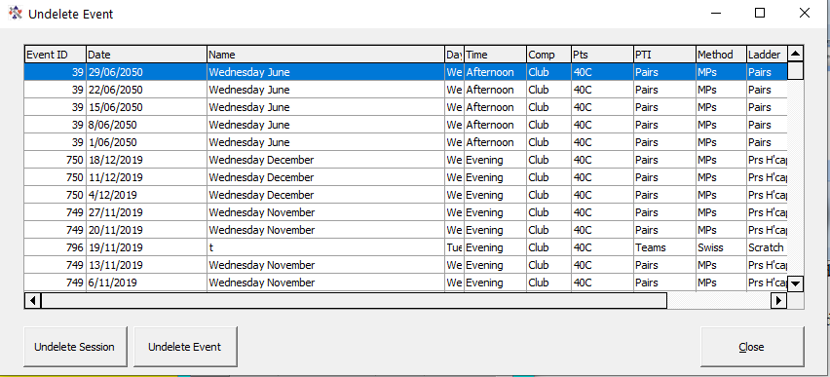
Restore Event allows the user to recover (or undelete) sessions or events which have been accidentally deleted from the calendar.
When an event or a session from an event is deleted from the calendar, it is not removed, but flagged as deleted so it will not display. The Restore process resets the flag so the session(s) are again visible.

Note that this does NOT restore any section deleted within the session which was deleted prior to the session being recovered.

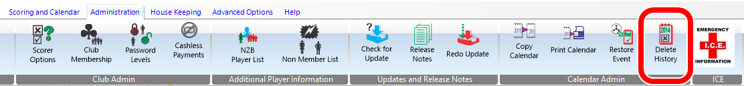
DELETE HISTORY
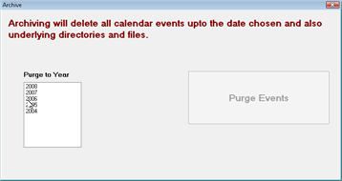
This facility is a nice way of removing historic events from the calendar and files from the underlying file system. The user is prevented from deleting the immediately previous year’s results, which are generally used for handicapping, but at the very least are important for club management and reviewing historic results.
When a year is selected, all files and events from that year and all earlier years will be purged.
The process recommended is:
- Make a backup.
- Purge to the appropriate year.
- Check the calendar and do a spot check on events that are to be kept.

House Keeping

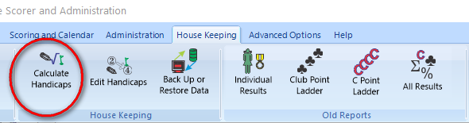
Calculate Handicaps
Figure 16 House Keeping
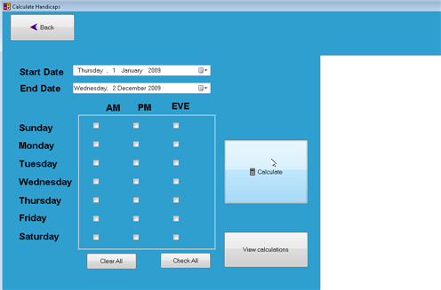
The .Calculate Handicaps panel
(fig 5.2) allows the user to choose a date range and select specific sessions for either standard handicaps or custom handicaps that use the date rand and/or the session selection. This panel will NOT be shown if “External Handicaps” are in use.
Figure 17 Calculate Handicaps
When the appropriate date range and sessions have been selected, the Calculate button is pressed to process the handicaps. Sessions which are used in the handicap calculations will be displayed for information purposes in the right pannel (see fig 4-14). When the calculations have finished a window comes up confirming calculations have been completed.
NOTE: With custom handicaps several pre-defined sessions may be used to calculate the handicaps and the session selection may not be relevant.
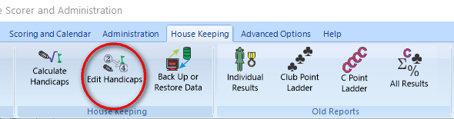
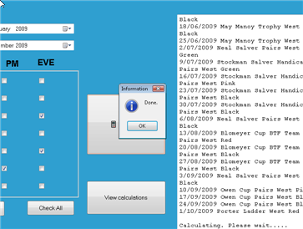
The View Calculations button opens the screen to the same window as “Edit Handicaps” (see below).
Figure 18 Info from calc handicaps

Edit Handicaps
This allows for
- Fine-tuning of the handicaps that have anomalies. (e.g. If a player has not played much and only played with weak players yet they are of a much higher standard, it may be decided that the handicap should be increased.
- Manual entry of handicaps if the user chooses to do so.
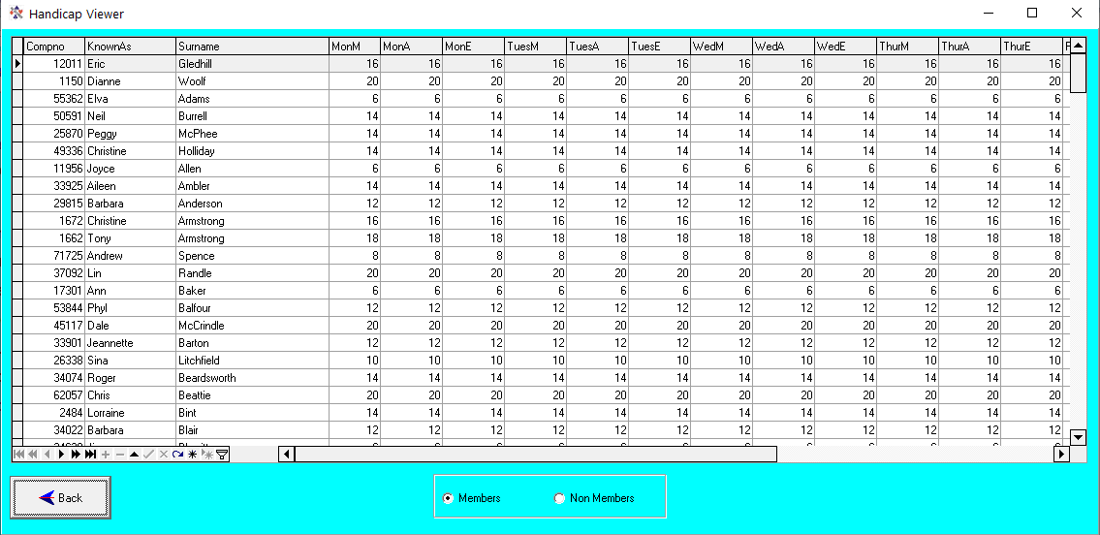
Standard sorting and filtering is available in the new screen.
Figure 19 Handicap Viewer
To edit an entry, numbers may be typed directly into the grid.
IMOPORTANT: Once the user leaves the cell after changing an entry there is NO UNDO.
Columns can be moved around and filters applied to simplify this task if entering specifically calculated handicaps.
To print the handicaps go to Reports Admin

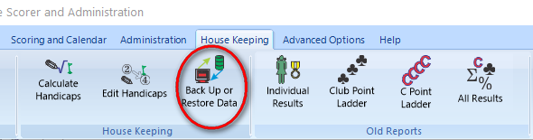
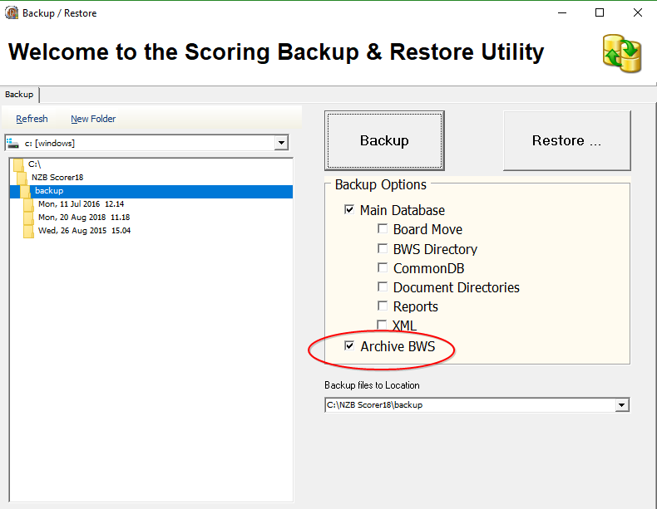
Backup or Restore
BACKUP
The backup function allows the user to make a copy of the FULL DATABASE and the CURRENT YEAR’S FILES. Because it only backups the current year’s files, it is strongly recommended that you backup after the last session of the year and save this in a safe place.
From V19 the files will rarely be used and the database backup will contain all that is required for complete data safety.
From Scorer V18, the sBackup programme has the option (automatically selected) to “Archive BWS”. This means that the (redundant) bws files will be archived. This should be left ticked as the information from the files is already imported into Scorer.
The backup must be done on the machine that has the Scorer SQL database on it.
From V19, the backup option will be displayed on exit from Scorer.
This backup can be configured to use a pre-set location which is located in a folder for DropBox/OneDrive or GoogleDrive for syncing to the web.
In the left pane of the backup window, choose the location to save the backup file. This can be on the C: drive (default is C:\NZB Scorer\Backup) or on an external/flash drive. It is good paractice to save a copy of the backup files to an external location (such as dropbox or similar).
When the Backup programme is started, Scorer will close. This is to ensure integrity of the backup.
If the “Shut down computer on completion” tick box is ticked, this will shut down the computer after backup (unless other programmes are running that will stop the shutdown).
When the user double-clicks on the folder, the path is put in the field on the right of the screen. Optionally, another directory may be created.
When the backup is started, it will create a directory named with the current date and time of the start of the backup. This leaves no doubt about when the backup was done!
There is a choice of directories to optionally back up.
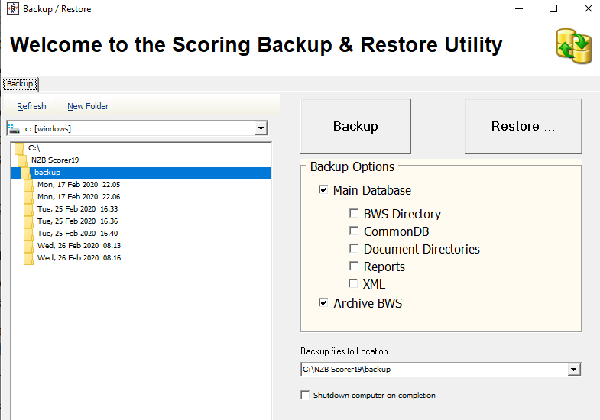
If the Main Database is selected, then the Scoring directory is automatically backed up, as it is vital that the database and the Scoring directory be kept synchronised. [This statement is near deprecation and the scoring folder is now seldom used.]
The backup can be restored with the Restore option to the same directories or different location, but best to do another backup immediately before trying a restore in case someone else has added information that you are unaware of!

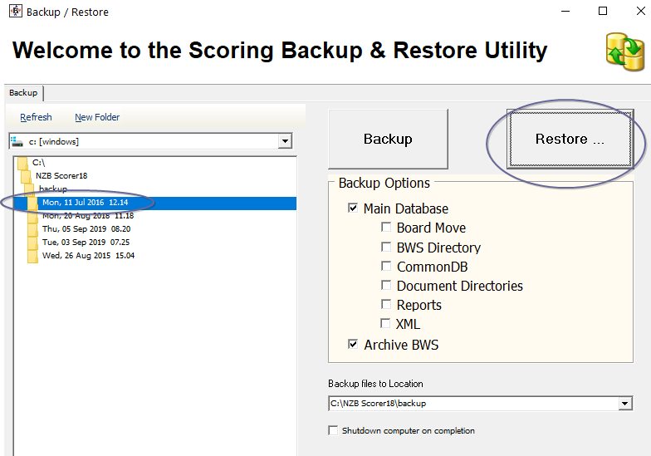
RESTORE
Please note that the restore may be run from within Scorer, or separately from another copy of “sBackup.exe”. If started from within Scorer, Scorer will be closed and the sBackup application will be started.
WARNING: Only technical and experienced users should even attempt this and there should be a confirmed backup immediately before the attempt.
To restore, select the directory containing the appropriate backup files (as above).
Click Restore
Highlight the folder that was created by the backup at the time.
The restore location may be customised.
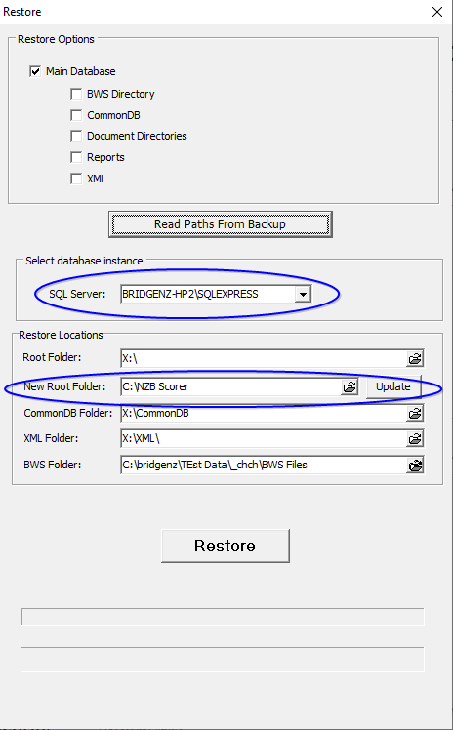
It is important that the correct SQL Server instance is located.
[This will normally be the “COMPUTER_NAME\SQLEXPRESS” and normally the only instance on the club computer.]
It is recommended that any mapped drive in the Restore Locations (X:\ here but usually S:\) be replaced by “C:\NZB Scorer” using the “New Root Folder” option. Type in the appropriate path or select the correct folder then click “Update”.
The RESTORE button on this screen may now be clicked.
The user is, at this point, able to change the location of the physical database files for Microsoft SQL Server, though it is recommended that this is left as the default.

When OK is clicked on this screen, the restore will begin.
*** DO NOT INTERRUPT THE RESTORE ***
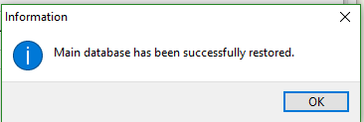
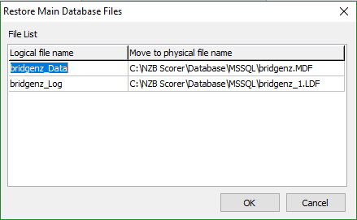
When the main SQL database is restored, the following message will appear:
When OK is clicked on this information screen, the file restore will begin.

Once the files have been restored, Scorer may be started. The data will be at the point in time of the backup that was restored.
NOTE: The restore does NOT restore the BridgeWeb database for Teams and Swiss Pairs.
NOTE: Please contact BridgeNZ if you are restoring to a different computer.

It is recommended that after the restore, the user goes to the administration tab and uses the “Redo Update” option. This will ensure that all folders are present in the scorer root directory, especially if the restore is done to a different machine from that which was backed up.

After restore, in the Settings Files tab, change “C:\NZB Scorer” to “S:\” in all fields starting with “C:\NZB Scorer”.

Individual Results
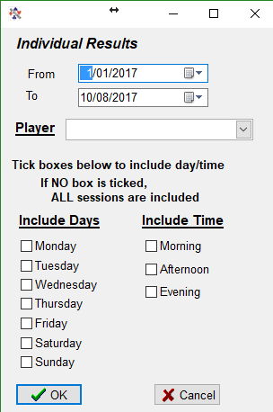
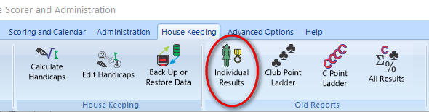
This, along with other items on this ribbon bar, uses reports.
The user is able to select a date range, individual player and choose all sessions or specific sessions.
The resulting report shows:
Date – Eventname – Partner – Session % - C points and Club points.
At the bottom of the report is the player’s average percentage, total C-points and total Club Points.

Figure 20 Example Individual Results
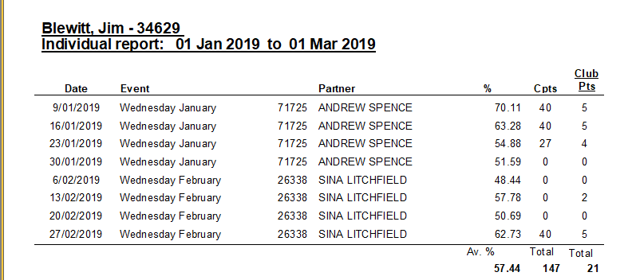

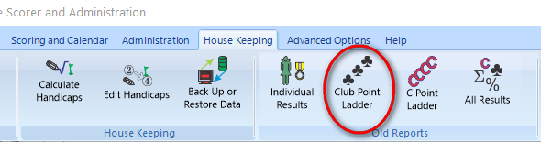
Club Points Ladder / C Points Ladder
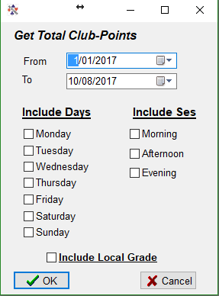
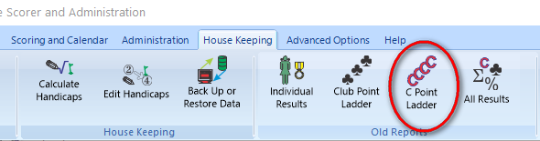
These use reports accessing data direct from the database. Each report is run for the selected date range and may optionally be for selected sessions or combinations of sessions.
NOTE: The C-point allocation may not be exact on the new NZB Masterpoints scheme.

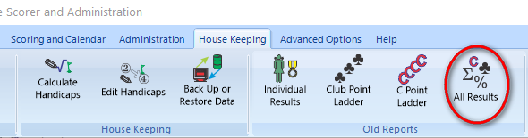
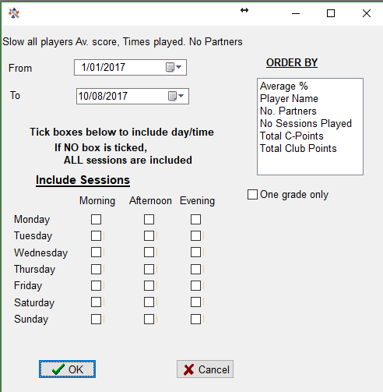
All Results
This report allows the user to select:
- Date range
- Session (or combination of sessions)
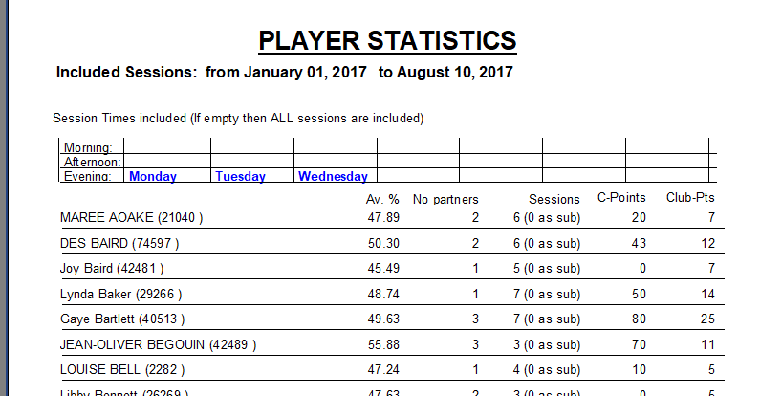
- Sort order of the report.
Figure 21 Example of Player Statistics

Advanced Options

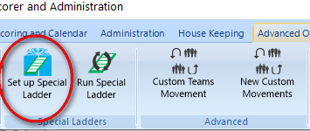
Set up Special Ladder

Special Ladder
The Special ladder setup is available from the ribbon bar advanced tab.

Special ladders are able to be set up for almost any pairs/individual event. Examples of occasions for using Special Ladders. Particularly:
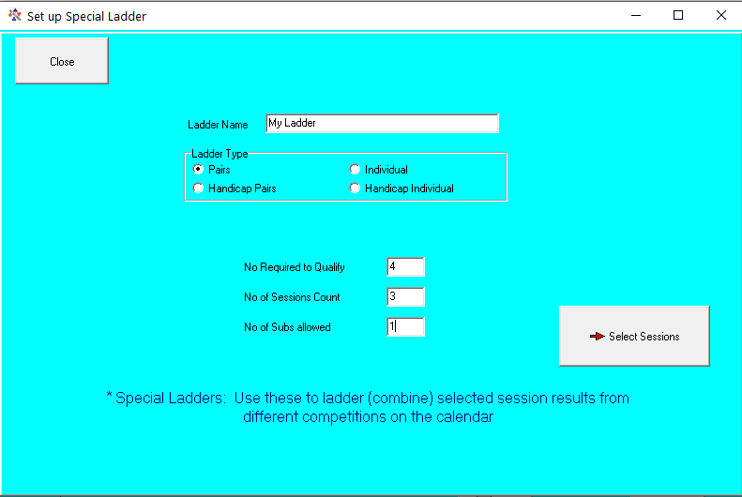
- When there are two events which overlap (say first session of each month counts toward an Individual Ladder).
- Someone has set up each session of the event under a different EventID.
i.e. the user has used “Add Event” to put in another session for an existing event!
Give the Special Ladder a name, set the type of Ladder (keeping in mind how all the sessions have been set up).
“Select Sessions”opens the session selection window. If all sessions for the event are from one night and/or one time of day you can restrict the displayed sessions using the filters at the bottom right.
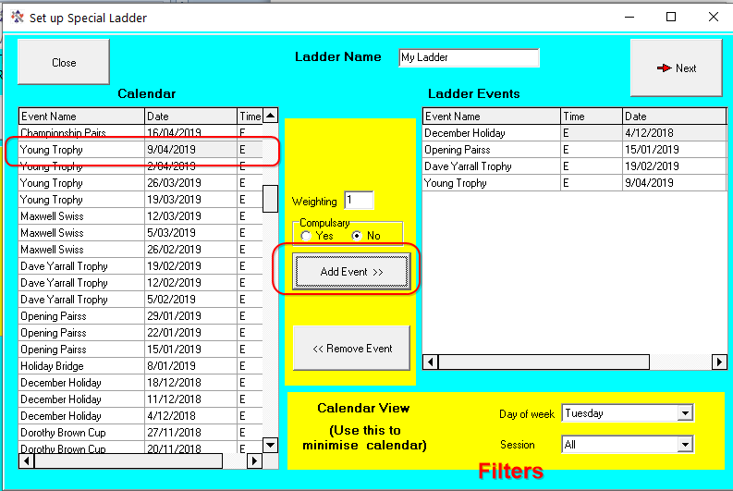
Select the sessions required for the ladder, weighting for the section, and define if the session is compulsory, then click the “Add Event” button (should read Add Session).
To remove a session, ensure it is highlighted on the right pane, and click “Remove Event”.
When all sessions are entered click on NEXT.
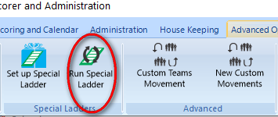
This takes the user to the Run Special Ladder screen.

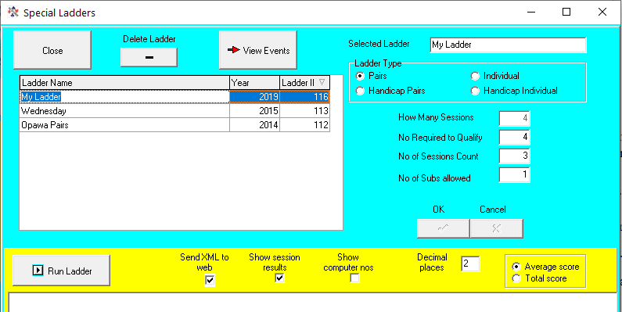
Run Special Ladder
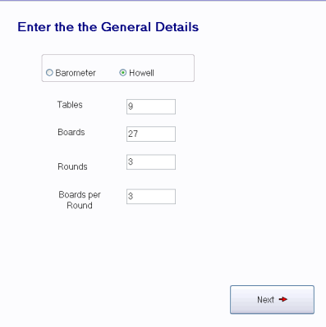
This screen shows all the Special Ladders set up in the club’s system and allows the user to run or modify a ladder. Note that the “How Many Sessions” is automatically populated from the sessions selected. This can only be changed by going to View Events and adding or removing sessions.
The Number to qualify, No Sessions to count and No Subs Allowed may be altered here.
For an INDIVIDUAL ladder only, if No Subs Allowed is NOT 0 then it will allow players to have the same partner.
The “Send XML to web allows the ladder to be sent to the BridgeNZ web results site.
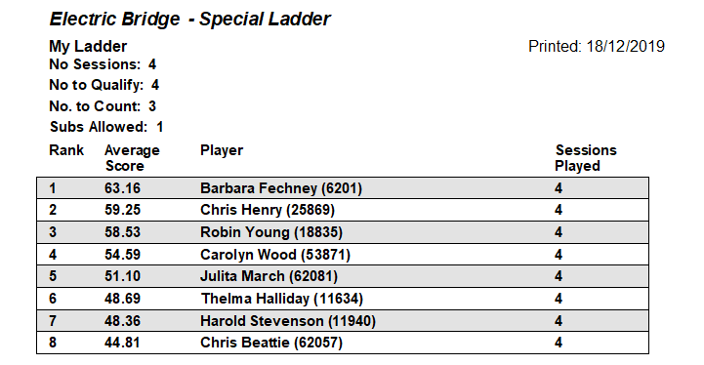
[For the example below the ladder was changed to Individual]

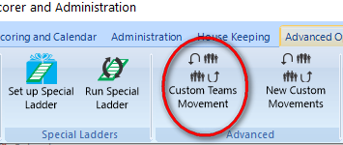
Custom Teams Movement
A Custom Teams Movement allows for the set up of teams events to fit specific requirements – this is not for swiss, but for set draws. It is particularly suitable for constructing movements for tournaments, especially if the movements are for 5, 7 or 9 teams and involve a three-way match, or are multiple round-robin draws requiring re-seeding between round robin matches.
The resulting movement may be loaded in from the teams Draw screen.
If using a three-way match, there must be an even number of rounds.
The numbers in the custom draw represent the team SEEDING numbers, not the team number and the teams may be re-seeded before a second cycle of the draw..
By default, when team names are entered, the seeding value is the team number. In most contexts this is of no consequence, but for RR teams it may be relevant to ensure that the top seeds and bottom seeds play against each other in the final round. (i.e. 1 v 2 and 11 v 12).
Training on creating custom team movements is available by arrangement (standard rates apply).
No further explanation at this point as they may change in the near future to be stored in the database.

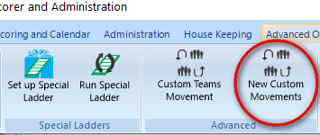
New Custom Movements
The New Custom movements remove the previous restriction where each boardset could not be played at the same table with different pairs. This means that a valid 3-table Howell was not possible with electronic scoring!
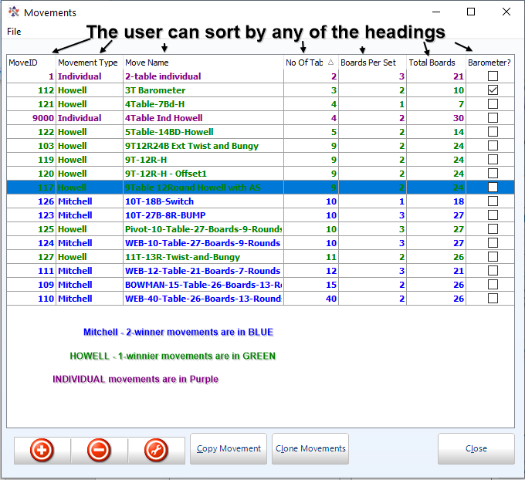
With the New custom movements it is not only possible to have a 3-table Howell but to have movements where all pairs move and the boards remain stationary. Not that we would do that.

The Movements screen has the same add/delete/modify buttons as on the calendar. The list of movements is stored in the database and the filters are able to be applied to show only movements of specific type/for specific numbers of tables/for specific numbers of boards/for specific numbers of rounds.
The “Copy Movement” allows the user to duplicate an existing movement (say 3-table Howell with 20 boards) and modify the copy to have a 3 table Howell with 25 boards merely by changing the number of boards per set.
Clone Movement is still available to allow users to clone Mitchell movements to produce Switch-Mitchell movements for one-winner sessions.

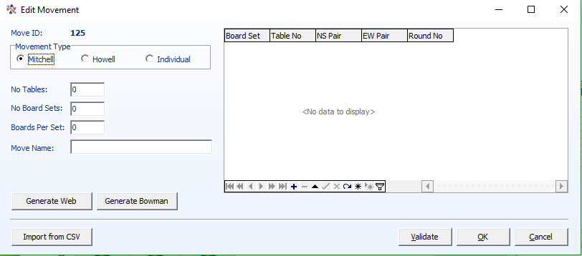
Add Movement
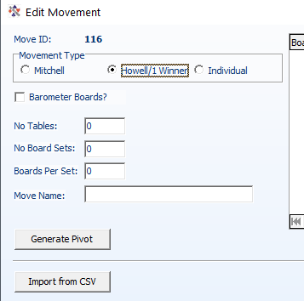
When the Add button is pressed the following window appears:

If the Movement type is set to Mitchell:
For EVEN TABLE web movements, and Bowman-Ewing movements the user may enter the number of tables, number of board sets (number of rounds to play) and number of boards per set, then click on “Generate Web” or “Generate Bowman” and the movement will be generated with the name automatically in the form:

BOWMAN-14-Table-24-Boards-12-Rounds

This makes the movements easy to identify, and very easy to generate.
Similarly, if the Movement Type is set to Howell, then single Pivot movements can be generated.

For Howell movements and other custom movements, it is better to generate these using a spreadsheet then saving the csv files.
There are many files available already from BridgeNZ at https://bridgenz.co.nz/movement-csv-files

CSV Format
The header in the csv should be:
TableNo, NSPair, EWPair, RoundNo, BoardSet
Other fields may be in the file, but these fields are required.
For individual movements the header fields South and West must be included also.

To add a Howell movement:
- Select the Howell radio button
- Enter a name (MEANINGFUL name)
- Click “Import from csv”
- Choose the file to import
- Set the number of boards per set
- Validate (validation is also automatically done on “OK”)
Because the movements are based on boardsets rather than boards it is important to enter the number of boards per set. This makes it a very simple task to convert a 22 board Howell into a 33 board Howell by just changing from 2 boards per set to 3 boards per set and saving with a different name.

The Validate button checks that no pair will play the same boardset more than once.

Although it is completely acceptable to enter a movement on the Edit Movements screen, it is by far preferable and less error prone to enter the movement in a spreadsheet then import it.

Edit Movement (Spanner tool)
Edit movement allows the user to change the content of a movement. This will also allow the user to save the changes either under the same name or a different name. It is strongly advised to validate the movement before saving, though the validation is automatic on clicking OK.

Delete movement
From time to time a user will find that they have entered an irrelevant movement or a duplicated movement. These may be deleted with the delete button.

NOTE: Movement overview and guide cards are automatically available for new custom movements when added to a session
NOTE 2: Under Reports Director there is a “Custom Move Overview report which allows for the printing of an overview of any movement and guide cards related to the movement.

NOTE: When RealBridge sessions have been imported, movement 49 shows. This is generated automatically by the RealBridge import and will reflect the latest session imported.

HELP

Local Help
There is a document in pdf format in the Scorer Root\Help folder named “LocalHelp.pdf”. This document is displayed when the Local Help button in the ribbon bar is pressed.
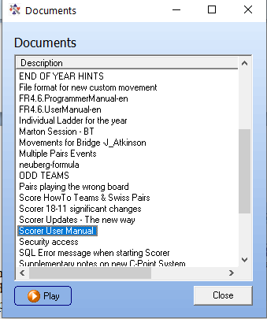
There is also a file called LocalHelp.docx which is a MS Word document allowing the user to put all local information in this document and then save as a pdf (or print to pdf) for the information to be available for local users.

Documents
This brings up a screen listing the pdf and avi files in the Scorer Root\Documents folder. These may be opened from this screen using the “Play” button.

Remote Support
This starts Team Viewer if the club computer does not have the Team Viewer Host installed.
This allows for one-off support by BridgeNZ.
TeamViewer allows BridgeNZ to:
- Connect remotely to the user’s computer and work on it directly OR
- Run demonstration web sessions which users can connect to on the internet for demonstration or training purposes.
- Transfer files to and from the user’s computer for update or analysis.

Team Viewer may be run in two modes:
- as a “stand alone” session from the user’s computer from Scorer by accessing Help/Remote Support in the menu (this starts “C:\NZB Scorer\BridgeNZSupport.exe”)
- a Team Viewer host may be set up on the user’s computer. This host programme starts whenever the computer starts and allows secure access to the computer. This access is only used on request.
Process for “Stand Alone” support
If the computer is connected to the internet :
- Arrange a time with BridgeNZ
- Start Scorer
- Start Team Viewer using Help / Remote Support
- Call BridgeNZ and give the ID for your connection.
BridgeNZ can now see and work on your computer to fix problems and explain what is happening.
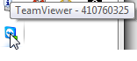
Process for Team Viewer Host (preferred)
If the Team Viewer Host is running, the user can see the icon at the bottom right of the computer screen (This may be under the “Hidden Icons”). If the mouse is held over this icon then the ID appears.

A computer will retain the same ID, so BridgeNZ can connect on request once an initial connection is set up. This means that the user can receive help without the need to start any extra programmes.

SUPPORT SERVICES:
Support services are chargeable at the discretion of BridgeNZ.
If requests are made for support which relates to computer setup or applications outside Scorer, then work can be done at competative rates. If the work required does not relate to Scorer, then please ask for a quote.
For installation of Scorer there is a minimal charge, and it is required that you have a Broadband internet connection and 2Gb or more of memory on the computer on which Scorer is being installed.
BridgeNZ owns and regularly updates a commercial licence for TeamViewer to ensure the best support for our clients.

About
Shows the splash screen with the Scorer version number

Reports
The reporting tool allows the user to create, modify and delete reports using information in the SQL Server database. This includes player information, club information and scoring information. The FastReports tool allows the user to present this information in a formal manner, and has options to save in many formats.
The Reports window opens as a different application. This means different reports can be run whilst continuing to work in Scorer or even run the reports as a separate programme without starting Scorer.
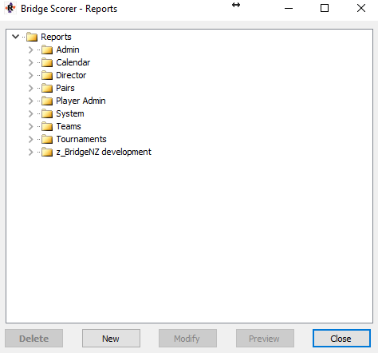
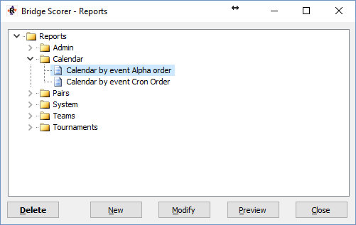
It also means that the report does not need to be closed before continuing in most cases.
Reports are stored in the “Reports” folder under NZB Scorer. They are divided into sub-folders for ease of access. The sub-folders are totally user-configurable, however the only sub-folder which is REQUIRED and must never be deleted or changed is the System folder.
Note: Scorer updates will restore the default set of folders. If the user renames or adds folders these renamed or added folders will not be updated or replaced.
The Reports window opens with all the folders collapsed. To expand the folders double-click on the folder or click on the triangle to the left of the folder.
Reports are able to be created or modified by a competent user. Training is available on request (standard charges) and full manuals for the report writer (Fast Reports) are in the Documents folder. If members write a report which they believe will be useful to other clubs they may submit this to Bridge NZ to be included in the next update, or send the .fr3 report file directly to another user.
Within Scorer, reports are available from the Reports menu item, or from the Reports button now on a number of screens. Clicking this opens the Reports Window with a list of all the available reports.
After expanding the list required, click on a report to highlight it.
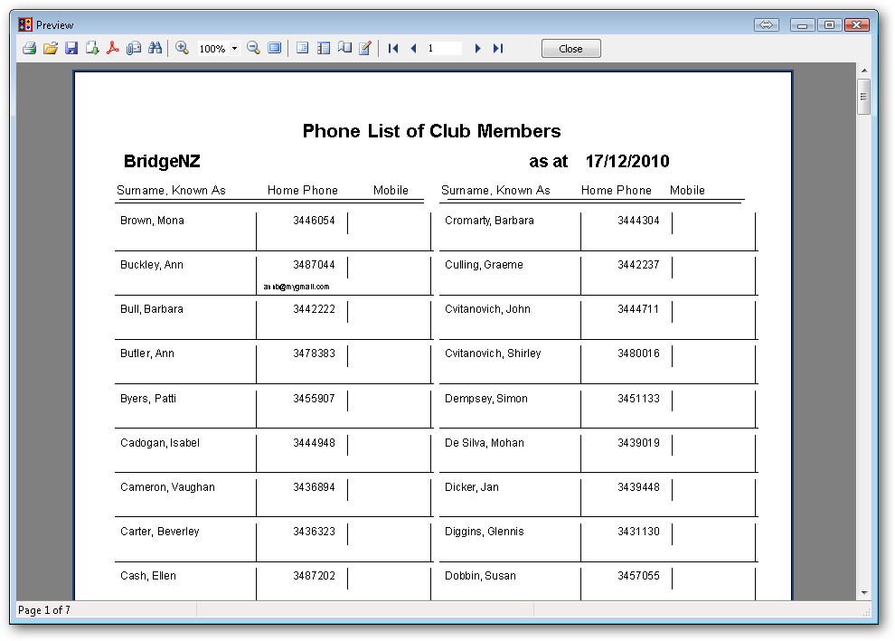
To preview and/or print the report, either highlight the report name and click “Preview” or double-click on the report name.
The report is then run and presented in a preview window where it can be printed or exported to a large selection of formats.
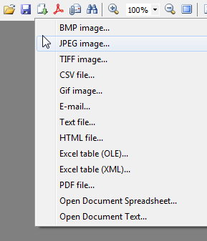
Note that many reports have dialogues which require the user to choose from available options to continue with the report.
The Print button brings up the printer dialog box allowing the user to print any specific page, multiple pages or multiple copies of the document.
Export
Options

When reports are previewed, there is an option to export as html. If the user sets Google Chrome as their default browser, and ticks the “Open file after saving” box then the user may show the report directly on another screen or use Chromecast to cast the report to another screen.

When finished with the preview – click the “Close” button.

Other options available on the Reports screen:
New will allow users to create custom reports.

Modify will start the report designer. Users should NOT modify existing reports unless they have a backup of all the report files AND they have the technical skills to use the report writing tools.

Delete will rename the report so it will not appear in the list. If the user accidentally deletes a report then please contact BridgeNZ to recover.
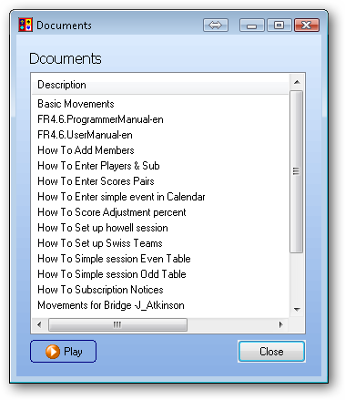
Documentation: Complete documentation of the Fast Reports product is included in the Help documentation (FR4.6). BridgeNZ will quote for custom report writing and/or training in report writing.

Scoring and Calendar

The CALENDAR
The Calendar is the central point or backbone of Scorer and it is essential that events are set up correctly to avoid problems later. To add an event to the calendar or modify an existing event, the calendar must be accessed in Edit mode. The calendar sort and filter options are active in all modes.

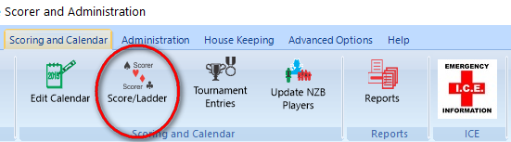
SCORE/LADDER
This gives a read-only view of the calendar enabling the user to search for events. The default is “This day” (lower left pane) but this can be changed with the radio button to show all days.
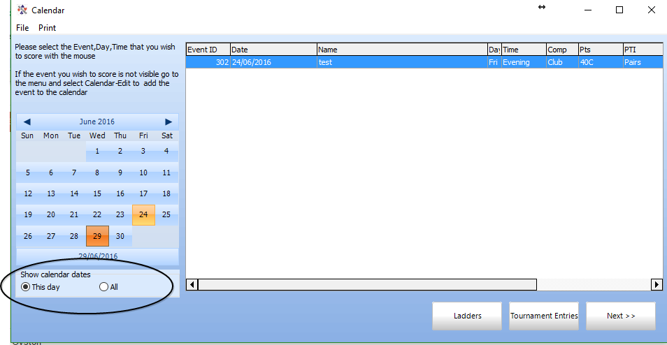
The Calendar allows the user to move by month and select specific days to choose the event that you require.
This is the default screen to start scoring as it opens at the current day only and allows the user to select the day’s session without any extraneous information on screen.
The Ladders and Tournament Entries are available via the buttons at the bottom of the screen. These are discussed later.

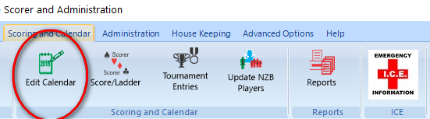
Edit Calendar
In Edit mode, entries for future dates are white, past dates are tinted. [This may not be obvious on some screens].
The calendar Edit screen, by default, shows:
Event ID | Date | Name of the Event | Day of the Week | SessionTime (Morning, Afternoon or Evening) |
Competition Type | Masterpoint Value | Event Type (Pairs, Teams or Individual) | Scoring Method |
Ladder Type | NZBID (Currently used to post results to multiple sites)
Other fields can be added to the screen (for the current session) by right-clicking in the header line and selecting “Field Chooser”. This allows the user to add such fields as calendarID to the visible list.
Calendar entries with the same Event ID belong to the same event, but if two entries have different EventID’s they will be for different events even if the event name is the same. Events with the same EventID will automatically have a ladder associated with them. From version 17 there is no longer a problem with ladders if the event sessions have different names (e.g. Champ Pairs 1, Champ Pairs 2 etc…). Although this is not a problem, it is strongly advised that each session of an event have the same name, and the name of individual sessions still cannot be changed once one session of the event has been scored.
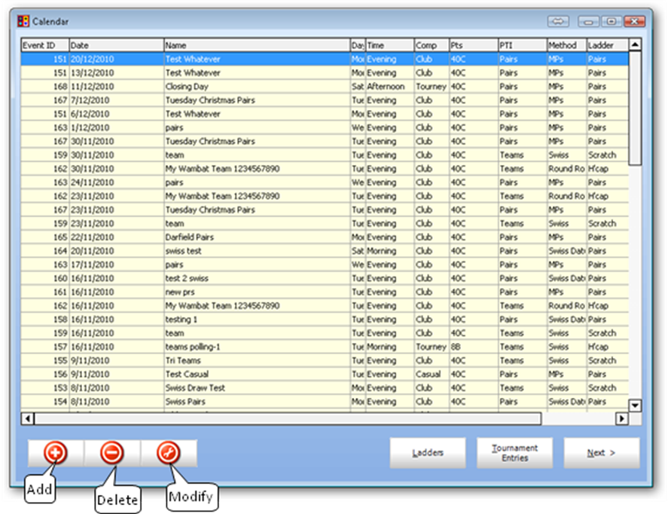
To enter non-sequential sessions for an event, set up the first session as a new entry in the calendar. Then use the Add Session option to add the remaining sessions. This ensures that all sessions relating to the event have the same Event ID in the calendar.
Figure 22 Calendar in Edit mode
The entries for one event MUST have the same Event ID, and it is strongly recommended that they have the same name, though this is no longer a requirement.
Events entered incorrectly in the calendar may be modified. If an event is changed (eg from Pairs to Handicap Pairs) you can make the change apply to all sessions in the event by ticking the box “Apply to all Sessions” before pressing OK.
NOTE: there are some fields where “Apply to all sessions” does not have an effect – please ensure that the event is checked in case the change needs to be applied to each session separately.
When adding an event, there is an option of “Swiss Matchpoints” in the Scoring Method. This is available from Version 15, but please be sure this is what is required rather than the Swiss Datum.

The red buttons at the bottom left of the screen allows the user to add events, delete sessions or whole events and modify sessions or whole events.
ADD EVENT (Ctrl-A)
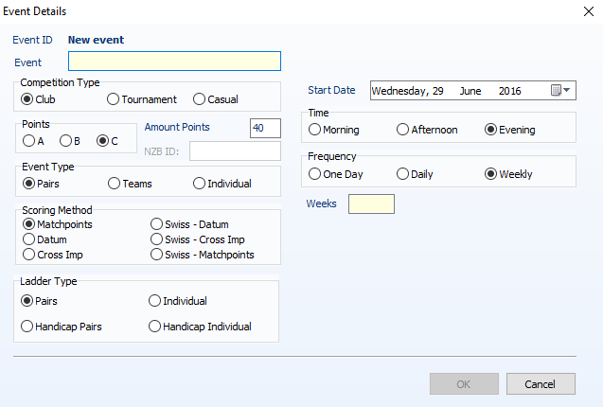
EVENT: The event should be given a meaningful name but may not have special characters such as “, ', ?, * etc. as these are not valid in event names.
This name is used to create a directory in the file system under the Scoring directory.
Although highly recommended, it is not a requirement that all sessions in one event have the same event name. The ladder selects required sessions using the “EventID”.
COMPETITION TYPE: Normally Club or Tournament. Casual events can be run but no C points allocated or sent and may be of a format that precludes the allocation of C points (e.g. playing all slam hands pre-set/lessons). Click the radio-button of the appropriate type, and set “Amount Points” accordingly.
POINTS: This is for NZB Masterpoints. If A or B is selected, the Competition Type automatically moves to Tournament, and the NZB ID field is activated.
AMOUNT POINTS: Although it is available to set the Points to different numbers, for Club sessions (including Teams and Swiss Pairs, if the Points are not set to 40 then the NZB system will NOT allocate C-Points
If Points is set to A or B, then enter the appropriate value for the Tournament (e.g. 5 for 5A tournament)
NZB ID It was intended to be used with NZ Bridge, but no progress was made. If any number is put into the NZB ID box then: If the club used BridgeNZ results and the region have requested, then results will be published to both the club and the region link. This will also act as a flag shortly for reporting results of tournaments.
With the new tournament registration system it is now advised to enter the NZB Tournament ID in this field.
EVENT TYPE: This is Teams, Pairs or Individual (Note that this Individual is where each player plays with a different partner each round of one session).
SCORING METHOD: For Pairs, scoring may be done using Matchpoint basis (most common), by comparison with the average score (Datum) and allocating IMP's [Butler scoring] or by comparison with every other table and allocating IMPs (Cross Imp). If the scoring is Swiss Datum, Swiss Matchpoint or Swiss Cross Imp, then the format is such that each pair's position for a round will be based on their ranking in the field at the end of the previous round.
NOTE: Although Swiss events can do automatic draws, the option is also available for the user to do manual draws and enter these to produce, for example, a round-robin event for 16 pairs over 3 nights.
For Teams: Swiss, Round-Robin or Multiple Teams may be selected.
LADDER TYPE: This is important for clubs. Please ensure Handicap Pairs is selected to have both raw scores and handicap scores calculated and printed for each session. Handicap scores will NOT be available if Pairs is chosen. The Individual ladder type is when players play with a different partner each session, and the winner is the individual player with the highest combined score. Once again, if handicaps are to be used then ensure Handicap Individual is chosen. Scorer now a flag to allow more than one session with the same partner for individual ladders. This is located in the ladder screen and is used at the club’s discretion.
START DATE: This can be selected from a calendar available using the arrow at the end of the field.
TIME: Is the session time, Morning, Afternoon or Evening. (In the calendar these show as “M”, “A”, or “E”)
FREQUENCY: This makes it easy to put in events that run for several weeks on one week-day (e.g. 3 Thursdays in a row). Just set the start date, set Frequency to “Weekly” then put the number of sessions in the box at the bottom left of the screen.
Once this screen is filled out, click on the ENTER button and the event sessions will be added to the Calendar database. Note that one line in the calendar is created for each session of the event. These all have the same EVENTID and EVENT NAME, but different dates or times (M, A or E).
[If a 3 session event is to be set up that skips a week, then an easy way to add this is to add 4 sessions then delete one (see later for deleting a session).] Alternatively, add the three sessions and change the date of the the session from the date which is not required to the appropriate date.

ADDING SESSIONS to an EXISTING EVENT
If an event runs on specific dates during the year, and is not easily added using the sessions in consecutive weeks, then create the first session in the calendar with FREQUENCY weekly and 1 for week. Then add the other sessions to this event using the ADD SESSIONS function.
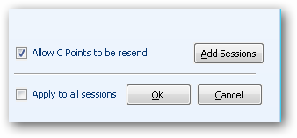
Click on the event in the calendar (make sure you have used the Calendar/Edit),
and click the Modify tool

Click the Add Sessions button
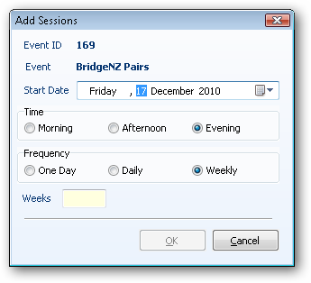
Sessions may now be added using the start date as the date for the next session and the number of sessions to add. If you are adding several sessions then this can be done without closing the “Add Sessions” window, just by changing the date and clicking OK when the other information is correct.
MODIFYING AN EVENT
The modify tool will allow you to change most properties for an event. e.g.an event may be changed from non-handicap to handicap. Also the event name can be changed (but only before the first session is set up).
It is recommended that all sessions in one event have the same name, though this is no longer a requirement
The time of the event, or of specific sessions may be changed. There is an option to allow C-points to be re-sent.

DELETING A SESSION or AN EVENT
From version 16 there is an undelete option in the Calendar menu – but PLEASE try not to have to use it.
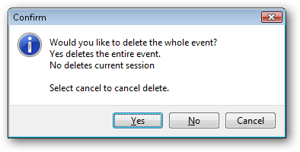
The delete tool is used to delete sessions from the calendar.
Highlight the session of the event to be deleted, then click the delete button.
You will then be presented with a window with three options:
YES = DELETE ENTIRE EVENT
NO = DELETE SESSION ONLY
CANCEL = Don't delete anything

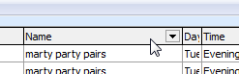
CHANGING THE APPEARANCE OF THE CALENDAR
Calendar columns are moveable –columns may be dragged into different positions for clarity of information.
The columns are sortable. Click on a column heading and the calendar will sort by the field.
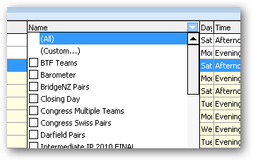
The columns are filterable. Holding the mouse over the column heading causes an arrow to appear at the right of the heading.
Click on this arrow and the filter option appears. Using this, the data may be filtered, for example, to display only selected events.
Double-clicking on a line in the calendar does NOT take the user to the sections screen of the event. If in Edit mode, double-clicking on a line in the calendar will bring up the event details window for the session of the event that was clicked.

Print Outs
This contains a “Reports” button that opens the reports window in the “reports\Calendar” directory.
There are two reports currently – one to list events in alphabetical order, and the other to list in chronological order. The reports are able to filter by session (e.g. Tuesday Afternoon) or ease of validation.

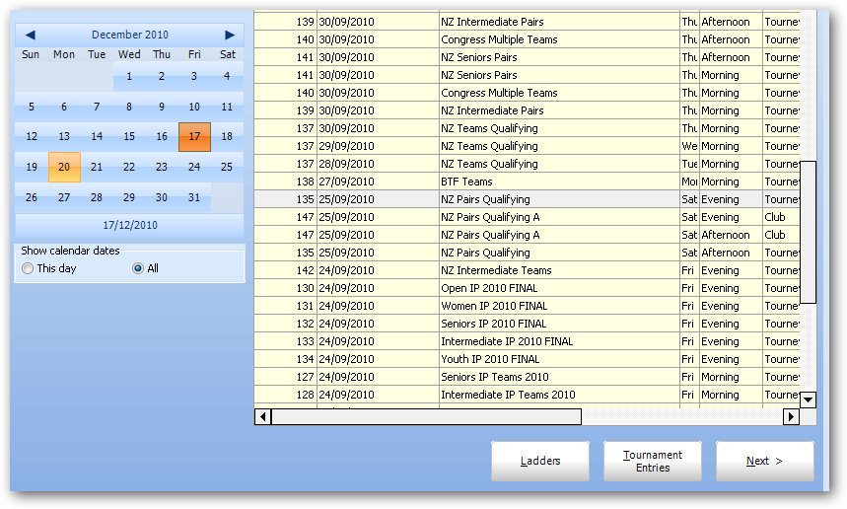
Ladders
When Pairs or Individual events are run, Scorer combines scores to form a Ladder in order to get a winner for the event providing the sessions are entered with the same eventid.
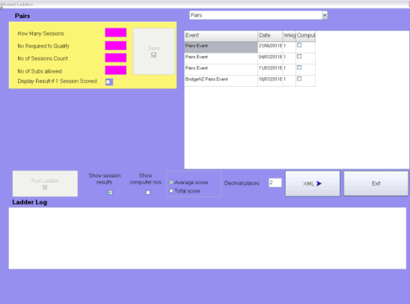
By default, Scorer can run a Ladder for all sessions of one event. The restriction of being in one calendar year is no longer in force..
NOTE: it is important that all sessions of the event have the same EventID – see “Adding sessions to an existing Event” above.
To run the standard Ladder for an event, go to any Calendar screen by using one of the following processes:
- From the Ribbon Bar choose Score/Ladder OR Edit Calendar
- From the Sections screen in a Pairs event: Click the BACK button on screen.
Ensure that a session from the desired event is highlighted in the Calendar Event pane, and click on the Ladders button.
The Ladders screen will now be displayed.
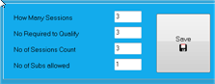
The important facts about the event are:
- How many sessions in the event? (This will automatically be populated with the number of sessions entered in the calendar for that event).
- How many sessions is a player/pair required to play in order to qualify?
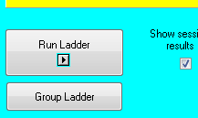
- How many sessions will count? (can they drop bad scores?)
- How many substitutes are allowed? (not relevant in Individual ladders)
- Are they permitted to have the same partner for more than one session for individual ladders? (Not relevant for Pairs ladders)

NOTE the “Group Ladder” button will only display if the event is a tournament.
It is possible to set some sessions as compulsory, so that players are required to play that session to qualify.

If “No Required to Qualify” is set to the total number of sessions for the event, then players must be present or have a valid substitute entered for each session of the event in order to qualify.
If “No of Sessions Count” is less than the total number of sessions, then the highest scores are used, and lowest scores dropped regardless of whether the scores are with valid substitutes or their designated partner.
Once these settings are entered, ‘Save’ stores/updates these values in the database. This process can be done before the event is started or when the ladder is first to be run. These settings will automatically come up for the Ladder on each session of this event.
NOTE 1: If the event is incomplete then the values of the “No Required to Qualify” and “No of Sessions to Count” will be decreased automatically by the number of missing sessions.
NOTE 2: If the ladder is to be run with different parameters, then they MUST be saved first or the original parameters will be recovered when clicking “Run Ladder”
NOTE 3: The ladder averages ALL of a players (pairs) scores until the number of sessions reaches the minimum number to qualify.
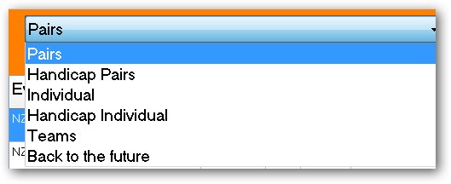
The drop down menu at the top right of the page allows selection of the ladder type to run. If the event has been set up as Handicap Pairs, for example, ladders for both raw scores (Pairs) and Handicap (Handicap Pairs) may be produced. If the Ladder Type was set up as Individual, then “Individual” should be chosen from this menu to run the Ladder.
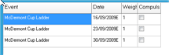
NOTE: The default ladder type is that designated by the ladder type set up in the calendar.
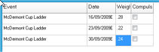
Each session of the event is shown, and can be ticked as compulsory if required. Also there is the opportunity to put weightings on sessions. This is usually done if a different number of boards is played in each session. The easiest method for this is to use the number of boards (divided by 100) as the weighting.
e.g. Here there were 28 boards played in the first session, 22 in the second, and 24 in the third. The weightings used were 0.28, 0.22 and 0.24 respectively. [NOTE: weightings of 28, 22, 24 would achieve the same result]
Once these have been set there are options to “Show session results” and use “Average score” or “Total score” to present the result.
Results are rounded to 2 decimal places by default, but more may be shown by altering the “Decimal places”.
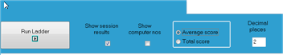
Once these are set, click on “Run Ladder” to run the Ladder.
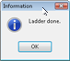

The confirmation window will come up saying the Ladder is done. Click OK.
The screen below shows the results from a Pairs Ladder. To see the players who played but did not qualify, click on the Non Qualifiers radio button.
From here the ladder may be printed or saved. NOTE: the session results are shown here. If session results are not required, untick the “Show session results” tick box on the Ladders screen and run the Ladder again.
If the results should be based on Total Score then set the Total Score radio button instead
Click RETURN to go back to the Ladders screen. 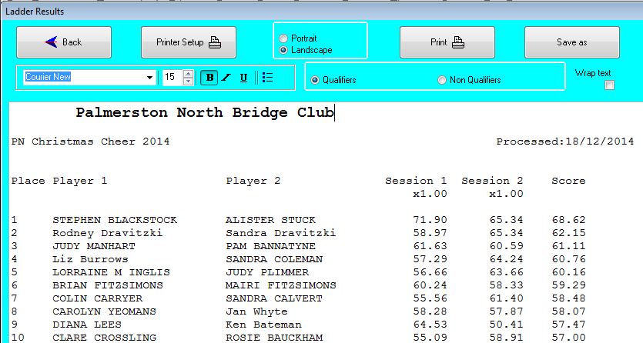

The XML button on the Ladders Screen will send the Ladder information to the web site under a Ladders directory. Standard pairs and individual ladders are available from the web in conjunction with the Pairs results.

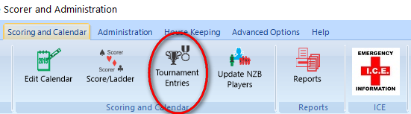
Tournament Entries
The Tournament Entries can be accessed either from the Ribbon Bar OR from the Tournament Entries button at the bottom of the Calendar.
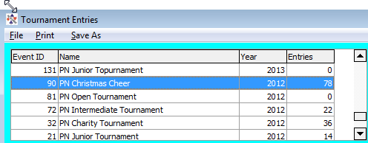
This function allows clubs to pre-enter player names for any Tournament that has been set up in the calendar and provides immediate feedback on the number of active entries at any point. [Current active entries]
The events entered in the calendar as Tournaments show in the top left pane along with the current total of active entries. The current entries (player names) show in the right pane.
If the event is not displayed in the top left pane, it probably has not been set up as a Tournament.
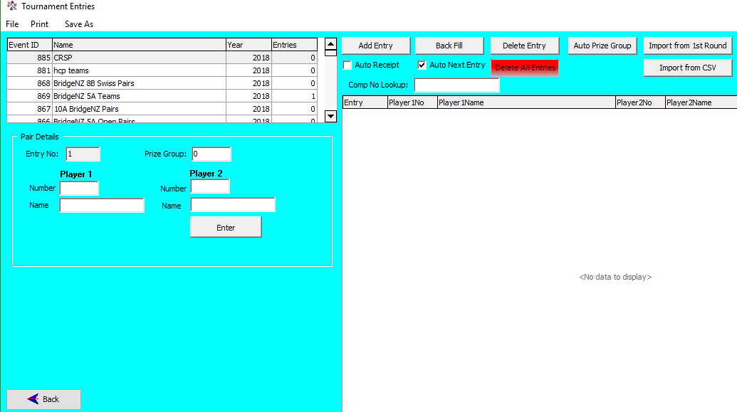
NOTE: The last entry number (Entry) may be larger than the number of entries if an entry has been deleted (withdrawn), but the “Entries” column in the top left pane gives an accurate count of the active entries.

Check Boxes:
- Auto Next Entry: This is used if you are adding a number of entries, and saves clicking the “Add Entry” button each time.
- Auto Receipt – Prints a receipt for the entry. Devised for congress it allocates a seat for the pair/team so the absentees can be checked and determined before the final seating is allocated.

Import from csv
The file format is reasonably flexible, and the csv file from the NZB Tournament entries is able to be imported with little or no change. So long as the appropriate fields are in the file, with correct headers, then extra fields are ignored. Thus the NZB entry file can be used directly without modification and irrelevant fields are ignored.
For NZB csv files, the team name and team captain are not in the entry list, so player1 is used for the Team Name AND the Team Captain.

If the user chooses to create their own csv file, then the following guidelines should be followed:
PAIRS:
[HEADER LINE] Entry, Player1, Player2
[Any other fields are ignored]
Entry=number,
player1 and player2 = computer numbers of players
TEAMS:
TeamName, Captain, Player1, Player2, Player3, Player4, Player5, Player6
TeamName = Free text team name
Captain = Free text name of captain
Player1 – player6 = NZB numbers of players (players 5 and 6 are optional)
Any other fields are ignored

NOTE: With the teams import, if the fields TeamName and/or Captain are missing, then Pleyer1 will be used for the missing field(s)
IMPORTANT: When importing from csv, current entries will be deleted and overwritten.

Add Entry (Ctrl-E)
Add an entry by entering the player numbers in the Pair Details/Team Details box (The usual database lookups are available for player names) then click the “Enter (Team)” button. There is a quick key (Ctrl-E) to add a new entry. This focuses the cursor in the player1 number field for the next available entry. For pairs tournaments, the entry field allows the user to manually add/modify the prize group (see below)

Delete Entry
To delete an entry, select the entry in the right panel and click the “Delete Entry” button at top.
If an entry is deleted, this does not automatically change the entry numbers of other entrants, nor the entry number of the next added entry. Entry numbers keep increasing, but the total of all entries, less those that have been deleted, shows in the top left pane.

Back Fill
Back Fill is used to fill the gaps where entries have been deleted. Entry numbers are maintained except for those at the end who are moved back to fill spaces. A report prints automatically for the moved entry numbers so there is a record of the changes allowing the user to advise contestants if the entry numbers are being used for a purpose.

Delete All Entries
Delete all entries is useful if importing from csv, and the entries have changed. Examples of this are quite obvious, when, in preparation for the tournament, the user wishes to import the entries to make an initial plan, then more entries are added, and maybe some removed. Deleting all entries then allows for the entire process to be started again.

Import from first round
Sometimes the entries are not known until the players turn up, or there are several changes to players due to unforeseen circumstances. Import from First Round will regenerate the tournament entries from the list of players playing the first round of the event.
An event may be set up as a tournament (even if it is just a 40C-point club session) and upload the names from the session, then allocate prize groups. This is useful if running, say, an interclub event where two sets of results are to be reported separately.

Highlight Paid Entries
From V22.2, payments for an event entry can be made through the cashless payments system. Any payment relating to this event for a player number is stored in the system and if the player number appears in the entry list the player in highlighted in green.
Please see the Scorer Cashless Payments documentation for more details.

Prize Groups
Tournament Prize Groups
This feature allows for the players to be grouped for the purposes of prize placing by any of the methods below (NOTE this feature only appears for Pairs events):
1. Group by ranking
2. Group by Rating Points
3. Manually Group

The number of groups can range from 1 to 6
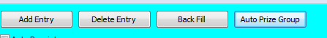
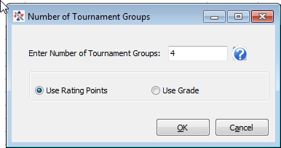
Help Button
On clicking this, the help text is displayed.

Automatic setting of prize groups can be done by:
1. Rating points
The Average rating points for each pair determine their group
Pairs are ranked by rating points, then divided as evenly as possible into groups
Extras are put in the lowest group e.g. with 30 pairs and 4 groups they will divide 7, 7, 7, 9

2. Ranking
Pairs are grouped by Open (O) Intermediate (I) Junior (J) in the following manner:
2 Groups O-any / [I or J]-[I or J]
3 Groups O-any / I-[I or J] / J-J
4 Groups O-O / O-[I or J] / I-[I or J] / J-J
5 Groups O-O / O-I / O-J / I-[I or J] / J-J
6 Groups O-O / O-I / O-J / I-I / I-J / J-J

Do NOT use this option if you have already set your own prize groups - it will overwrite any groups set.

This can be used to make adjustments manually by pair on the Tournament Entry screen.

There is now a button “Group Ladder” in the Ladders screen which will print a report showing the placings of each pair within their group (along with their overall placing).

Reports

There are a number of tournament reports accessible through the Reports menu item, including a ranked list of entries in order of rating points using NZB player information for the purpose of aiding seeding. The reports also include a Pair Group list showing the prize groups with the pairs included.

NOTES ON PATCHES AND UPDATES:

- New version releases have the licence number automatically installed from the web
- Updates are installed in two parts:
  - “SQL Only” updates are installed without the need to restart Scorer
  - “SQL AND Programme” updates will install the SQL part first then download the
programme installer. Scorer is then closed and the user is prompted to do the programme updates. These should be installed as below

Patch Installation
Sample screen of update offered:
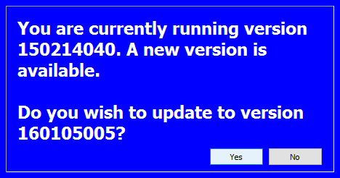
After saying YES to an update requiring file updates, Scorer will download and install any SQL update required (the download window on screen may say “(Not Responding)” but the process will be running in the background). When the files are downloaded (automatically) then Scorer will close and a window will appear on screen.
IMPORTANT: If the download window says “Not Responding” DO NOT kill the process, the download is still happening!
Windows will ask if you want to allow bridgesetup??.exe to run and you should say YES
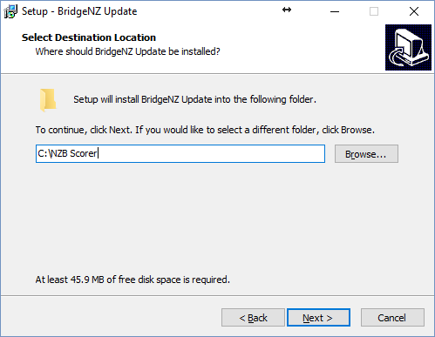
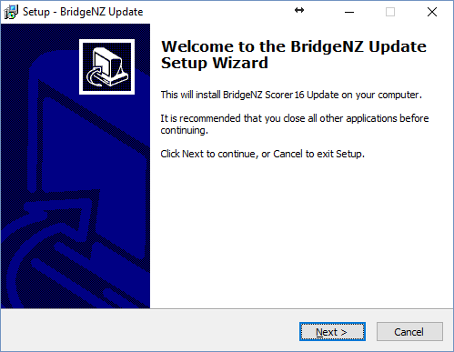

NEXT

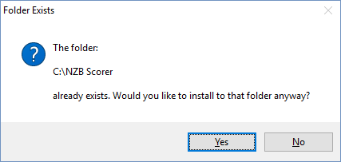
Leave the path for the install as it is unless you have scorer installed in a different location. If you have done updates previously then the path should be remembered from previous updates. You may get a warning that the folder exists – say Yes!
Don’t create a desktop icon. The update now confirms the path to install – if this is correct press “install”

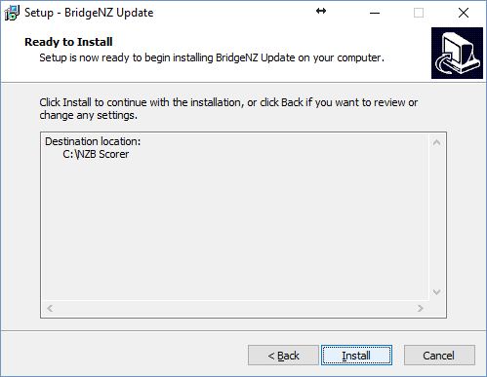
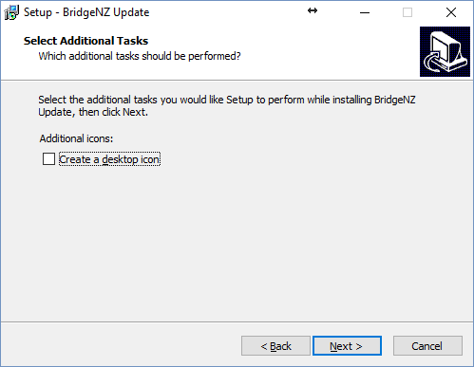

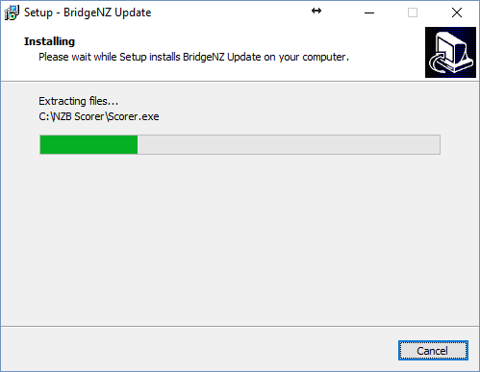
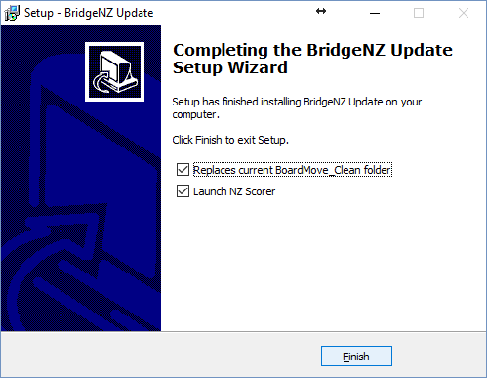
A progress bar will show the install progress which may take a while depending on the network and internet connection speed.

When the install is complete click “Finish”
On most systems this will restart scorer, but if it does not restart Scorer then restart in the usual way.
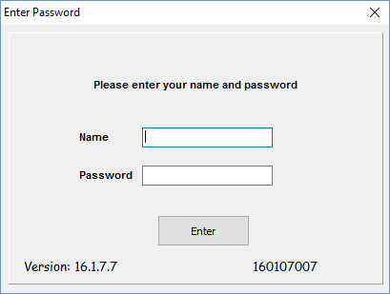
Please check the versions on the login screen – for the first release of Version 16 they should read as below. The left number is the programme version and the right number is the database version.

Pairs Events Scoring

Pairs Section Setup
From the calendar, the user may:
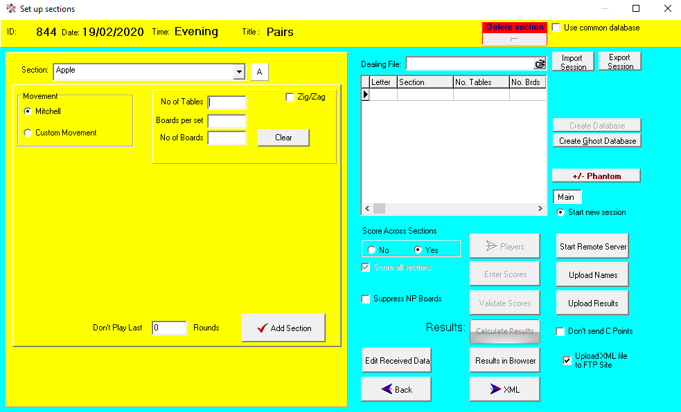
- Double-click on the line of a session OR
- Click on the line of the session then click the NEXT button
This takes the user to the Set Up Section screen for the session.
The “Section Room” and “Section” are technically free text – the user can type into these fields, but the preference is not to do this.
The values assigned in section 4.1.3 (Sections) are displayed in the drop-downs for Room and Section (Fig 9-1).
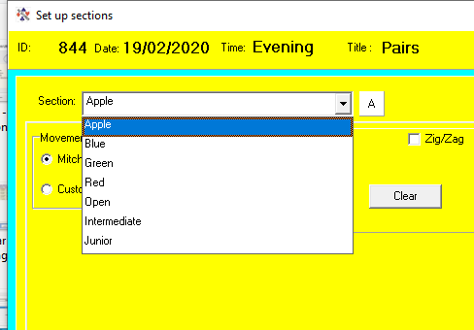
From V19, the Section will automatically be populated with the next available fields from the drop-down when entering the Section Setup screen. These values may be changed by the user, but usually the order will be set so that the user does not need to change them.
Figure 23 DropDown Section
The Section Room is a required field, and is required to start with a letter (which will be converted to upper case if not already). This first letter is used for the “Section” in any electronic scoring to be used. This will then be the same as the “Letter” in the grid to the right, and letter will be the section name for the scoring device. i.e. For BridgePad/BridgeScorer/BridgeTab setting Section Room to “B” will make available Section “B” on the BridgePad/BridgeScorer/BridgeTab.

From V19 the “Section” field may not be left blank. It is preferable to use simple names for the sections, avoiding characters such as / or % or *. Where possible stay with colours or a simple word. [Scorer can handle other names BUT the NZB Master Points system does not like them so players may not get their winnings].
Each section should be a different “Section Room”.
[Smart Idea: If running more than one section use Room B with colour Blue, G with colour Green, R with colour Red, W with colour White .. this will show the sections B, G, R, W on the BridgeTab for the players to choose their section. The colours may be associated tith the table number colours or the table cloth colours.]
From V19, on entering the Setup Section screen, the default Room and Section are completed, the default Mitchell is selected and the cursor is in the field to enter the number of tables.
NOTE: The section name may be changed by double-clicking on the letter. This takes the user to a screen where the name of the section may be changed.

Mitchell Movement, ODD Number of Tables
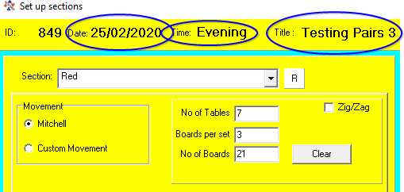
Leave the Mitchell Radio button ticked, put in the number of tables, number of boards per set, and the total number of boards.
Scorer will display a warning if the number of boards is can’t be played with this number of tables and boards per round!
Once a valid movement is inserted, the “Add Section” button appears.
Scorer will bring up a window asking “Is there a Phantom pair?” (Fig 9-2)
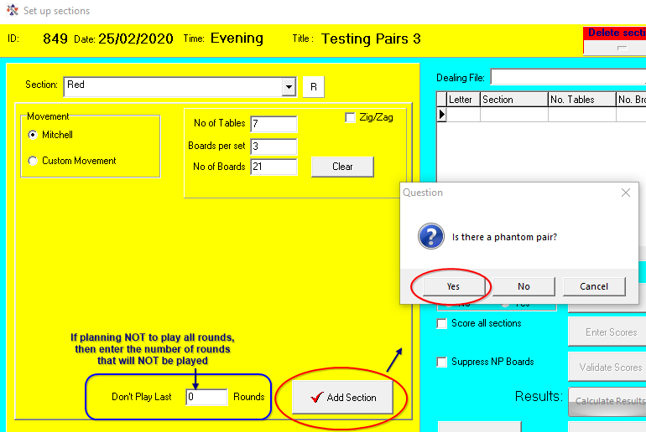
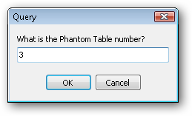
If the user clicks YES, then Scorer will bring up a window asking “What is the Phantom Table Number?”
Figure 24 Pairs add section
Type in the pair number ..
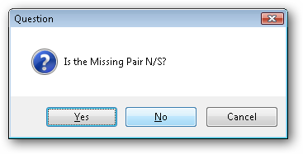
Scorer will bring up a window asking “is the missing pair NS?”
The user should click Yes if there is no pair sitting NS and NO if there is no pair sitting EW.
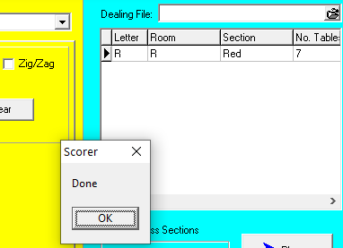
Cancel is available if the user determines they have entered the incorrect table for the phantom or if the situation changes and there is no longer a phantom.
Figure 25 Done when section added
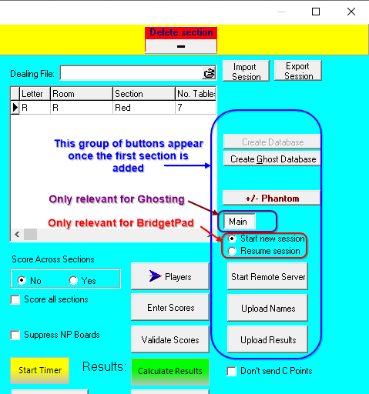
A “Please Wait” screen will appear (if Yes or No has been clicked) while Scorer adds the information to a scoring database, then the message “Done” will appear (Fig 9-3) and the user must click OK to confirm.
Figure 26 Electronic Scoring buttons
Notice that the section is added to the right panel at this point, and the electronic scoring buttons now appear. (Fig 9-4)
If the section is incorrect (such as an extra pair arrive, or you find you have 2 phantoms so lose a table) the user can remove the section by clicking on the line in the right pane and then clicking on the “Delete Section” button above the right panel.
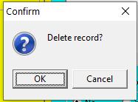
When the section is deleted, a message asks “Delete Record?”
The user will usually choose “OK”, but may choose to cancel to avoid deleting the section.
More sections can be added, and scoring across sections is permitted. For this to be valid, of course, the same deals would need to be played in each section (NOT NECESSARILY THE SAME NUMBER OF DEALS).
It is not required that you score across sections, and each section may be scored separately.

Mitchell Movement, EVEN Number of Tables
Figure 27 Even Table Mitchell
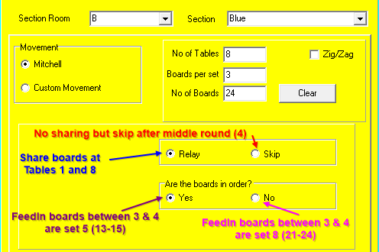
If there are no feed-ins, then a skip move may be used. With the skip move, EW skip one table after half the boards are played.
With a Relay, the top table shares boards with table 1, and there is a resting set of boards between the middle two tables.
NOTE: The Relay only appears when the number of tables = number of BoardSets.
With this movement, the resting boards can be in order (use “Boards in order?” = Yes), or they can be the top set of boards (Use “Boards in order?” = No).
With extra board sets (there must always be an even number of extra board sets).
There must be one set of boards between the middle two tables, and the remainder of the board sets feed in at the top table. The option is available for the resting boards to be the highest numbered boards or the boards in order.
There is a switch move when half the total number of feed-in sets are left to be played.

ZigZag
Many clubs play a competition with another club whereby the two clubs supply equal numbers of pairs.
A Mitchell movement is set up but the “ZigZag” box is ticked – this changes the movement so that the stationary pairs are NS at ODD numbered tables and EW at EVEN numbered tables, with the moving pairs changing direction each round. This means that the balance between scores being compared is maintained between clubs with half the comparisons’ with their own club and half with the opponents’ club.
When ZigZag is used the results will print a total of the percentages scored for each group.

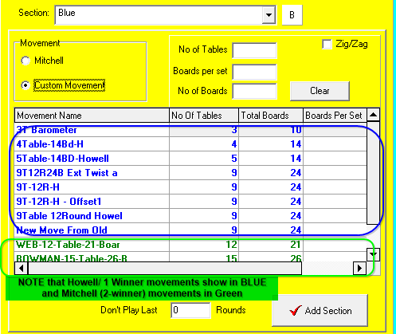
Howell/Barometer Movement
Figure 28 - Custom Movements
This is now combined with the New Custom Movements

New Custom Movements
Scorer V19 the New Custom movements have been built in to the selection panel.

Selecting “Custom Movement” will bring up a list of all custom movements in the user’s system.

The usual sorts and filters are available in the grid in the panel .. but there is an easier way.

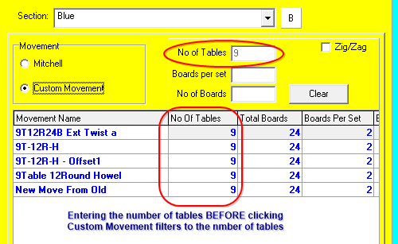
If the user enters a number in any of the fields
Figure 29 Custom Move with Filter
No of Tables
Boards per Set
No of Boards
and subsequently the Custom Move radio button is clicked, the movements available are filtered on those numbers.

This makes it easy for the user to see the available movements for say 9 tables for example (as in fig 9-7)

When the movement is selected and Add Section clicked the fields are fully populated with the values from the movement (Fig 9-8).

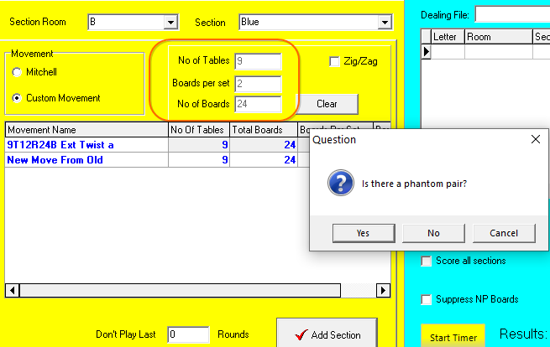
When a Custom Movement is added, and the section selected in the right panel, the “Movement Overview” button is available.
Figure 30 Add custom move section
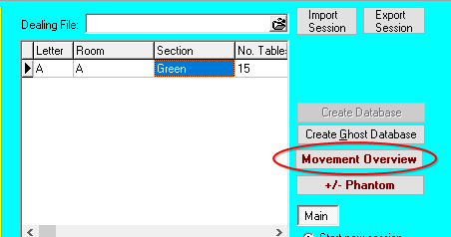
This runs a report giving the Director an overview of the movement and allowing for the printing of guide cards for the tables (Fig 9-9).
Figure 31 Movement Overview button

Adding Sections
Once the section is entered, the user may add more sections (with different Section name/Letter). These should be added BEFORE the “Start Remote Server” button is pressed.
Adding sections gives information to the electronic scoring system at startup. Once ALL sections are added, then the user may click “Start Remote Server” and their electronic scoring system will start with all the information required for the session.
NOTE: If Multiple events are to be run with the one scoring system then please read the appendix on running multiple pairs events.

Start Remote Server
When the Start remote Server button is pressed then the BridgePad server OR BSControl (BridgeTab server) will be started.
Use of the BridgeTab in relation to Scorer is detailed in an appendix below.

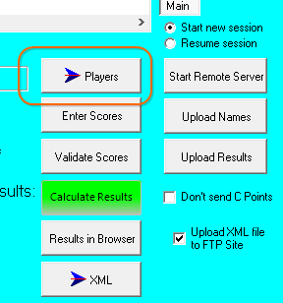
Manually Entering/Modifying Player Names
Once the section(s) have been entered, select a section in the right pane, and click on the “Players” button.
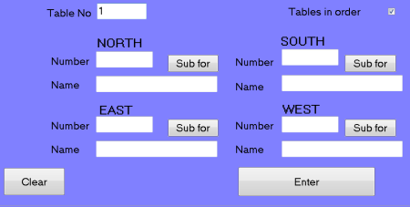
Type in a table number to bring up the grid to enter the players.
Ticking the “Tables in Order” tick-box will ensure that when you complete one table, then the next table in sequence will be ready to enter without typing the table number.

Entering Players:
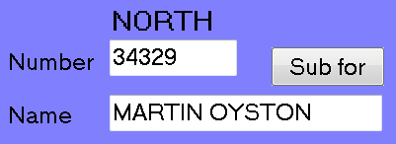
Type in the NZB Number for the player and press the ENTER key on the keyboard.
Do NOT click on the ENTER button on screen!
Do NOT TAB between fields!
If the number is in the Club Members OR in the NZB Player list OR in the Non Members list, the name will appear, and the cursor will move to the next number field.
For PHANTOM type 0 then press the ENTER key on the keyboard. Both members of that pair will be set to PHANTOM.
NOTE: If a player is entered with 0 as their number, then the PAIR will NOT show in the results.
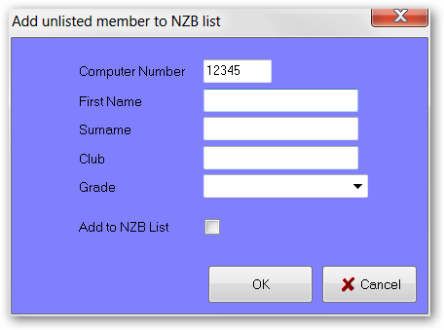
If the number is not found in any of the three lists mentioned, a screen will come up asking for the player information. By default it will be added to the non-members list, but there is an option to add to the NZB list. Adding this must NOT be done unless the user is ABSOLUTELY certain that they have the correct number. Click CANCEL to return to the Name Entry screen, or OK to enter the player in the required list.
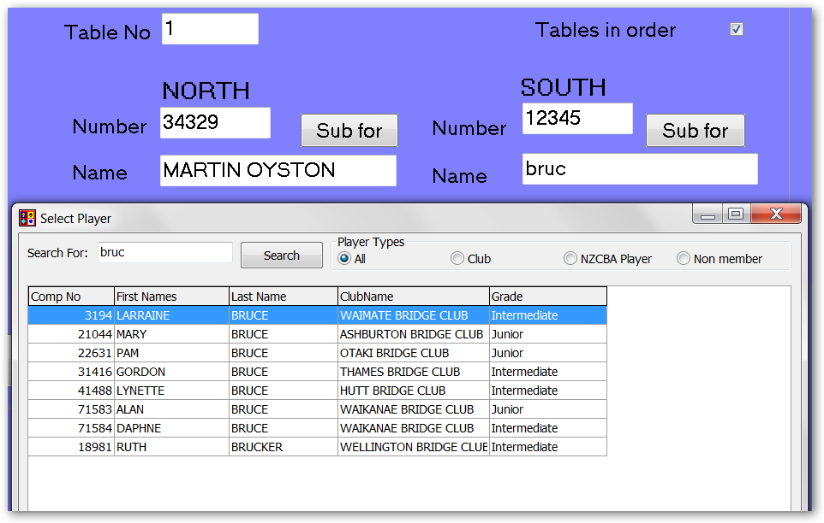
Search for a player number: Tab from the Number field to the Name field.
Type in the first few letters of the player's Surname, then press ENTER on the keyboard
A list of names will appear at the bottom of the left pane, and the appropriate name can be selected by double-clicking on that name.
Note that the sort and filter options are available on all fields in this search window.
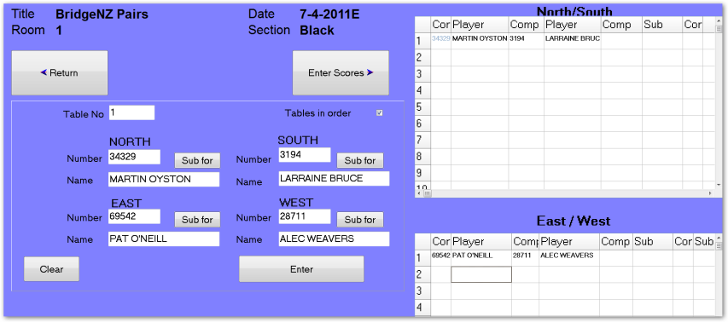
If all this fails, then a number can be typed in, tab to the Name field, type in a name, then tab to the next field. This is VERY bad practice and should only be used on rare occasions.
When all 4 players are entered for a table, the ENTER key on the keyboard may be pressed again OR click on the ENTER button on screen to insert the names of the players into the grid on the right of the screen.
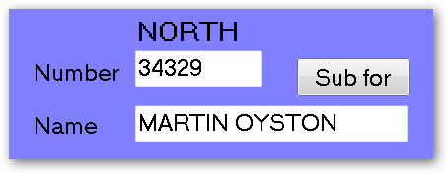
If a player name is to be changed at a particular table, then just type in the table number in the “Table Number” field then click in the “Number” field for the player. After changing the player number (pressing the ENTER key to get the correct player) then click the “Enter” button to ensure the entry is changed in the right pane.

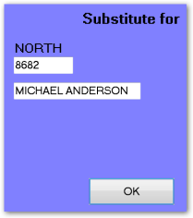
Substitutes can be entered using the “Sub For” button. The players at the table should be entered in the main window. The player for whom they are substituting needs to be entered in the “Sub For” window.
When the sub has been entered, click on OK and the Substitution screen closes returning to the Player Entry screen.
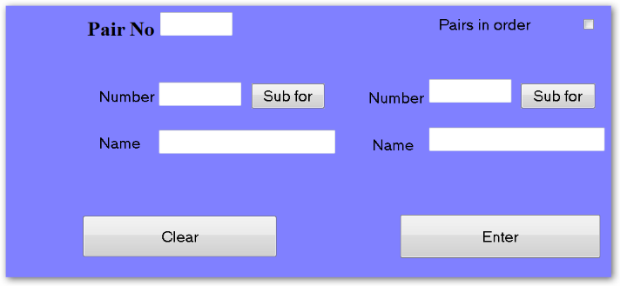
For Howell movements, the HOWELL PAIR number, not the table number is entered.
Ensure that the players are correctly entered against the pair numbers.
When all player names have been entered, click on the RETURN button to return to the Sections screen, or click on the ENTER SCORES button to start entering scores manually.

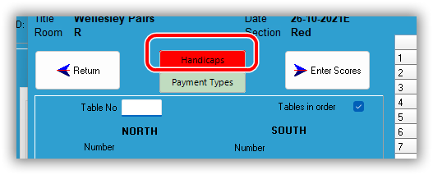
Entering Handicaps
If the session is handicapped, then in the Players screen a Handicap button will appear.
Clicking the button takes the user to the screen to enter missing handicaps.

Scorer does allow a zero (0) handicap and this is distinct from having NO handicap.
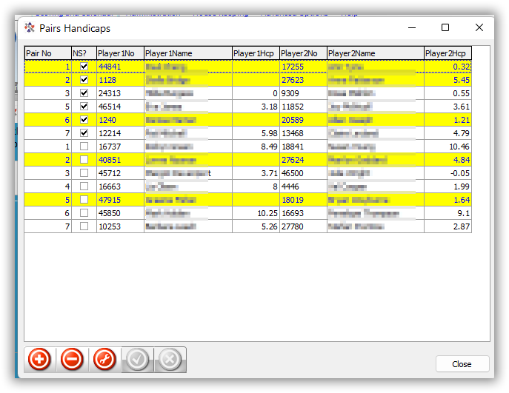
Any pair where one or both players do NOT have a handicap is highlighted in yellow.
Figure 32 Entering Handicap
The player can be assigned a handicap in this screen.
NOTE: Once the handicap is typed in, either select another row OR click the tick control at the bottom of the grid to confirm the addition.
Closing the screen immediately after entering the number will NOT add/change the handicap.

After all players have handicaps, the Handicap button will be Grey.

If handicaps were incorrect and need to be reloaded (after amending all handicaps in the handicap screen);
- Delete all the handicaps on this screen
- Return to the Player Entry Screen
- Select a table number
- Click the Enter button
When the players are entered a routine is run to update all handicaps with no value.

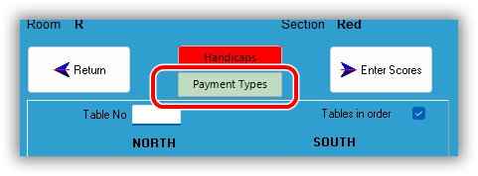
Entering Payment Types
From Scorer V2202, there exists a “Payment Types” button allowing the Director or other appropriate user to confirm the payment type for each player in this section of the session.

Please refer to the Scorer Cashless Payments documentation for full details.

Entering Scores Manually
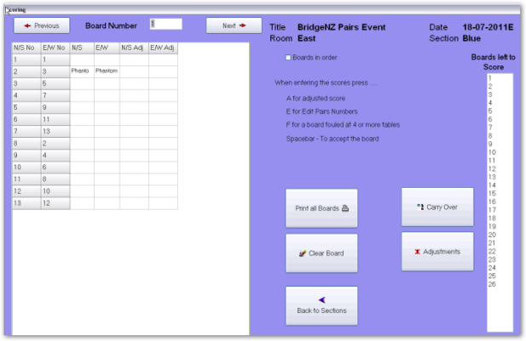
The Enter Scores screen has three parts.
Left - is the scoring grid
Centre - the control/navigation buttons and hints
Right - a list of boards yet to be started for scoring.
When a score sheet is available, type the board number into the “Board Number” box at the top of the screen and press the ENTER key on the keyboard. This will move the cursor to the top line of the score sheet.

When entering scores:
Do NOT type the final 0 in the number
e.g. for 120 type 12 [ENTER]
for 2400 type 240 [ENTER]
for 50 type 5 [ENTER]
Type the number and press Enter. The score is entered and the cursor moves down a line
For an E/W score:
EITHER: Put a “-” in front of the number e.g. -30 [Enter] for 300 E/W
OR: Type in the number then press the “-” key instead of [Enter]
i.e. 30-
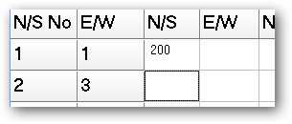
See examples following
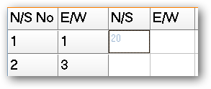
ENTER →

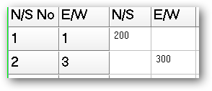
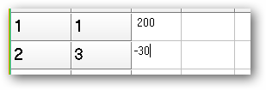
ENTER →
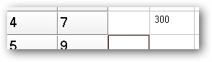
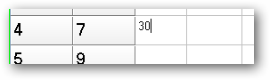
– (minus)

Pressing the ENTER key repeats the score from the line above.
PHANTOM line will be skipped over if you use ENTER.
NOTE: It is possible to over-ride the Phantom and enter a score on that line. This is because it is possible for players to get to the wrong table and play boards that they would not normally play!
A board that is PASSED IN has a score of 0.
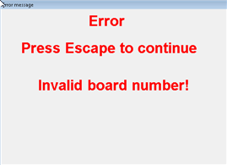
Any board NOT PLAYED should have the field left BLANK. To do this, use the arrow keys to move over the field OR click in the field of the next score to be entered with the mouse.
If an invalid board number is entered, an error message will be displayed.
Press ESC to close the message window and then correct the number.

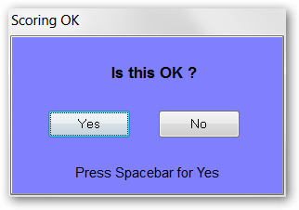
When all scores have been entered for a board, a confirmation box will appear. Depending on how the options are set it may be possible to:
- Click on Yes with the mouse to accept [always available]
- Press the Space Bar to accept [if this is active in the Options setup]
- Press ENTER to accept [if this is active in the Options setup]
When the boards are all entered, click Back to Sections to go back to the Sections screen.

Adjustments
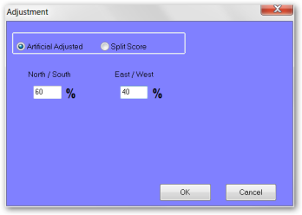
If the Director makes an adjustment to say NS 60% EW 50% on a board, this is done on the screen where the scores are being entered for that board.
To do this instead of entering scores for a board, press A on the keyboard.
The adjustments window appears. Type in the assigned percentages and click OK.
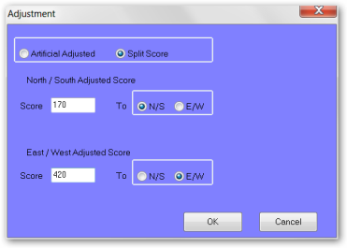
If the Director assigns a split score, type A, click on the “Split Score” radio button.
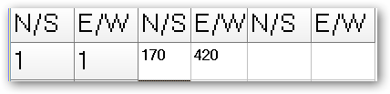
Fill in the scores assigned by the Director.
Click OK.
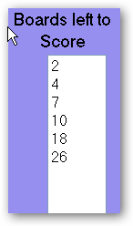
This last example leaves 2 scores on the score sheet.
If there are any numbers in the “Boards left to score” window at the right of the screen, then someone needs to go hunt for travelling score sheets!

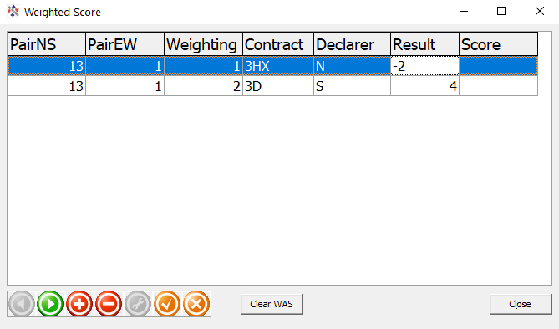
Weighted scores
Figure 33 Weighted Scores
V19 introduces Weighted scores.
The implementation allows for exactly one weighted score for the board at the table – not a split weighted score.
Pressing W in the board screen brings up a grid to enter the possible contracts and results.
Use the + button to a line. The weightings are all relative and may be entered in any form – they will be converted to a percentage when the calculation is done.
The scores for the contracts entered will be calculated when the window is closed.
Fig 9-11 shows an example of a weighted score where the Director assigned 2/3 of the time South is playing 3D making 4, while 1/3 of the time North is playing 3H Doubled 2 light.
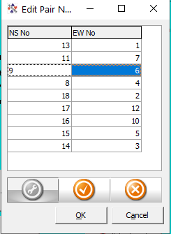
The weighted Match Points will be assigned during the result calculations. The line in the scoring screen will show WAS (for Weighted Adjusted Score).
Figure 34 Change Pairs

Changing Pair Numbers
If the Director has cause to change the pairs playing a board (e.g. a pair played the wrong board or a pair sat in the wrong direction for a board in the Howell) then pressing E in the Enter Scores screen allows the user to change the pair numbers.
Note that the changes must be confirmed with the tick and no changes will be made if any pair appears twice. Cancel will exit without changing the original pair numbers.

Other functions
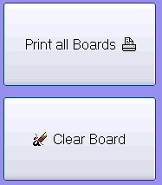
F: Allows for a board to be scored as two separate fields if it has been fouled at more than three tables.
Print All Boards: Will print out the score sheets with the scores on them.
If the results have been run, then this printout will include Match Points.
Clear Board: Removes all the scores from the current board.
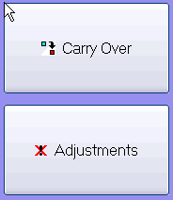
Carry Over: Allows entry of carry over from qualifying rounds to a final
Adjustments: Allows entry of Match-point adjustments unrelated to any specific board.

Generating Results
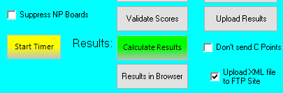
The “Calculate Results” button, by default, uses the Neuberg formula to adjusts match points to a common top in the case that boards are not played the same number of times. It also allows for scoring across sections which are not playing the same number of boards (eg one section 26 boards, one section 27 boards).
AFTER calculating the results, the “Results to Browser” button creates a html file (with a report) and opens this in the default browser. This method allows for customisation of the html if required and is browser independent.
If there is an error in manually entered scores, then the Validate Scores button can produce a report which will highlight invalid scores like 14300 (instead of 1430).
“Don’t send C-points” allows the user to test the consequences of a score change without actually re-sending the C-point file to NZB.
NOTE: The “Don’t send C-points” unticks when you press Results, so if another test is required, the tick box will need to be ticked again. This is to prevent it accidentally being left ticked.
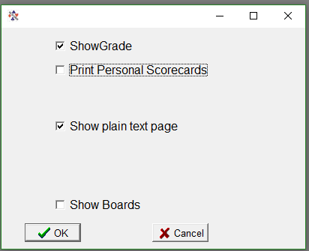
The box “Upload XML file to FTP Site” allows the XML to be sent automatically, otherwise the file is produced but not sent.
Figure 35 Results Options

Calculate Results
This is a fairer method of scoring when some boards have been played a different number of times to others. This can happen for (but not limited to) the following :
- An artificial adjusted score has been awarded at one or more tables
- The movement has been curtailed when there are feed-ins
- Two sections are playing different numbers of boards
NOTE: If all boards are played and completed then the traditional and Neuberg results are identical.
The report has options to print the personal score sheets immediately, produce handicap as well as raw score results, show local gradings and produce a plain text page in a similar layout to that traditionally printed.
The default for the tick-boxes on the Results Options screen (Fig 9-11) are set in the Scorer Options screen (Section 4.1.2 above)

If the session is a Handicap session then both Raw Score results and Handicap results will be printed.

If multiple sections are played, then all sections will be printed.

If multiple Mitchell sections are played, then a combined NS group and a combined EW group result will be printed.

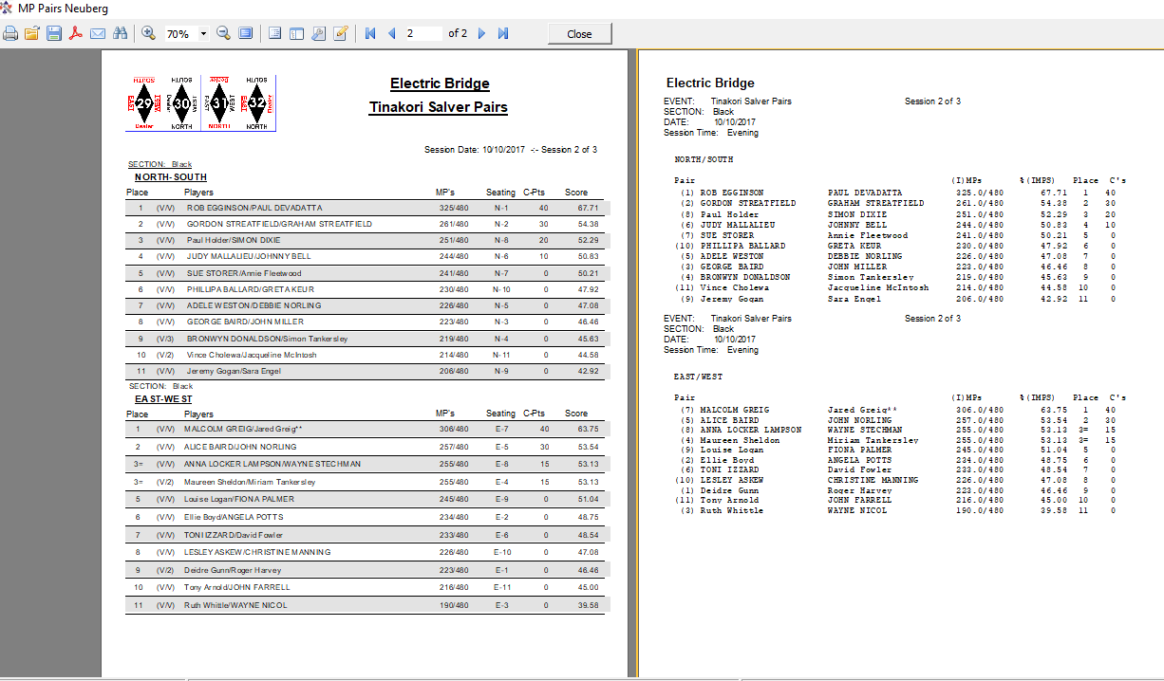
Export / Import session
Occasionally a user will score on the wrong date or score two events as two sections in the one event. This can be easily sorted by exporting the session and importing it to the correct session.
Export Session: Creates a .zip file of the data (section details, players and board results) created relating to a session. This may not work correctly if the session has been renamed in the calendar.
Import Session: Recreates the session by opening a .zip file created by the Export Session command. The section name is appended with a prefix to identify where it has been imported from.

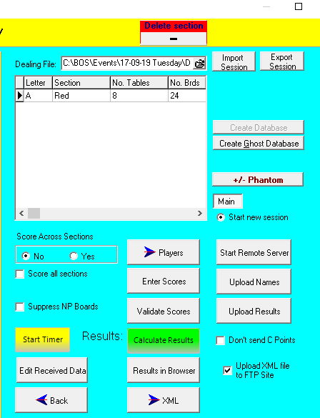
XML and the WEB
Under the Results button is the XML button, and beside this is the tick-box to “Upload XML file to FTP site”
This takes the results from all sections, creates an XML file in the XML directory (as configures in the options screen). If the “Upload...” is ticked, then two scripts are created in Scorer's root directory: FTPStart.bat and FTPAction.txt
The batch file uses the FTP configuration in the Options screen to send the files to the FTP site, renaming them in the form:
999~20100930A~139~248~Event_Name_Pairs.xml
Club Number ~ datetime ~ EventID ~ CalendarID ~ Event Name .xml
All spaces are replaced with “_”.
Attaching a dealing file will enable the makeable contracts to be provided as well as the results. This file must be a text file (suffix of .txt or .edr). Most dealing software has an option to produce a text file of the hands.
Additional documentation for this is available from the downloads section of the BridgeNZ website.

Start Timer: Starts the BridgeNZ Timer clock in a web browser (initial web connection required). By default this allows 6.5 minutes per board + .5 minutes moving time.
If the parameter :DSTimer… is set in the options screen club details (sec 4.1.1) then David’s timer will start either locally or from the web.depending on the parameter entered.
+/- Phantom: Allows the user to change the Phantom pair without deleting the section.
NOTE: This option is best used before users have logged in. If any tablet has logged in BEFORE this option is used then the Replace option should be used on each such tablet to reload the movements.
Suppress NP Boards: allows upload of results without giving a warning on NP boards. This is useful in BTF teams pairs and Multiple Teams where the first round is not played.
Results in Browser: runs a report to generate html and starts the default browser showing the results.
Edit Received Data: allows the user to modify the uploaded received data from (e.g. altering the contract/declarer/result) directly in the SQL Server database. When the screen is closed the results are re-calculated and appropriate scores corrected.
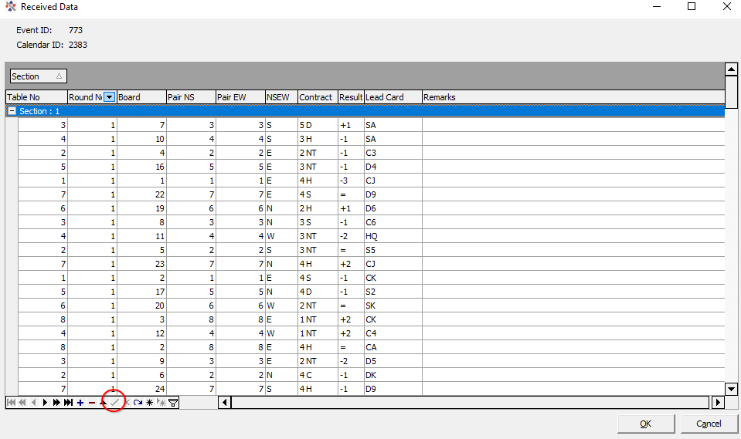
The user should be careful to click on the green tick at the bototm of the grid to commit the last change before clicking OK or the final change will not be saved.
This feature is mainly of use if the bws files have already been archived.

Individual Scoring
Scoring individual events, from Scorer 19, is very similar to scoring Pairs events with custom movements; with a few notable exceptions.
This section will only focus on the exceptions.
Implementation of the individual movements is restricted to complete tables at this point, although having one, two or three missing pairs will work if no score is entered for tables with “phantom” players.
The BridgeTab will work with these movements, but not all player names show correctly (as of version 1.83 of BridgeTab), so guide cards are recommended and careful monitoring of players is recommended.

Below are the points of difference between Pairs and Individual scoring:
- When entering the individual setup for a session, there is only the selection of individual movements. This is similar to the custom movements in Pairs.
- Extra 2 columns in score entry and single player in player entry.
- At the time of writing, player number changes are not validated, and the score on the line of the cursor should be recorded before making any changes to player numbers as it is likely this will be overwritten.

Teams Events Scoring
There are 3 types of teams event in Scorer:
- Swiss Teams (each team plays a team designated by a draw)
- Round Robin Teams (each team plays every other team)
- Multiple Teams – set up much like a pairs event
Swiss and Round Robin can be Scratch or Handicap while Multiple Teams can only be Scratch.
As set up and scoring for each of these is very similar, detailed instructions are provided for Swiss Teams only, while instructions for the other types of teams highlight the unique options and differences.
Player names are captured for each by round, so the “C” points will be allocated to the players who are actually playing the round.

Swiss Teams

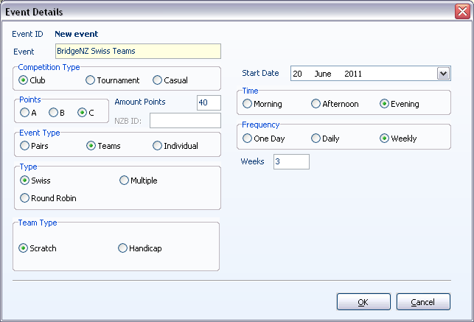
Set up the Event in the Calendar
Enter the event in the calendar for each night the teams are running. This makes it easier to access the event on the night.
Swiss events can be scratch or handicap.
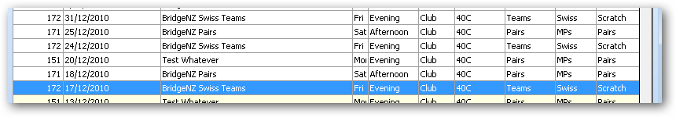
Once the event is in the calendar, select the line of the first night and click the NEXT button. This will bring up the Sections menu.
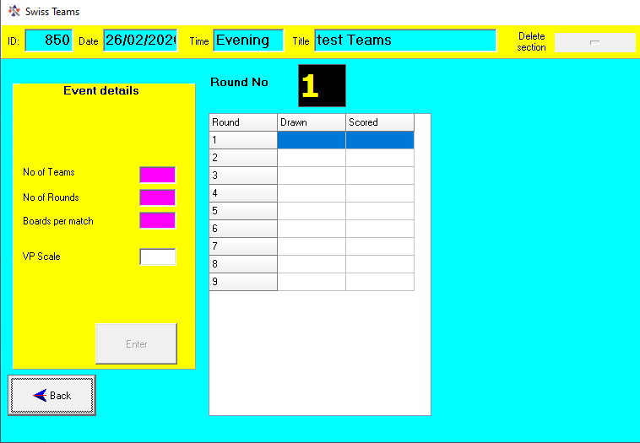
NOTE: Although the C-points allocated to the matches are not “40” the NZB Master Points system will NOT accept any results without “40” as the C-point amount.

Set up the Section
Before setting up, the following information is required:
- Number of teams playing.
- Number of rounds that will be played.
- Number of boards per match.
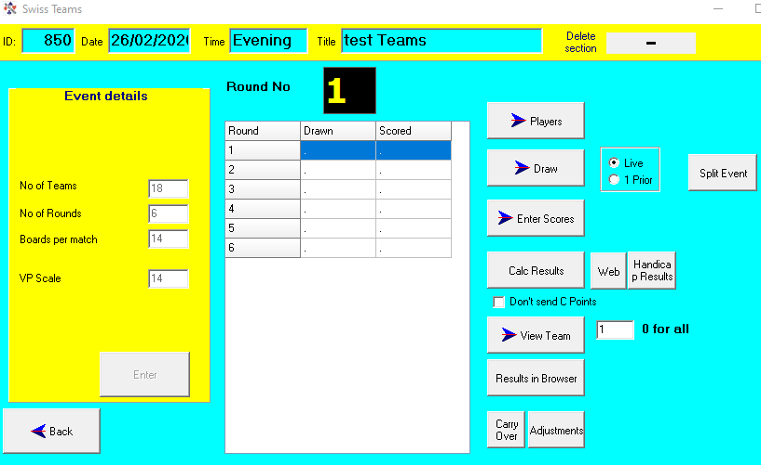
- The VP scale to use (this should be equal to the number of boards per match).
This information is filled out in the Event Details. When the ENTER button is clicked, the grid at the right reduces to the number of rounds entered and the event is ready to.start.
The event is now set up with a grid indicating which rounds have been Drawn and Scored.
If using Handicaps, the Handicaps are in IMPs and are added to the IMPs of the team before the VPs are calculated.

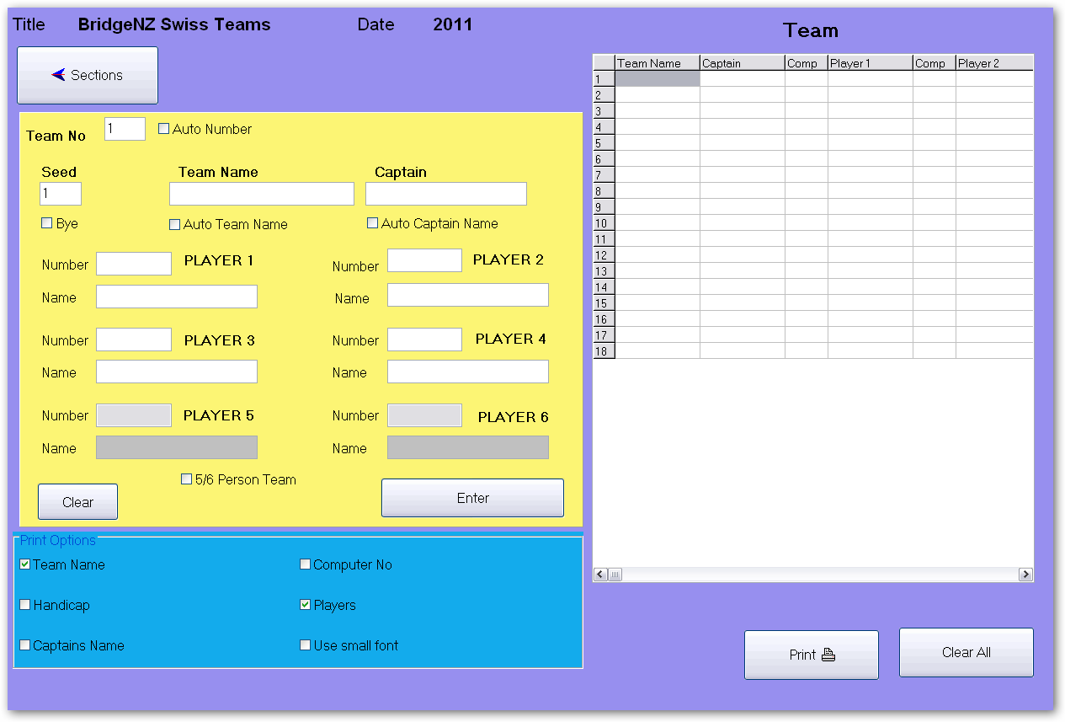
Enter team names and Players
The “Players” button allows for the entry the Team Name, Captain and members for each team.
If using electronic scoring, you need only enter the Team Name against each Team Number, as player details will be captured from the electronic scoring units when the first round names are uploaded.
Team No: This is the number that Scorer will use for the team throughout the event for draws and results.
Auto Number: When this option is ticked, the next team number display automatically once the ENTER button is clicked.
Seed: This indicates the seeding for the team. By default this is the team number and it is seldom relevant.
H'cap: The H'cap field only appears if you have set up Handicap Teams.
This is the Handicap in IMPs for the team. This will be added to their score before calculating the Handicap VPs.
Team Name: Free text. If Auto Team Name is ticked, this field is populated with the full name of the first player entered.
Captain: Free text. If Auto Captain Name box is ticked, this field is populated with the full name of the first player entered.
Bye: This is a Bye. Opponents drawn against a bye get the round off and score 12VPs
Number and Player: This is the standard name entry as in other places in Scorer. These players will be the official team members, and it is only necessary to complete ALL the members of a team with more than four competing players if the event is a tournament and the team will be allocated master-points for final ranking.
5/6 Person Team: When this is ticked, extra team members may be added. (See above)
Print Options: These determine what is printed when the Print button is clicked.
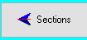
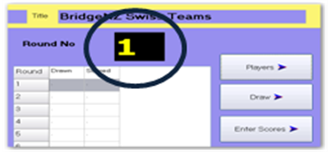
The Sections button takes the user back to the Teams Section screen.
For teams events, many clubs set up to this point in advance of the event.
Ensure that the Round Number is set to the round which is about to start.

Perform the Draw and Set up for the Round
The Draw button takes the user to the draw screen.
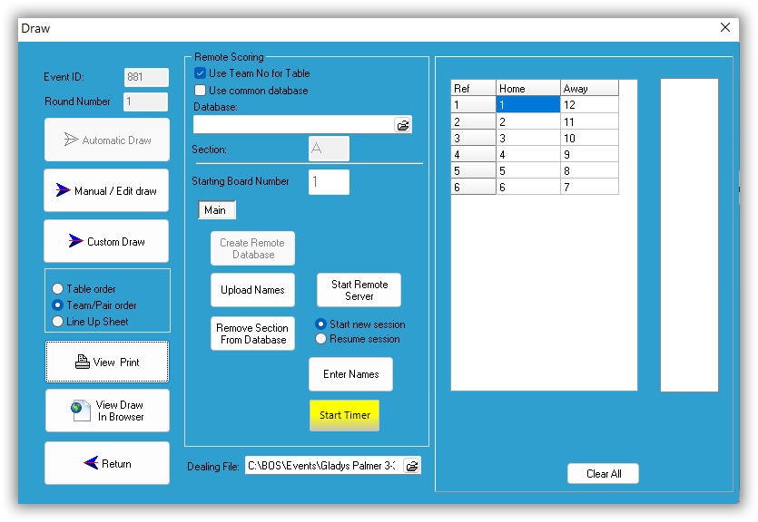
For the first round, if a manual draw is required, click the Manual/Edit draw button and fill in the draw. (tab between cells).
For a random draw, click on the Automatic draw button.
When the Automatic Draw is used, a window should pop up saying the draw is good.
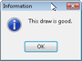

Use Team No for Table: PLEASE LEAVE THIS TICKED! | Each team always sits at the table of their team number regardless of their position in the field. Using this you must IGNORE THE TABLE NUMBERS ALLOCATED BY SCORER.  If this is NOT ticked, then the teams will sit at the HOME and AWAY tables allocated by Scorer. In this case TWO sections will be available on BridgeTab, A for the home table and AA for the Away table. If this option is chosen then the whole event should be run this way, and tems will move table every round.
Use Common Database: | This is used when multiple events are being run from one Computer. The database can be selected. If the database does not exist, it is created.
Section: | This is a letter to tell the Electronic devices which section to use.  If it is not directly entered, it will default to “A”.  NOTE: If you try to use a section letter that is already in use, you will be warned and the section will NOT be created.  NOTE: Do NOT use section T – this is reserved for Trifecta matches.  IMPORTANT NOTE: BridgeTab will accept 2 letters so long as they are identical (AA, XX, PP,…) but NOT if they are different (AH, XY,…) The section will be added but the BridgeTab will not log in successfully.
Starting Board Number: | This is the first board in sequence for the set to be played. Scorer knows how many boards per match from the Sections screen. If playing more than one round in a session, make sure the correct starting board number is entered for the round.
Create Remote Database: | This enters all the information about the movement for the Electronic scoring system to use. When starting a round, ensure that the “Clear Data from Server” box is ticked. If restarting the server to correct or check results, ensure this box is NOT ticked. When the Database is created / loaded, an XML file is generated with the draw. This may now be viewed / displayed with your browser by clicking the “View Draw in Browser” button.
Remove Section from Database: | If there is an incorrect set up (e.g. the wrong starting board has been entered, and the database created) then this button will allow the user to remove the section from the database. After removing the section, make the corrections and Create Remote Database again.
Start Remote Server: | This is to start the Electronic Scoring Server ready to receive information from the table units.
Upload Names: | This will populate the player data for the specific round from electronic scoring units. If no names have been entered for the team members, this will populate the first four member names in the Players table.
Enter Names: | If electronic scoring devices are not used, then names for each round can be defaulted from the entered players list. Substitutes should be entered manually in this screen for each round so materpoints can be assigned.  For each round there is a button “Default All” which will copy the names from the player screen to the teams for the round.  After round one, button is available to “Copy Names from previous round”.  If electronic scoring devices are used, this screen will be populated after “Upload Names” has been clicked. After names have been uploaded they should be checked here to enter any visitor names, or correct any that were entered incorrectly on the scoring devices.  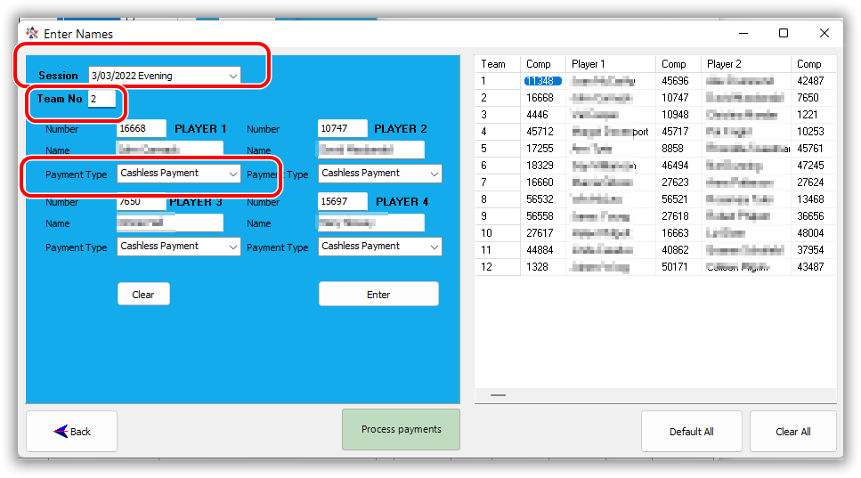  Names on this screen are used for assigning masterpoints and if there are no names here, then the round will not be included when C points are sent to NZ Bridge.  From V22.2, The enter names screen allows the user to specify the session date and time for the round, and to define the payment type for each player of each team. See the Scorer Cashless Payments documentation for full details.
Dealing File: | This box allows the user to attach the dealing file (txt, EDR or pbn) for each round for use with Web publishing if the club subscribes to this service from BridgeNZ. Note: If the dealing file contains boards for more than one round (eg it comprises boards for all the rounds to be played on one night), the web display will only show the boards relating to the appropriate round.
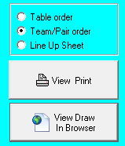
The print options allow you to print the draw in three ways:
Table order: This uses reports and may be customised from the system reports if desired.
Team/Pair order: This uses reports and may be customised from the system reports if desired. This is the default from V18.
Lineup Sheets: These are used for the Home team to write in their player positions and the Away team can then choose who they put at the tables with those players.
View Draw in Browser: This option runs a report to generate html code which is opened in the default browser. The delivered report scrolls the draw if the number of teams exceeds 12, otherwise it produces a static draw in the browser.

Scoring the Round
The user should ensure that:
Player Names are uploaded in the Draw screen OR
In the Draw screen Enter Names screen there are buttons to allow the user to copy the player names from the player list or from the previous round.
These player names are used for master Points and for the Round sheets.

The user should check the Round No BEFORE CLICKING ON ANY BUTTON AND BE SURE THE CORRECT ROUND IS DISPLAYED.
Click on the Enter Scores button.
The top panel is to enter scores manually and to apply adjustments, while the bottom panel (Remote Scoring) is for electronic scoring users.
There is the ability to enter non-balancing IMP adjustments. This may happen, for example, with a fouled board where each side should be assigned 2 or 3 IMPS (depending on the number of boards in play). Enter the adjustment IMPS for each team and the result for each team is calculated with VPs not adding to 20.
ELECTRONIC SCORING USERS:
Upload Results: | This uploads match results from the electronic scoring database to Scorer.  Once results are uploaded, the Results process is automatically run, bringing up the Results screen.
Print Round Sheets: | This prints the match sheets for each team – a complete set in numerical order of the teams. If the Include Datums box is ticked then the datums and each pair's IMPs against the datum will be printed on each sheet.
Print one match: | This asks for a team number and prints the match sheet for that team.
Max boards per page: | Limits the number of boards printed on a page.
Poll Results: | This starts a window that shows the teams and number of boards to play at each table. It is sorted by “number of boards to play”. If this is running, matches are automatically processed as they finish, and matches completed are written to an XML file and can be automatically displayed by using a web browser. The results file is stored in the XML folder configured in the options screen.
Display Results in Browser: | This uses a report to produce html code and displays in the default browser
Director Adjustments: | This allows the Director to make adjustments to results in the database, including assigning +/- IMP results for a board. The IMP result entered here is a BALANCED result. i.e. if Team 1 gets +3, then their opponents will get -3. See “Enter Scores” to assign a NON-BALANCING adjustment.
ENTERING SCORES MANUALLY:
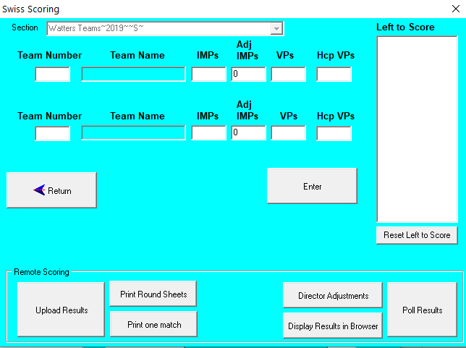
Type in a team number in the top entry box under Team Number, and press the enter key on the keyboard. The opposing team number, and both team names will be filled in, and the cursor moved to where the IMPs are to be entered.
Type in the IMPs for the first team and press the enter key on the keyboard. The cursor moves to the IMP entry box for the second team.
NOTE: It is possible to enter a non-balancing adjustment. The most common of these is with a fouled board, where +3 IMPS is awarded to each side, so if the original result for the match (with the fouled board removed as not played) was
17 IMPS – 15 IMPS
then the first team would be scored as if the result was
20 IMPS – 15 IMPS
and the second team would be scored as if the result had been
17 IMPS – 18 IMPS
Type in the IMPs scored by the second team and press the enter key on your keyboard. The VPs are calculated and show in the boxes. The handicap VPs are also calculated if the event is set up as Handicap Teams.
NOTE: It is possible for the Director to adjust the VPs directly due to infractions.
Click on the Enter button or press enter on the keyboard again and the results are entered. The matches will disappear from the list of matches yet to be scored and your cursor will be placed in the entry box ready to type in another team number.
When all results are entered, click on the Return button to go back to the Sections screen.
If all results have been entered, then the “Scored” column will contain “Y” and focus will be moved to the next round ready to do the draw. Be careful not to click RESULTS while an incorrect round is selected!

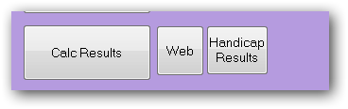
Publish the Results (Print and Web Publishing)
Check that the correct round is selected and click on the Calc Results button. This will show the IMP and VP results from each match. NOTE: If using the “Team Number for Table” then players can ignore the “Table” column.
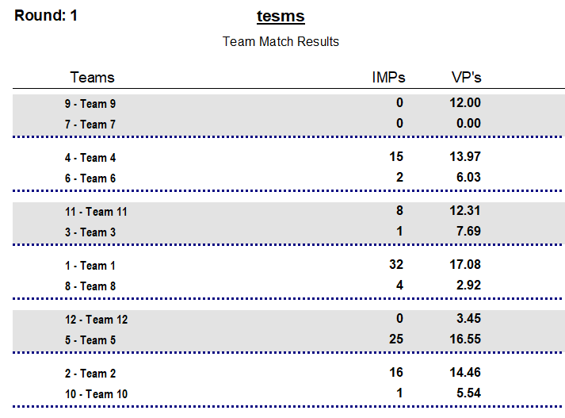
This should be printed and posted for the players. Landscape format is recommended.
Page 1 shows the match results for that round
and
Page 2 shows the placings as at the end of that round.
The Full results overall ranking shows:
VPs: Total of VPs to the end of this round.
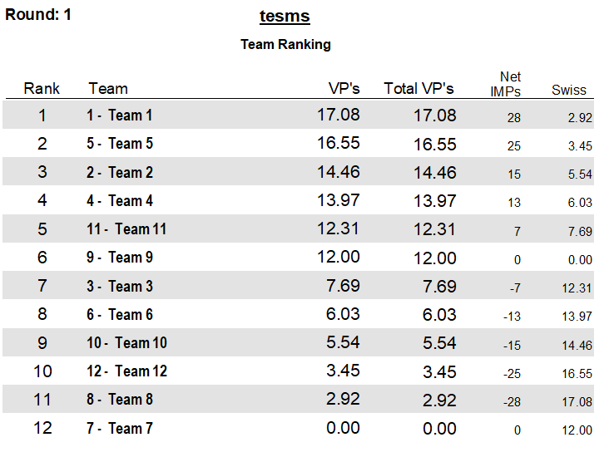
Swiss: Total of VPs of all opponents played.
Net Imps: Net of all IMPs gained – IMPs lost.
If the event has been set up as a Handicap teams event, there will be a “Handicap Results” button beside the Calc Results button. This will produce a report of the round results inclusive of the handicap (which is entered on the team entry screen).
The “Web” button beside Calc Results runs a procedure to transfer the data through to the tasp.bridgenz.co website if the club has subscribed to the BridgeNZ service for web publishing.

OTHER OPTIONS from the sections screen:
View Team: | Enter the team number in the box to the right of the View Team button. Click View Team and a complete history of the team match will show. From the team results screen, options are available to view/print the results or export them to Excel/CSV format in the same manner other teams results are printed.
Adjustments: | This allows the Director to enter VP, Swiss or Net IMP adjustments for each team. These should be saved using the save button on the adjustment screen.
Carry Over: | Carry Over has been separated from adjustments. Scores for the purposes of Draws will include Carry Over, but will NOT include Adjustments. This means that if a team has a penalty, they will not benefit by getting an easier draw.
Split Event: | If the viewed event is partially or completely a qualifying event, then this button is used to populate the team/player names and carry-over for the alternate event. Once players have been selected for the alternate event they will no longer be included in the draw for subsequent rounds of the current event.

RESULTS – SAVING to other formats
On pressing “Calc Results” the Fast Reports report writer is used to present the results. Full documentation is available under the Documents tab and all standard options for saving in other formats are available.

Round Robin Teams
These are set up in a similar way to Swiss Teams in the calendar, but select the Round Robin button. Once the event is in the calendar, select the line of the first night and click the NEXT button. This will bring up the Sections menu.
The event can be set up with multiple Round Robin matches. This is useful when, say, 6 teams are to play 10 rounds. This is a double round robin. In this format, each team plays each other team twice.
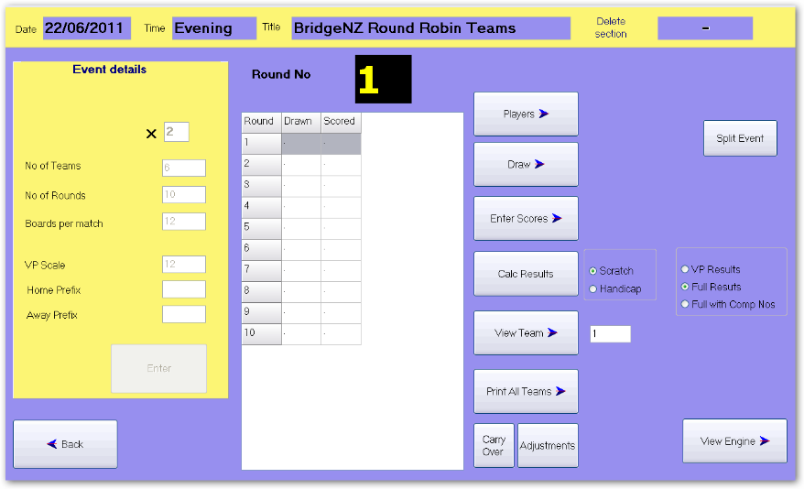
In the Event details pane, the box marked X is to enter the number of complete round robins to play. For this example 2 round robins (with 6 teams).
When 6 is typed in the “No of Teams” field and Enter is pressed on the keyboard, the No of Rounds automatically changes to 10.
Press Enter on the keyboard, then type in the number of boards per match. Please ensure that the “VP Scale” field contains the same number as the “Boards per Match” field.
After filling in this information click the Enter button on screen.
The setup is similar to those for Swiss in terms for adding players, entering scores and calculating results. A key difference is in the Draw.
The Draw screen for RR teams looks the same as for the Swiss, but if the Automatic draw is done, all rounds for that Round Robin are done. The Draw is based on the seeding (entered in the player entry screen) and cycles the teams. This is arranged such that the top seeds and bottom seeds meet in the final round.
The default automatic draw does not balance Home and Away matches.
It is possible to manually reverse certain pairings in the draw to balance this if it is deemed important.
NOTE: In the Reports Teams run the RR Draw for Team Captains. This prints a list for each team showing who they play in each round.
CUSTOM TEAMS DRAW: In the Custom Movements, there is an option to create a custom Teams Draw. This uses seeding rather than Team number, so the teams may be automatically re-seeded after the first Round Robin, and finish up with appropriate seeds playing one another in the final round (usually top two teams playing against each other and bottom two teams playing against each other). The second Round Robin automatically balances the Home & Away, so if Team X was HOME to team Y in the first RR, then Team Y would be Home when they play X in the second RR.
The remainder of the teams match is handled in the same way as Swiss, but draws are known in advance and can be published in advance, so scores can be entered while a subsequent match is being played.
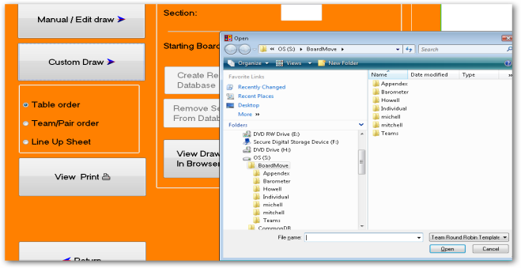
ODD TEAMS: With the Custom Draw the option of playing an ODD number of teams with a trifecta is available.
Once the setup of the event is done, it is expected that the three teams will play 2 x half-matches per stanza. This has the basic advantage that they can talk to their team mates between stanzas.
Under Draw, choose Custom Draw, then select the (pre-entered) custom movement from the Teams folder in BoardMove folder.
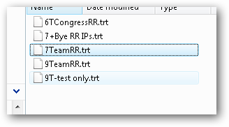
When entering scores for these, be careful as the three-way match can't have say 5v6 and 6v5, so typing 5 on the entry line will get 5v6, and typing 6 on the entry line will give 6v7, and typing 7 on the entry line will give 7v5. It is important to get these in the correct order.
At the end of ODD numbered rounds, the half-way IMP scores should be entered for the three-way match. If playing overlapping boards with the three-way, then enter 0-0 for the scores at the half-way point, and the complete IMP result at the end of the even rounds. [For more details on this –please contact BridgeNZ]

Multiple Teams
The event should be entered in the Calendar with one entry for each session of the Multiple Teams. Multiple Teams does not have a Handicap option.
With Swiss Teams and RR Teams, each entry in the calendar moves to the same screen to continue with the same event. This is not so with Multiple teams because the format is more like a pairs session.
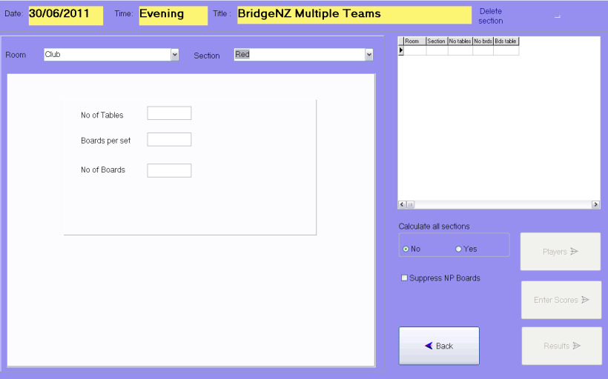
Click Next in the calendar screen, to go to the Sections screen (just like pairs).
This looks a lot like the Pairs Section screen, and is used in much the same way.
Add a section using the drop down menu from the Section
Currently Scorer only supports Odd numbers of tables for Multiple Teams. The movement is based on players moving UP 2 tables and boards moving UP 1 table.
When the number of tables and the number of boards per table are entered, scorer uses the only movement it knows and assigns the total number of boards. Remember that teams will never play the first round (against their teammates), so one round can be removed from the timing.
Having entered the numbers, click the Add Section button.
Enter the players as for Pairs, the Players screen looks the same, and has the same functionality.
Enter the scores as for Pairs. This screen also has the same options and functionality.
Results show the 4 players in the team, the total IMPs for the team and the total C points gained for the session. NOTE: C Points are available for each match scored in the round, and matches are played in a 7 table Multiple Teams session.

PLEASE NOTE: The following illustrates the layout for a Multiple Teams result sheet.
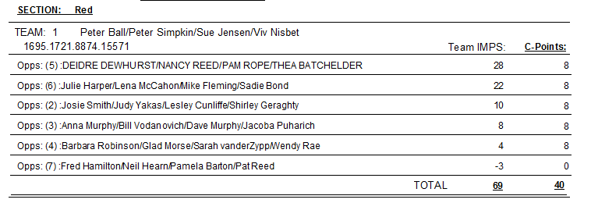
NOTE: The teams are identified by the 4 computer numbers, so to ensure that the ladders work as required, please ensure all substitutes are entered.

Swiss Pairs Events Scoring
The Scorer functions for Swiss Pairs are very similar to those for teams so those functions will not be covered here.

Pair Numbering
There must be an even number of pairs in a Swiss Pairs event. If a stand-by pair has been organised to fill any phantom, then there is no need to pre-register players (this is normally done to ensure an even number).
Seat the players, then give them simple instructions to move so that they mix up (i.e. players don’t get to choose their first round opponents). Usually this is done by saying something like ..“EW pairs should move 1 row to the west . Those on the west wall move to the other side of the room”.
Set the first round draw with the NS pair as the table number and EW pair as [Number of tables]+Table Number. For example, if you have 8 tables, then NS are 1 to 8 and EW at table 1 will be 9 (=8+1), EW at table 2 will be 10 (=8+2) and so on. The players should be told that this is their pair number for the whole event regardless of where they sit from here on in.
If using electronic scoring, when the names are uploaded for the first round, all the pairs will be assigned numbers based on the draw. For subsequent rounds with the same players, the name entry may be turned off.

RESULTS – SAVING to other formats
On pressing “Calc Results” a report is run to generate match results and overall rankings in a similar manner to that for teams.

Personal scores are available.
Results can be sent to a browser to display in the room using the “Results in Browser” button.

The results are from Fast Reports, so saving in other formats is not a problem.

Swiss Pairs Events and Masterpoints
One key difference between Swiss Pairs and Teams is that names for Swiss Pairs are only entered at the first round. After that, it is assumed the same players will be playing.
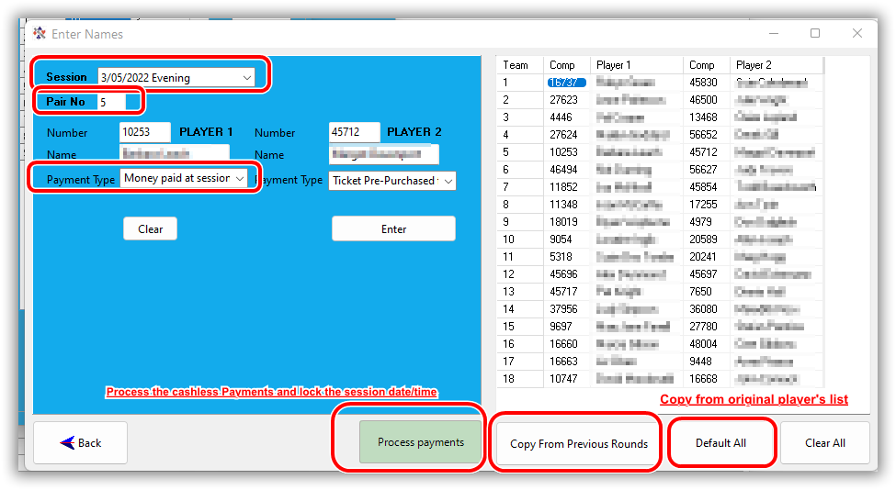
Scorer V22.2 has included the ability to allocate player names by round, so if different players are playing the current round from those with the same pair number in the previous round, then the player names may be changed in the Enter Names screen
As with teams, the date/time for the round is able to be assigned (selected from entries in the calendar for this event).
Each player in each pair should be assigned the appropriate payment type.
Once Process Payment has been pressed, the round date/time is locked and the payments processed, but can be unprocessed and modified.
Please see the Scorer Cashless Payments documentation for full details.

NOTE: The “Upload Names” button in the Draw screen ONLY appears in the first round for Swiss Pairs. Names should be manually adjusted after that if different or extra players are present.
The use of player names in electronic scoring is for the players benefit at the table only.

Ghosting
The Ghosting has been specifically implemented for Wellington Bridge Club and the following documentation reflects the use of BridgePads but this is totally portable to other electronic scoring devices.
The Ghosting function has been developed to allow for the situation in which an event is being held in two rooms (e.g. due to space constraints) and where there is no radio communication between the two rooms. Each room, therefore, has its own radio receiver that is collecting data, operating on different channels.
The principle is that the event and sessions are created on one computer, then a ghost copy of the Electronic device (e.g. BridgePad) database is made at the click of a button, and this ghost database is used to collect some of the data whilst the primary database is used to collect the remainder.
In order for Ghosting to operate, the Ghosting option in the Options/Scoring Options screen must be ticked.
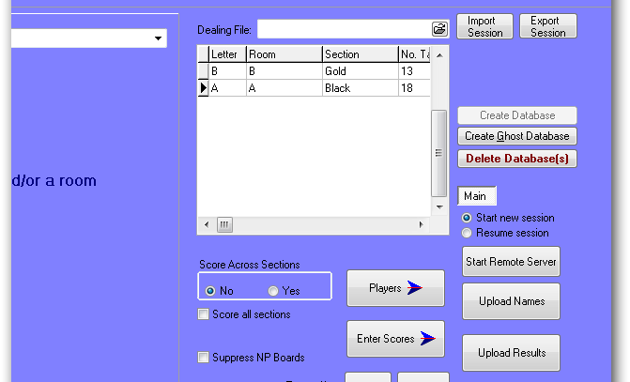
PAIRS
For purposes of this example, we will have 18 tables, 26 boards playing in the primary room, and 13 tables, 26 boards playing in the secondary room. Create both sections on one computer; it does not matter what order these are done in. In this example, section A is playing in the primary room, section B in the secondary room.
Once the sections are created, click the “Create Ghost” button which sets up two tabs – MAIN and GHOST. Behind the scenes, each of these tabs relate to a main and a ghost .bws database that collects the scoring data for each section.
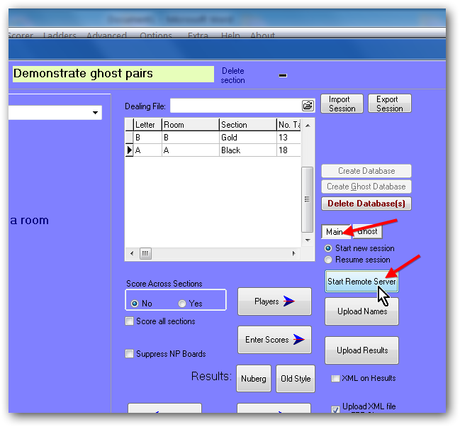
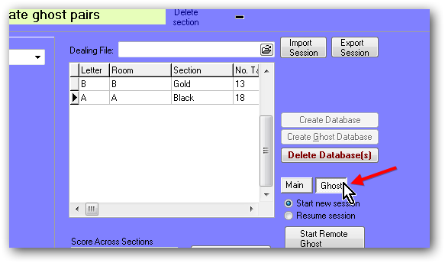
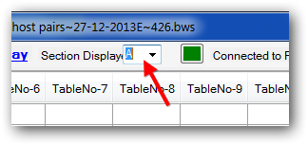
To setup in the primary room, click the Main button and then click Start Remote Server to start Electronic Scoring. Enter the BridgePad options for pairs and select the channel the primary room is using. When users start their bridgepads, they will need to enter their section number. Here the primary room is section A=1.
In the BridgePad screen, you will be able to see a display layout for the A and B sections with the appropriate number of tables for each section, but you will only see data populating the A section as the game progresses.
To setup in the secondary room, click the Ghost tab. The button called Start Remote Server is now called Start Remote Ghost. Click this to start BridgePad. Enter the BridgePad options for Pairs and set a different channel to the one being used in the primary room. When users start their bridgepads, they will need to enter their section number. Here the secondary room is section B=2.
In the BridgePad screen, you will be able to see a display layout for the A and B sections with the appropriate number of tables for each section, but you will only see data populating the B section as the game progresses.
Upload names and results from each room separately on each of the two PCs.
If you want to review the names or results in the separate rooms, make sure you have clicked on the correct section first.
After the results have been uploaded, you will be able to score across sections as if both sections had been playing in the one physical room.
TEAMS
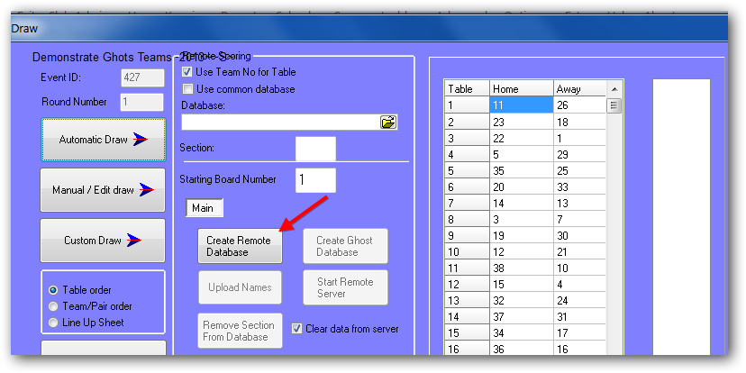
For Swiss Teams, the “Create Ghost” button is in the “Draw” screen. Do the draw as normal, enter the starting board number and Click Create Remote Database.
Then click Create Ghost Database. When this button is used, a “Ghost” tab is displayed to the right of the “Main” tab.
To setup in the primary room, first click the Main tab and then click Start Remote Server to start BridgePad. Set the BridgePad options and channel and ask people in the main room to login to their BridgePad. Check that all tables have logged in to the correct table numbers (i.e. that no tables that you expect to be used in the secondary room have initialised).
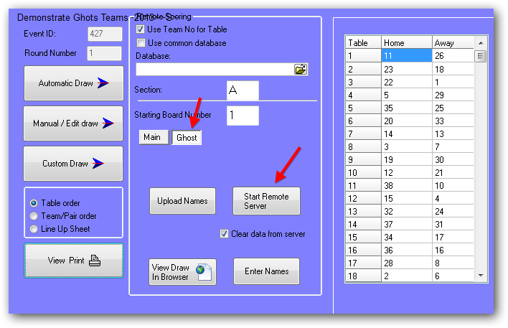
To setup in the secondary room, click the Ghost tab, and then click Start Remote Server to start BridgePad. Set the BridgePad options and set a different channel to that being used in the primary room.
You must ensure that the table numbers are entered correctly in both rooms, as an incorrectly entered table number affects the data collected and it is difficult to correct on the night. To ensure that tables get setup correctly in the secondary room, it is recommended that the Director enter the table number on the BridgePad units before they are placed on the tables.
Uploading names for the primary room and the secondary room can be done from the PC in the primary room by clicking the MAIN and GHOST tabs in turn and then clicking Upload Names.
When you Upload Results in the primary room, the update includes any results that have come in from the secondary room.

List of Supplied Reports [incomplete for V22.2 – to be updated]
This section lists the Scorer default report directories and the default reports contained therein.
Please be aware that users may change the directory structure (other than the Reports/System folder) and may add their own reports or move reports to a different place in the folder structure.
Report files are found in the Reports directory under the NZB Scorer root directory. All report files have a suffix of .fr3.
Reports may be customised to suit the club, either by a club member or by BridgeNZ on request. Reports that are customised should be named accordingly to avoid being overwritten during updates.

System
Reports in this directory are assigned to buttons. DO NOT REMOVE OR RENAME.
These reports are defined in the database and are fed parameters from Scorer. They will not run properly directly from the reports menu, but the reports menu can be used to modify the layout.
Report | Comment
BoardScoreExceptions.fr3 | Prints boards without valid scores
BoardScores.fr3 | Print boards from a session
BTF_TeamsLadder.fr3
BTF_TeamsLadder_XML.fr3 | BTF teams ladder for the web
C-PointPairsLadder_new.fr3 | Used for tournament ladder Master Points
C-PointPairs_new.fr3 | Produces C-point file
C-PointTeamsLadder_new.fr3 | Produces C-point file
C-PointTeams_new.fr3 | Produces C-point file
checkscores.fr3 | Score validation report
CustomMoveOverview.fr3 | Prints movement overview for new custom movements
Draw_Swiss_browser.fr3 | Report for Swiss teams/Pairs draw in browser
HandicapTeams Results-for chromecast.fr3 | Handicap teams results suitable to save and open in browser
HandicapTeams Results.fr3 | Handicap Teams results report
ICE.fr3 | Emergency Contact details
InvalidScoreReport.fr3 | Score validation report
logo.fr3 | Displays club logo
MissingPlayers.fr3 | Reports missing players
MP_ind_neuberg.fr3 | Not used currently
MP_pairs_nuberg.fr3 | Pairs results
MT-BoardScore.fr3 | Board results for Multiple teams
MT_Ladder.fr3 | Multi Teams Ladder
MT_LadderXML.fr3 | Multi Teams Ladder for web
MT_XML.fr3 | Multi Teams results for web
MultiTeamsResult.fr3 | Multi Teams results for printing
Pair-Grouped-Ladder.fr3 | Tournament group ladder - pairs
personal_scores.fr3 | Personal scores - no longer required
Player Club point ladder.fr3
Player Individual Results.fr3
Player-Cpoint ladder.fr3
Players All Results.fr3
ReceiptPayment.fr3
Result_Pairs_Barometer.fr3
Result_Pairs_browser.fr3 | Pairs html to browser
Result_Swiss_browser.fr3 | Teams/Swiss Pairs html to browser
SpecialLadder.fr3 | Special Ladder
SP_draw_failure.fr3
ST_draw_failure.fr3
SwissPairsDraw.fr3 | Swiss Draw
SwissPairsDrawTO.fr3
SwissPairsPsc.fr3 | Swiss Pairs personal score cards
SwissPairsResults.fr3 | Swiss Pairs Results
SwissTeamResult.fr3
SwissTeamsResults.fr3 | Swiss Teams Results
TeamsDrawSwiss.fr3 | Teams draw by team number
TeamsDrawSwissByTable.fr3 | Teams draw by table
TeamsMatchSheetsSingle.fr3 | Single Teams match sheet
VPScales.fr3 | Print VP Scales for specific No Boards

Admin
Contact List.fr3 | Contact list with phone and email
Contact with address.fr3 | Contact list including address
Envelope-sample.fr3 | Sample of envelope print for mail
FullMemberDetails.fr3 | Full details for membership update purposes
Handicap.fr3 | Basic handicap report - should be copied and customised
LocalEmails.fr3 | Produces a “;” delimited list of emails for import to other applications
Member Programme Book Labels.fr3 | Labels for programme books
Member-Playing-Data.fr3
Member Info for csv.fr3 | Report written to take member info to an accounting system
Members Mail Label DL30.fr3
Members Mail Label L7159.fr3
Members Mail Label No Email.fr3
Members Mail Label.fr3
Member_by_Type.fr3 | Lists membership by type
moneyvars.js | Used for subscription notices
NZB PlayerList-Select Club.fr3 | Lists players in selected club flagging non-home members
Phone List.fr3 | Member phone list
PlayerMismatch-with-NZB.fr3 | Run this after player update to compare your member data with the NZB member data.
Subscription Notices-new.fr3 | Subscription notice - should be copied and customised
Table Numbers by calendar week.fr3 | Report comparing playing numbers for current and prior year
Unfinancial Members.fr3 | Lists members who are unfinancial

Calendar
There are two calendar reports – one in Alphabetic order of event, and the other in Chronological order.
Calendar by event Alpha order.fr3
Calendar by event Cron Order.fr3
Export for Google Calendar.fr3 | Format suitable for import to google calendar

Pairs
Barometer-psc.fr3
BoardScores.fr3 | Board printout
CustomMoveOverview.fr3
Grading report_bridgenz.fr3
LadderEachSessionOverTime.fr3 | Session ladder for multiple events - specific session time
Non_Qualifyers.fr3
Pairs_Results_with_Grades.fr3
Pairs_Results_with_rank.fr3
pair_movement_card.fr3 | Movement card for pairs in a Howell showing seating, opponents and boards for each round
Slams bid and made by individual.fr3
Slams bid and made by pair.fr3
Slams bid and made.fr3
swiss_psc.fr3
Table Guide Cards.fr3

Teams
All Players.fr3
All_VPs.fr3 | Print VP Scales
Check Pairs.fr3 | Check to see if players at the table belong there at start of team round
FourClub-8Team-6Round-Result.fr3 | Report to group pairs of teams from 4 clubs in 6 round teams
lineup.fr3
Player Imp Cross Tab.fr3 | Player Datum IMPs
RR-Draw for team captain.fr3
Team Handicap Results.fr3
Team list with Handicaps.fr3
Team Pair Datums - player alpha order.fr3
Team Pair Datums.fr3
TeamMatchSheet.fr3
TeamsOfSix-Results.fr3 | Groups 3 Swiss Pairs events by pair number and ranks total
ThreeClub-18Team-Result.fr3 | Groups 6 Teams from 3 clubs for 4 round competition
VP_Scales-A6.fr3
VP_Scales-Continuous.fr3
_TE_Seeding List - TEAMS.fr3

Tournaments
Alpha List - PAIRS.fr3
Handicaps_from_Rating_points-for_Tournament.fr3
Handicaps_from_Rating_points-individual.fr3
Name Tags.fr3 | Name tags for Tournament with home club
Pair-Grouped-Ladder.fr3
Pair-Grouped-List.fr3 | List of prize groups
Player Alpha List - PAIRS - With numbers.fr3
TeamPlayerList.fr3
tournament.fr3
_TE_Player Alpha List - PAIRS.fr3
_TE_Player Alpha List with grade and club- PAIRS.fr3 | Alpha list of pairs with grade and club
_TE_Player Alpha List with grade- PAIRS.fr3
_TE_Player Entry Order - PAIRS.fr3
_TE_Player grade listing- PAIRS.fr3
_TE_Seeding List - PAIRS Grouped.fr3 | Seeding list
_TE_Seeding List - TEAMS.fr3
_TE_Team Name List with RP.fr3

Player Information
Member-Playing-Data.fr3 | Reports members who have played less than a specific number of sessions over given period
NZB Player Info.fr3 | Shows NZB player information for player number
Player Club point ladder.fr3
Player Individual Results.fr3
Player-Cpoint ladder.fr3
PlayerMismatch-with-NZB.fr3 | After player import this shows any mismatch with the club membership information
Players All Results.fr3
PlayerStats3.fr3

Director
handrec_single.fr3 | Allows hand record print with selected hands only and bidding added

REPORT LISTING

REPORTS
│
├───Admin
│ │ FullMemberDetails.fr3
│ │ Grading report.fr3
│ │ Grading report_bridgenz.fr3
│ │ Handicap.fr3
│ │ Member-Playing-Data.fr3
│ │ MemberInfo for csv.fr3
│ │ Member_by_Type.fr3
│ │ moneyvars.js
│ │ Subscription Notices.fr3
│ │ Subscription Notices_template.fr3
│ │ Table Numbers by calendar week.fr3
│ │ TableMoney.fr3
│ │ Unfinancial Members.fr3
│ │
│ ├───Labels
│ │ Envelope-sample.fr3
│ │ Member Programme Book Labels.fr3
│ │ Members Mail Label DL30.fr3
│ │ Members Mail Label L7159.fr3
│ │ Members Mail Label No Email.fr3
│ │ Members Mail Label-Rangiora1.fr3
│ │ Members Mail Label.fr3
│ │
│ ├───Member Contact
│ │ Contact List.fr3
│ │ Contact with address.fr3
│ │ LocalEmails.fr3
│ │ Phone and Email List.fr3
│ │
│ └───NZB info
│ NZB Player Info by Name.fr3
│ NZB Player Info by number.fr3
│ NZB PlayerList by Club.fr3
│ PlayerMismatch-with-NZB.fr3
│
├───Calendar
│ Calendar by event Alpha order.fr3
│ Calendar by event Cron Order.fr3
│ Export for Google Calendar.fr3
│
├───Director
│ handrec_single.fr3
│ sp_results_total_imps.fr3
│
├───Pairs
│ Barometer-psc.fr3
│ bidding.fr3
│ BoardScores.fr3
│ CustomMoveOverview.fr3
│ Howell Seating.fr3
│ pair_movement_card.fr3
│ swiss_psc.fr3
│
├───Player Information
│ Handicap.fr3
│ LadderEachSessionOverTime.fr3
│ Member-Playing-Data.fr3
│ Non_Qualifyers.fr3
│ NZB Player Info by Name.fr3
│ NZB Player Info by number.fr3
│ NZB Player Info.OldFR3
│ Player Club point ladder.fr3
│ Player Individual Results.fr3
│ Player-Cpoint ladder.fr3
│ PlayerMismatch-with-NZB.fr3
│ Players All Results.fr3
│ PlayerStats3.fr3
│ Slams bid and made by individual.fr3
│ Slams bid and made by pair.fr3
│ Slams bid and made by session.fr3
│
├───Special Events or Ladders
│ 5-Club-Multi-Teams-3-Grades.fr3
│ BTF_TeamsLadder.fr3
│ FourClub-8Team-6Round-Result.fr3
│ TeamsOfSix-Results.fr3
│ ThreeClub-18Team-Result.fr3
│
├───System
│ │ BoardScoreExceptions.fr3
│ │ BoardScores.fr3
│ │ BoardScoresException.fr3
│ │ BTF_TeamsLadder.fr3
│ │ BTF_TeamsLadder_XML.fr3
│ │ C-PointPairsLadder_new.fr3
│ │ C-PointPairs_new.fr3
│ │ C-PointTeamsLadder_new.fr3
│ │ C-PointTeamsLadder_new_on_hcp.fr3
│ │ C-PointTeams_new.fr3
│ │ C-PointTeams_new_on_hcp.fr3
│ │ checkscores.fr3
│ │ CustomMoveOverview.fr3
│ │ Draw_Swiss_browser.fr3
│ │ HandicapTeams Results-for chromecast.fr3
│ │ HandicapTeams Results.fr3
│ │ ICE.fr3
│ │ InvalidScoreReport.fr3
│ │ logo.fr3
│ │ MissingPlayers.fr3
│ │ MP_ind_neuberg.fr3
│ │ MP_pairs_nuberg-Angela.fr3
│ │ MP_pairs_nuberg.fr3
│ │ MT-BoardScore.fr3
│ │ MT_Ladder.fr3
│ │ MT_LadderXML.fr3
│ │ MT_XML.fr3
│ │ MultiTeamsResult-all.fr3
│ │ MultiTeamsResult.fr3
│ │ Pair-Grouped-Ladder-XML.fr3
│ │ Pair-Grouped-Ladder.fr3
│ │ personal_scores.fr3
│ │ Player Club point ladder.fr3
│ │ Player Individual Results.fr3
│ │ Player-Cpoint ladder.fr3
│ │ PlayerList.fr3
│ │ PlayerListInd.fr3
│ │ Players All Results.fr3
│ │ ReceiptPayment.fr3
│ │ Result_Pairs_Barometer.fr3
│ │ Result_Pairs_browser.fr3
│ │ Result_Swiss_browser.fr3
│ │ SpecialLadder.fr3
│ │ SpecialLadder_XML.fr3
│ │ SP_draw_failure.fr3
│ │ ST_draw_failure.fr3
│ │ SwissPairsBoardPrint.fr3
│ │ SwissPairsDraw.fr3
│ │ SwissPairsDrawTO.fr3
│ │ SwissPairsPsc.fr3
│ │ SwissPairsResults.fr3
│ │ SwissTeamsResults.fr3
│ │ TeamHistory.fr3
│ │ TeamsDrawSwiss.fr3
│ │ TeamsDrawSwissByTable.fr3
│ │ TeamsMatchSheetsSingle.fr3
│ │ VPScales.fr3
│
├───Teams
│ All Players.fr3
│ All_VPs.fr3
│ Check Pairs.fr3
│ Player Imp Cross Tab.fr3
│ RR-Draw for team captain.fr3
│ RR-new format.fr3
│ Team Handicap Results.fr3
│ Team list with Handicaps.fr3
│ Team Pair Datums - player alpha order.fr3
│ Team Pair Datums.fr3
│ TeamHistory.fr3
│ TeamMatchSheet.fr3
│ TeamsOfSix-Results.fr3
│ ThreeClub-18Team-Result.fr3
│ Trifecta_teams_Match_Sheets.fr3
│ VP-Scales.fr3
│ VP_Scales-A6.fr3
│
└───Tournaments
Handicaps_from_Rating_points-for_Tournament.fr3
Handicaps_from_Rating_points-individual.fr3
Name Tags.fr3
PAIRS - Alpha List with grade and club.fr3
PAIRS - Alpha List.fr3
PAIRS - Entry Order.fr3
PAIRS - Listing by combined grades.fr3
PAIRS - Prize Grouped List.fr3
PAIRS - Prize Grouped-Ladder.fr3
PAIRS - Seeding list.fr3
Player Alpha List - PAIRS - With numbers.fr3
TEAMS - Names list with Rating points.fr3
TEAMS - Player List.fr3
TEAMS - Seeding list.fr3
Tournament Summary.fr3

NZB Master Points System

Setup
In the Scorer Options FTP Options screen there is a new window setting the FTP site, username and password for the NZB C-points to be sent. The password will not be accessable to the club user, so if this is changed then the club should contact BridgeNZ to reinstate.
Alternatively the club may choose a more secure option of sending through the bridgenz server. Please enquire from BridgeNZ for details.

In the Scoring Options tab, the tick-box “Send C Points on Results” will be ticked. If the user chooses to untick this box then no C-points will be sent until it is ticked again. After the box is ticked again the unsent C-points will NOT be sent automatically – the user will need to calculate results for each session to be sent.

Every time the Results button for any session is pressed, results will be sent to NZB for C-point processing. If an error is found and corrected, then the next press of the Results button will overwrite the previous results.

There is one exception – if an event is set up as a “Casual” event then no C-points will be sent.

For testing purposes there is a tick-box in the pairs and in the teams section screen to allow the C-points NOT to be sent if it is obvious that the result is not relevant; e.g. the Director would like to see the consequences of adjusting a score without sending results to NZB. The box unticks automatically in the Pairs section screen but not in the Teams

NOTE: If the computer is not connected to the web when the result button is clicked, then the results will be queued. When the computer is connected to the web, and Scorer started, the queued files will be sent.

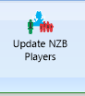
NOTE: On the first Ribbon bar of Scorer is an icon to update NZB Players.
It would be wise to do this at least weekly. The information supplied by NZB is less than was supplied previously as associate members are no longer advised – only home club members. With each update the latest list of NZB players is included in Scorer and a combination of the NZB Player list, the club membership and the club non-member list is combined into a list for electronic scoring.
PLEASE run the report “PlayerMismatch-with-NZB” from the Reports Admin

APPENDIX 1 Running Multiple Events

Multiple Pairs Events
From Scorer 16.2.14.14 the user is able to run multiple pairs events using one computer and electronic scoring.
The process must be followed and the following limitations/cautions are IMPORTANT. So please read carefully.
- There will be multiple sections, and each section MUST have a different “Letter”
This letter is entered in the “Section Room” field in the “Set up Sections” screen, and if a longer name is entered (such as “Powell” for the Powell room”) then the FIRST LETTER of that word will be used for the “Letter” of the section.
- All sections for sessions to be run concurrently MUST be set up and added to the SAME Common database BEFORE starting the remote server.
- The “Start Remote Server” button should only be pressed once, and it does not matter which of the sessions it is started from providing that the session is contained in the sessions to play.
- If a section is entered incorrectly, then that section may be deleted and re-added correctly, but this should be done BEFORE the server is started.

The Process
- Set up events
e.g. Open Pairs / Junior Pairs where you are planning to play 3 x 24-board sessions with the Open Pairs and 2 x 24-board sessions with the Junior Pairs.
In the calendar it may look like this:
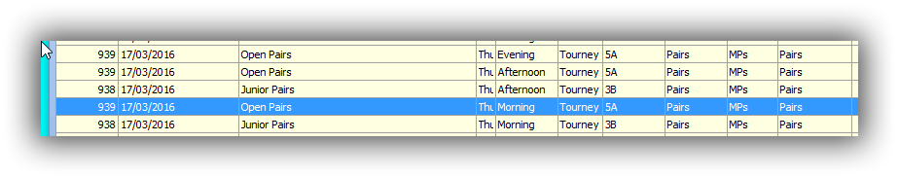
- In the Set up section screen, top right, there is now a tick-box to “Use Common Database”
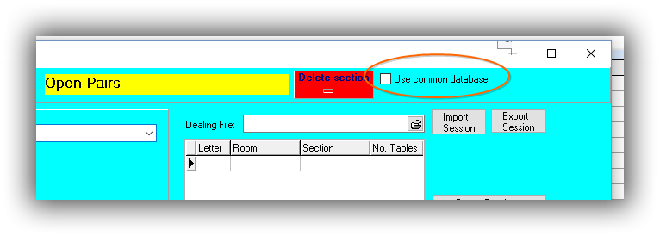
When this box is ticked, then the option to browse for a file is available.
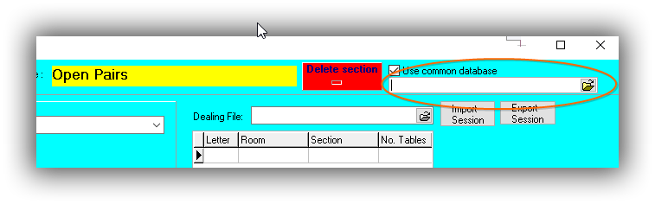
Click the folder at right to browse – the default folder is the “CommonDB” folder defined in the Options Screen.
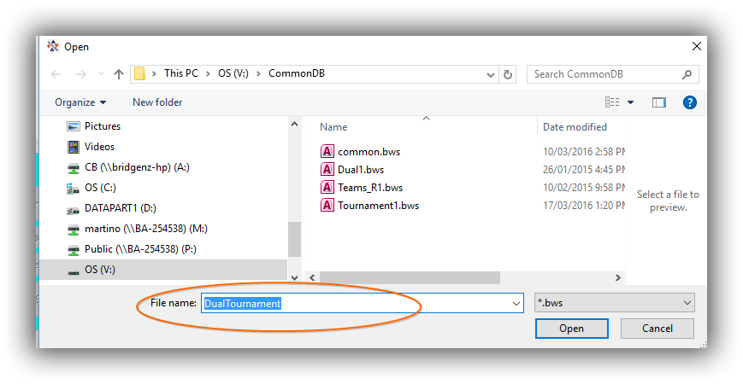
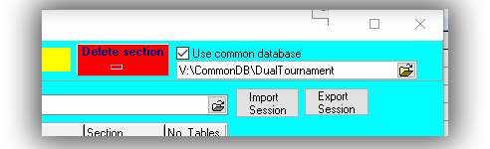
- Enter a filename for the common database file
DO NOT USE AN OLD database that has been used before!
then click Open
The filename now appears in the Common Database box
- Now add sections to this event as usual.
NOTE: The “Create Database” and “Delete Database” buttons are hidden when scoring multiple events as these perform operations which may compromise data from the other event(s)
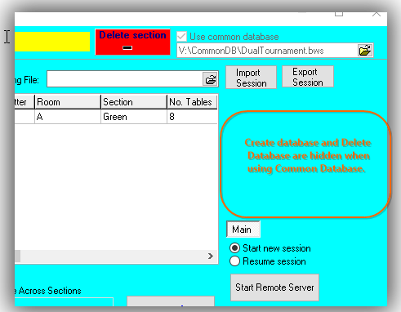
- Move to the next event session to be scored and ensure that the “Use common Database” box is ticked.
If no common database has been set up previously for this session, Scorer will remember the last used name so be careful when starting to set up another session!
If a common database HAS previously been set up for this session Scorer will recall this name to the file box. Another database may be selected by clicking on the folder box at right of the common database box.
CAUTION: Please ensure that you use the SAME COMMON DATABASE FILE for all sections you wish to play concurrently.
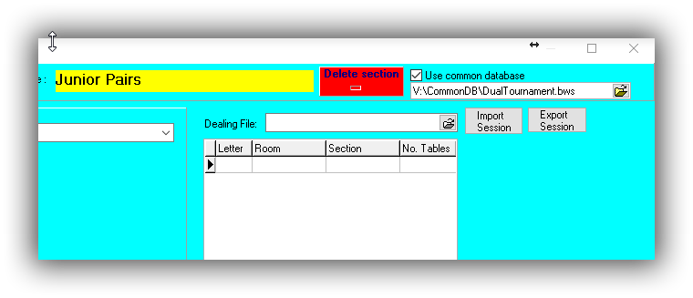
- Ensure that the sections added in the second event have a different LETTER to those in the first event.
If the user tries to add a section with the same LETTER, even if it is a different section colour, then the following message will appear.
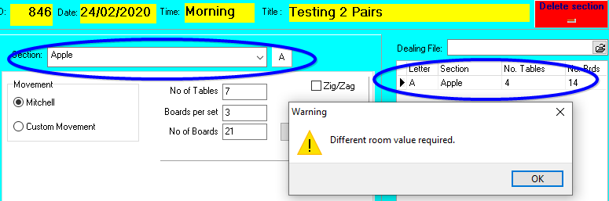
The user may recognise this from trying to create two SECTIONS in one event with the same “Section” set, and this follows the same scenario that the electronic scoring cannot use two sections with the same “Letter”.
- All sections will be added to the named database, and the “Start Remote Server” button can be pressed in any ONE of the sessions used.
- When the server is running, the user may go into the different event sessions in Scorer and upload names / upload results as per normal.
- The electronic scoring will have the different sections visible under the section lookup (depending on which scoring system the club is using) and information is accumulated across the events.
- The server MUST be left running until the last board in the last session is received.
- If using BridgeTabs, then the same hand records are available to each section, so the same deals should be played in all events.
- NOTE: Do not use a common database which has been used previously for other sessions.
- NOTE: Do not use this process for a teams match and a pairs session

TEAMS
When Multiple events are being played as TEAMS then it is easy to set up the events
Set up the two events in the calendar – they should be Swiss OR Round Robin and preferably playing the same number of boards per round, but that is not essential so long as the start time for the rounds is the same.
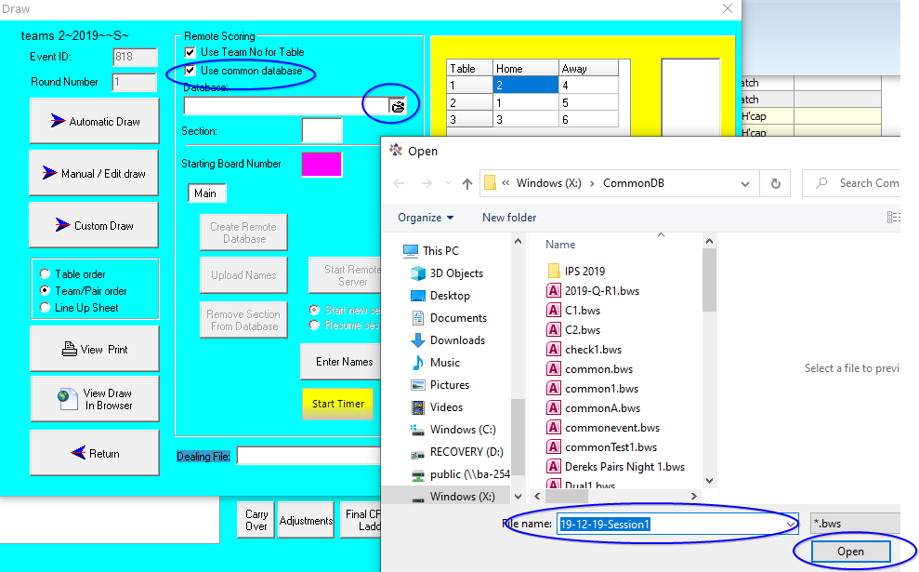
The Example below uses a Swiss Teams with 18 teams and Round Robin Teams with 6 teams, both having 5 x 12-board matches. It is often the case that one event will have say 4 rounds whilst the other has 5 rounds, and that is not a problem.

FIRST EVENT
In the Draw screen tick Use Common Database then click on the folder to enter the database name for the first session.

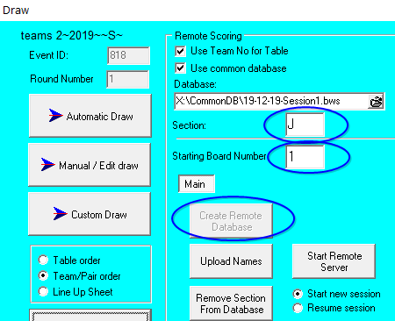
Click on Open and add the Section and starting board values, then create the remote database.
DO NOT START THE REMOTE SERVER AT THIS POINT

Go back to the calendar and into the second event.

SECOND and SUBSEQUENT EVENTS
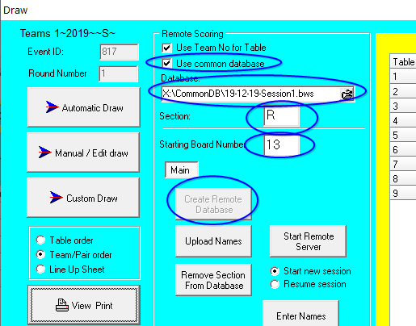
In the second event tick Use Common Database and search for the common database just set up for this round.
Enter a section DIFFERENT FROM the other event section.
Enter the starting board – this may be (and usually is) the same starting board as for the other event, but that is not essential.
If boards are being used in one round that will be used in the other event later then this poses a security issue with players discussing boards, so try and keep them consistent.

Once all the events have been added to the common database then start the remote server from any one event.

Upload names in the Draw screen of each event.

Upload results from the Enter scores screen of each event

Close the Remote Scoring screen at the end of each round and create a NEW common database for each round, adding the session rounds to the new common database.
If the events are Round Robin then the common databases may be created in advance, but for Swiss then need to be created after the Draw is done.

Appendix 2 - Using BridgeTab for Pairs
- Start BOS ensuring that either a new event is set up for the current session and the deals imported OR an existing session with the correct deals is opened, then click “Start Scoring”
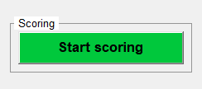
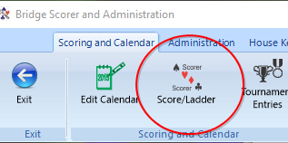
- Scorer will now start and ALSO the BTAdmin icon 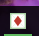 will appear at the bottom of the screen.
NOTE THAT THIS ICON MUST BE AT THE BOTTOM OF THE SCREEN AT ALL TIMES WHEN THE BRIDGETABS ARE RUNNING.
- Log in to Scorer if required
- Click on Score/Ladder
- Double-click on the event line in the calendar OR select the line and click the NEXT button at the bottom of the window.
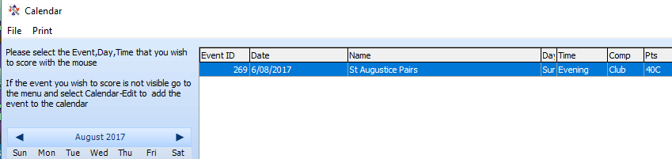
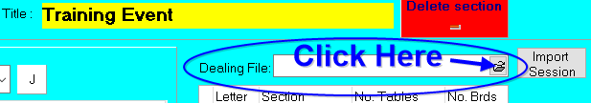
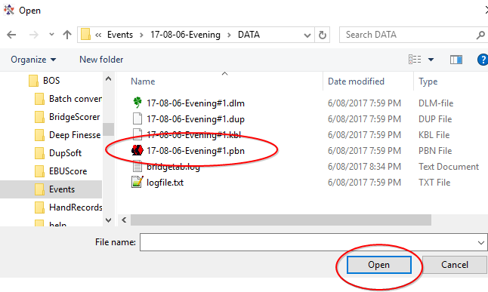
- Now attach the dealing file to the session:
Select the Dealing File from the same location that you selected it for dealing (See Files section 4.1.7 )
When selecting the file there are a number of available files, make sure you pick the “.pbn” file.

The screen will now look something like this, and you are ready to set up the section for the night.
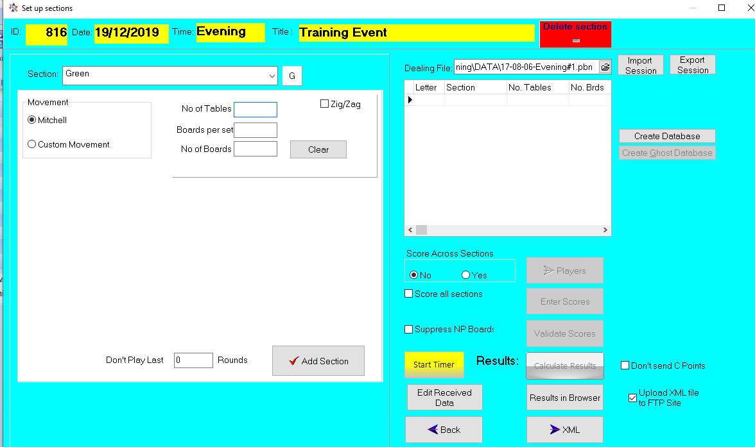
Set up the section as usual
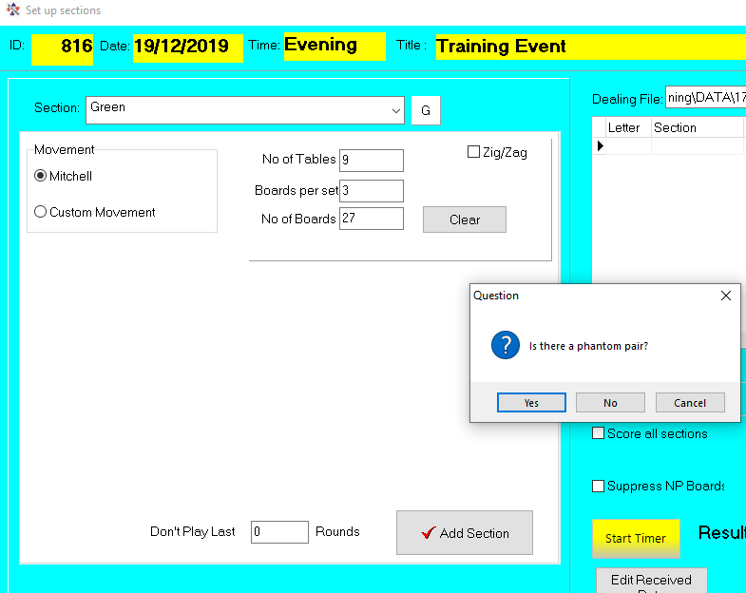
If there is a phantom, please check the table and direction for the phantom.
REMEMBER THE PHANTOM IS THE PAIR THAT IS NOT THERE, (not the pair at the table with no opponents)
If you get this wrong, there is now a button to change it:

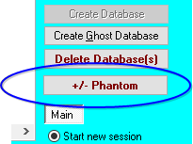

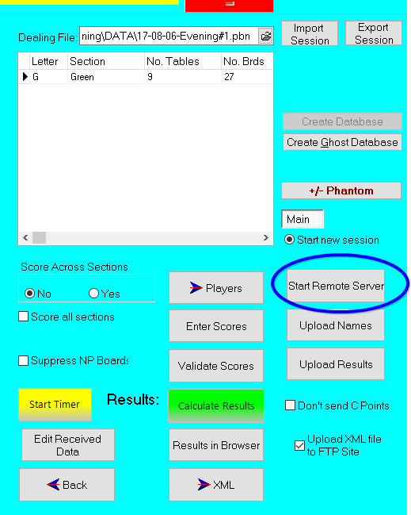
Now the section is there you can start the server by clicking “Start Remote Server”
The defaults should be set correctly for your club – click Save
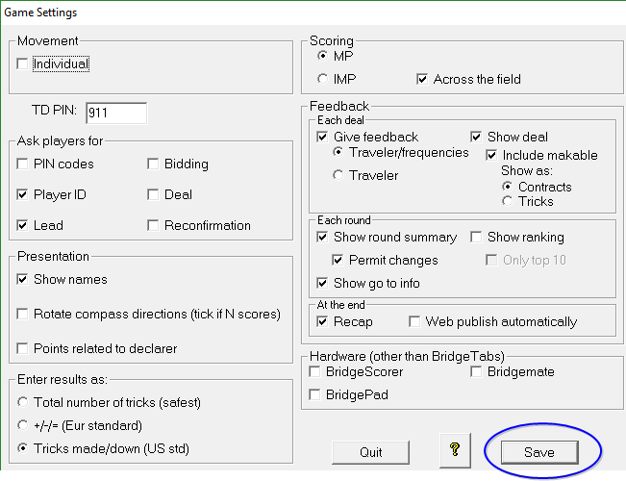
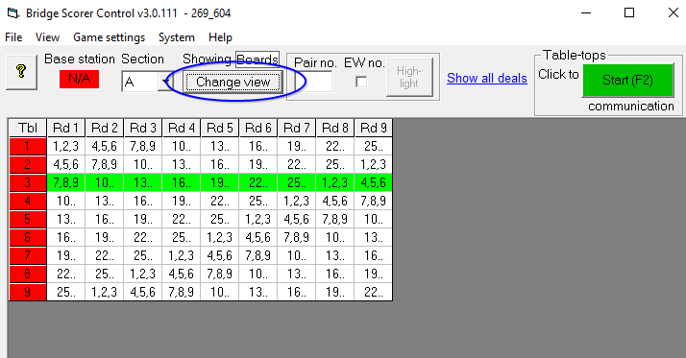
When the BSC starts, the grid will be blank – Click on “Change View” to see the boards that should be at the tables to start, and the phantom, if any, will be highlighted.

Now click START and you are ready to go.

Appendix 3 - Using BridgeTab for Teams [Event already set up]
- Start BOS ensuring that either a new event is set up for the current session and the deals imported OR an existing session with the correct deals is opened, then click “Start Scoring”
- Scorer will now start and ALSO the BTAdmin icon will appear at the bottom of the screen.
NOTE THAT THIS ICON MUST BE AT THE BOTTOM OF THE SCREEN AT ALL TIMES WHEN THE BRIDGETABS ARE RUNNING.
- Log in to Scorer if required
- Click on Score/Ladder
- Double-click on the event line in the calendar OR select the line and click the NEXT button at the bottom of the window. 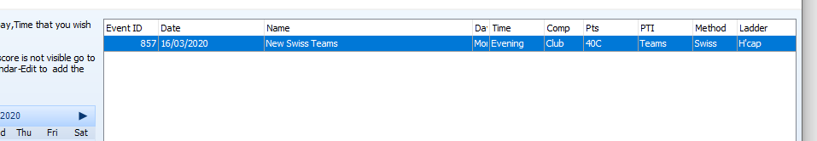
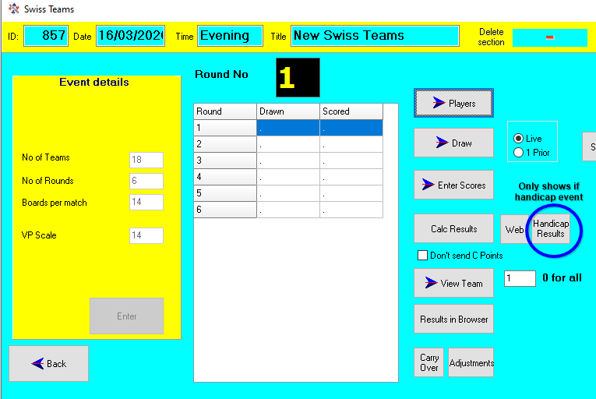
Figure 36 Swiss Teams on handicap with 18 teams, 6 rounds of 14 board matches
- Go to Draw screen – click “Automatic Draw
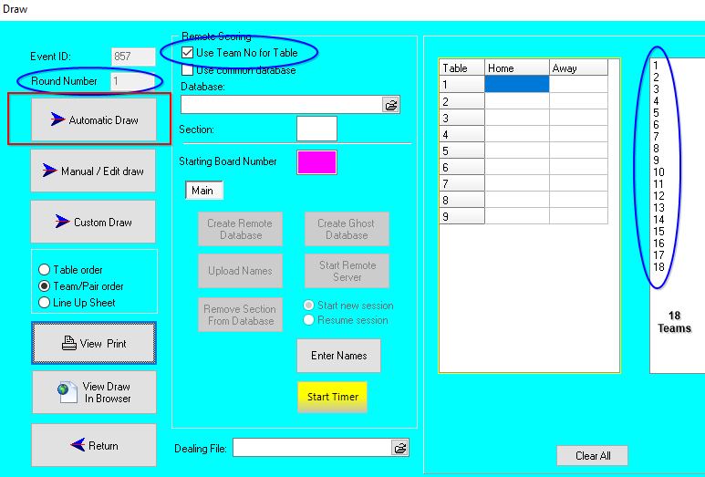
- The Draw shows a “Table” – IGNORE THIS COLUM
The TEAM NUMBER determines the table the players sit NS at their OWN table (table of their team number) and EW at their opponent’s table.
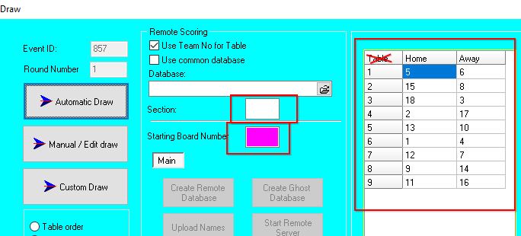
- Enter the Section and starting board for the set required and “Create Remote Database”
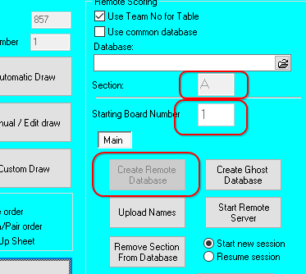
NOTE: If the incorrect starting board is entered, then
REMOVE SECTION FROM DATABASE
CHANGE STARTING BOARD NUMBER TO THE CORRECT NUMBER
CREATE REMOTE DATABASE
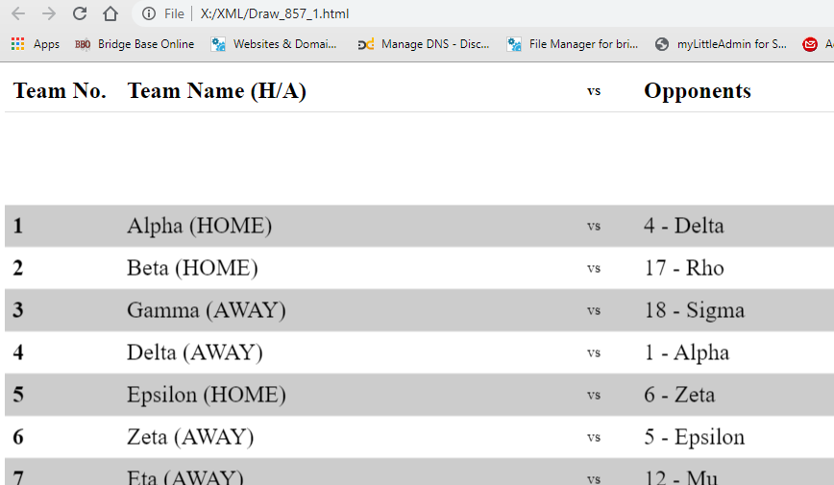
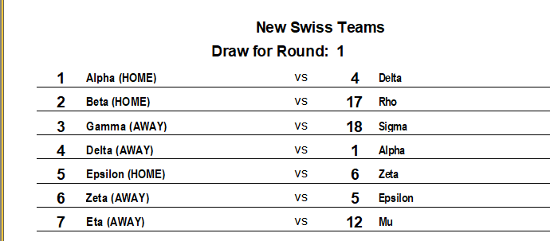
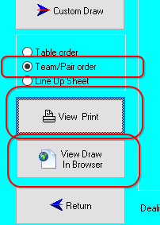
- Print the draw and/or send to screen with “View Draw in Browser
Note that the default is to print in Team/Pair order – this should NOT generally be changed.
Figure 37 Draw in browser
Figure 38 Draw Print
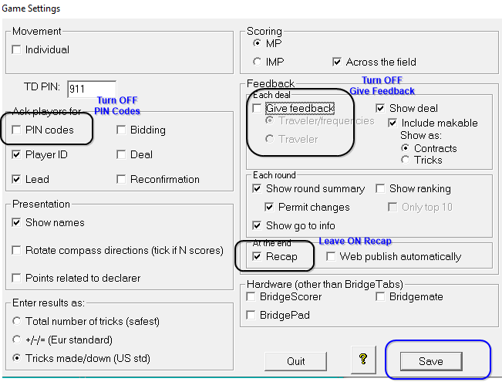
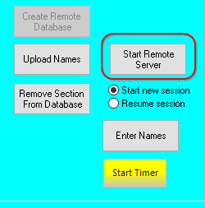
- Now start the BridgeTab – ensure Give Feedback is OFF and PIN codes are OFF
It is recommended to leave Recap on – the % shown are irrelevant but scores can be checked.
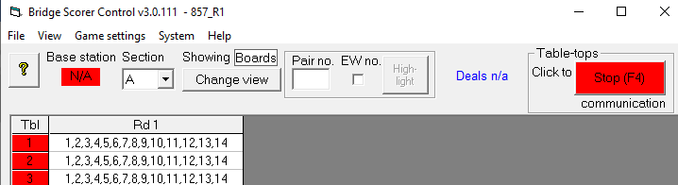
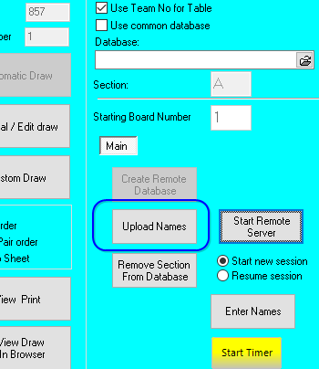
- After all teams have entered the player numbers (for their team NS and the opponent’s numbers EW) the player names may be uploaded in the Draw screen.
After uploading names go to Enter Names and check that all teams have valid players and that the teams look like they should (i.e. players have not entered their own team at the table instead of the opponent’s EW numbers.
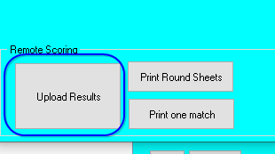
- At the end of the round:
When ALL reaults have been entered:
CLOSE the BSControl screen
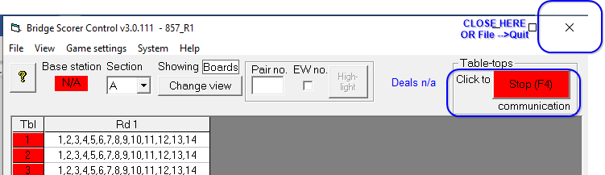
In Scorer go to Enter Scores and upload results
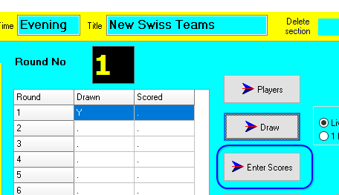
- Processing will be done and the results will be printed along with the Match sheets for the round.
- Go back to the Draw screen for the next round and start the process from step (8)
NOTE that hand records for the web should be loaded into the Draw screen for each round
NOTE sending results to the web should be done for each round
Both the above tasks can be done at any time

Round Robin Teams
For Round-Robin teams, the draw for the first round will do the draw for the entire round-robin.
This eliminates the step of doing the draw in subsequent rounds, but the section and starting board still need to be entered to create the remote dataabse.

Appendix 4 – Starting the SQL Server Service
On Windows 10 computers:
Right-click on the Windows icon and select Computer Management
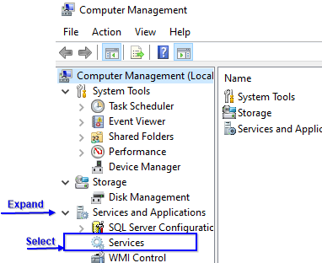
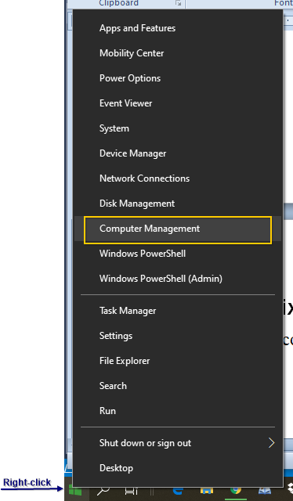
Expand the “Services and applications” entry
Figure 40 Finding SQLServer service
Figure 40 Finding SQLServer service
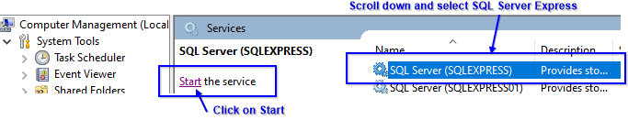
Select Services
Scroll down in the right panel to SQL Server (SQLExpress)
Select this option
Click “Start” to the left of the list.
Once the service is started, re-start Scorer.

Appendix 5 – Overview of scoring tables
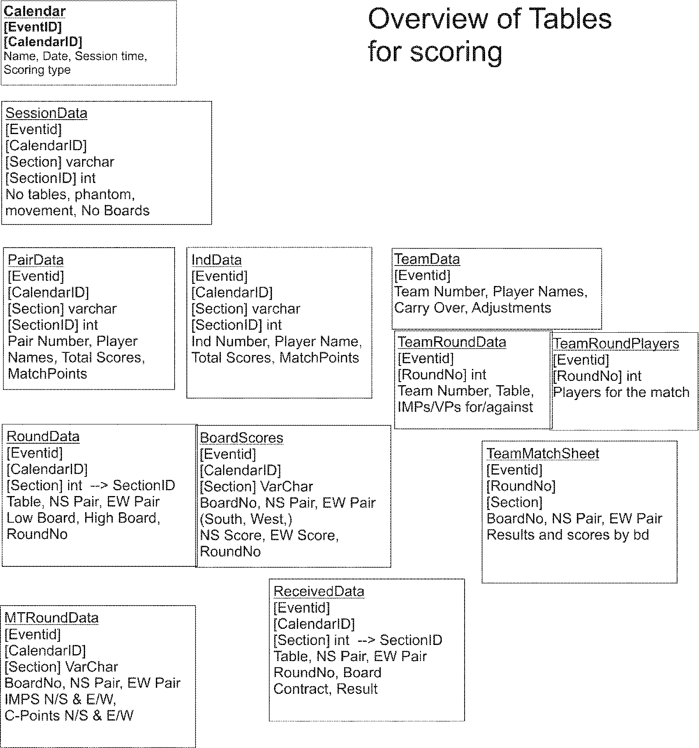

Appendix 6 – Real Bridge USEBIO imports
Scorer V22 includes the ability to import sessions played on Real Bridge into Scorer.
The initial release deals with Pairs and Teams, but will shortly be followed by Swiss Pairs.
The imported sessions act just like the normal club sessions in terms of being part of the events alresdy set up in Scorer.
BridgeNZ can arrange RealBridge sessions for your club if you do not want to set up an account of your own with RealBridge and can manage the configuration and payment to RealBridge and charge back to the club – We can also provide assistance for Directors initially if required.

PROCESS:
After a REalBridge session, the Director is able to export a USEBIO file (for the players and results) and a PBN file for the deals.
In Scorer, in the pairs events, there is an option to import USEBIO files to a session
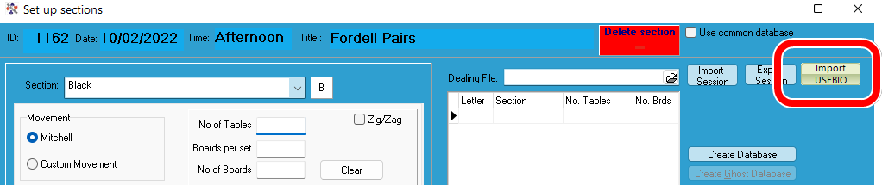
This allows the user to select a XML file and the session is importd
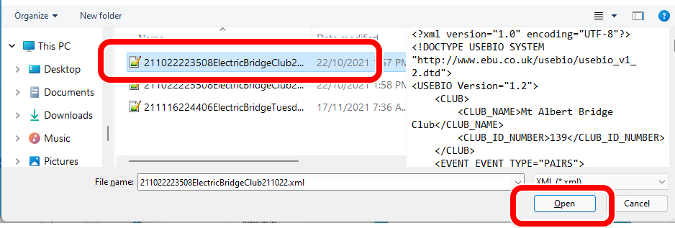
After the initial import, the session shows, but the result button does not show until the user returns to the calendar and selects the session again
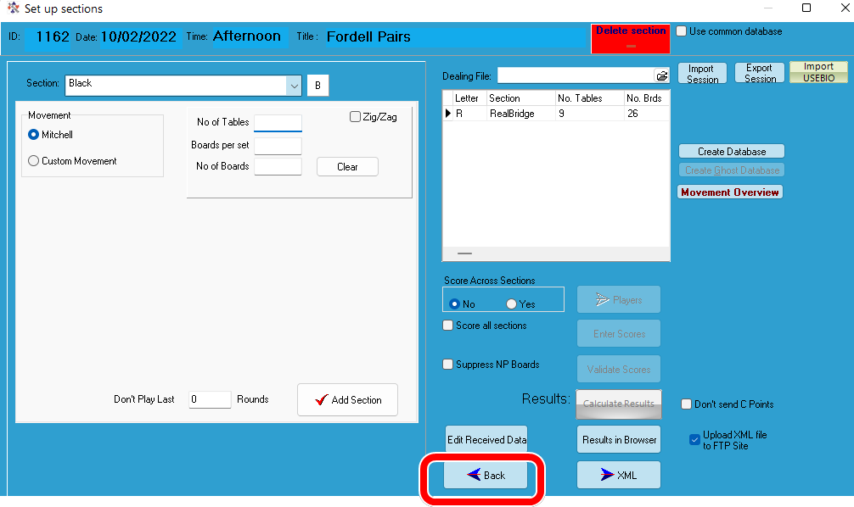
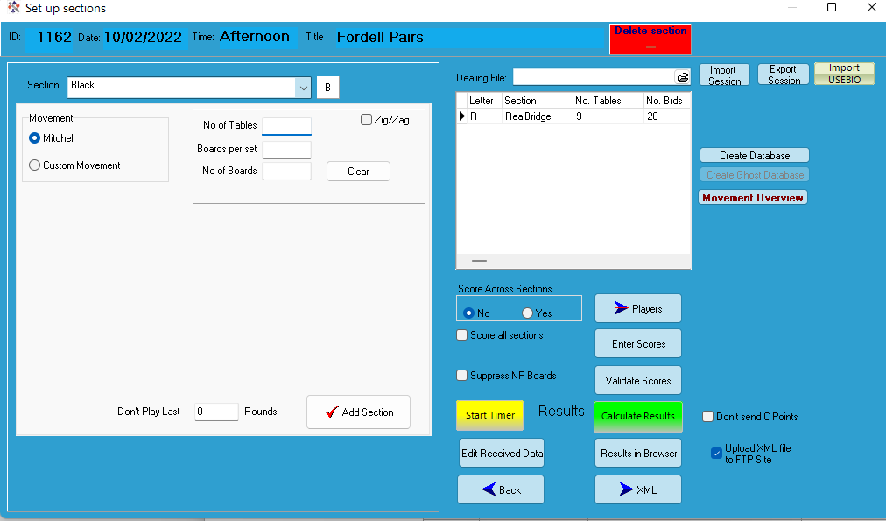
Once all the buttons are active, the user can check the names in the players screen and calculate results. The masterpoints will be sent off just like a normal session.
The pbn file doenloaded can be attached to the session for sending to the web and this will display the hand records and makeable contract on the BridgeNZ results page as usual with the ability to replay the deals.

TEAMS:
For teams, a similar arrangement is in place. Set up the teams event as you intend to play it (e.g. 6 rounds of 12 boards to be played over three nights)
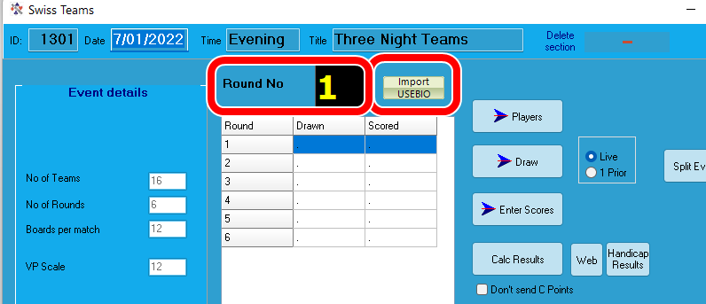
After the first night on REalBridge, inport the session from round 1. This will import both rounds if the file is exported after the session is complete.
It is possible to export after the first round, and import into round 1 to post on the web if you wish, the after round 2, import from round 1 again and it will import both rounds 1 and 2.
On the second night, start from round 3 to import rounds 3 & 4 etc..
The players who play the match on RealBridge will be entered into the team round players and when the results are calculated for each round in Scorer, the C-Points will be sent to NZBridge for processing.
NOTE: The user MUST calculate the results for each round for the C-points to be sent.
In the Draw screen, the pbn cile can be attached to send the deals to the web as usual.

A similar procedure is available for Swiss Pairs.

Martin Oyston
8.6.2022

