Creating Custom Movements
There are many methods for creating custom movements.
WEB AND BOOMAN
Even table Web movements and Bowman movements are able to be automatically generated.
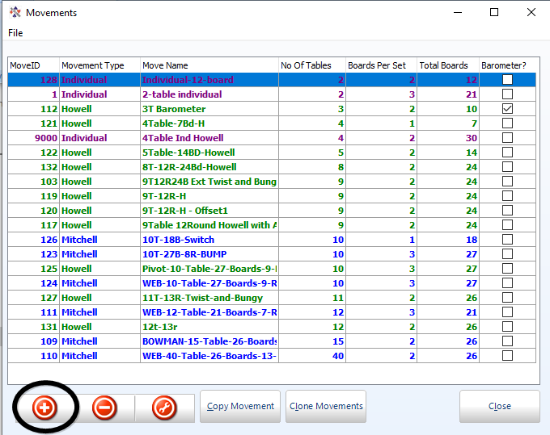
From the New custom movements screen
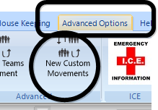
Click the + button to add another movement.

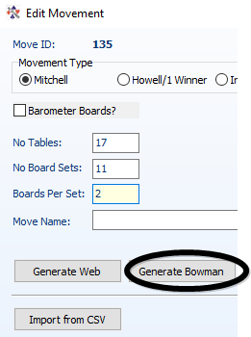
For 16 tables, 13 rounds of 2 boards (26 boards in total) fill out the options as below, then click “Generate Web”. The file will be automatically named. The movement is now available.
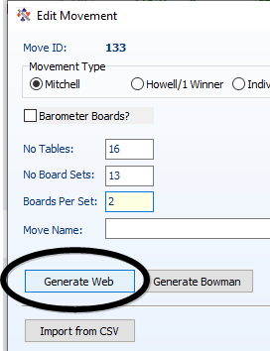
Similarly, for a Bowman, set the number of tables, number of boardsets (=rounds) and boards per round, then click “Generate Bowman”.

Once the movements are generated, click “Validate”.
If an error box appears, then click Cancel, and delete the movement (using the “-“ button) and start again.

Howell/1 Winner
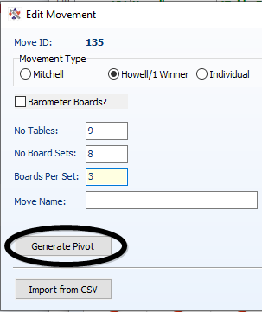
If you choose “Howell” when entering the movement, the options at the bottom of the screen change, and a Pivot movement may be generated. The Pivot allows you to play a movement where there is one more table than boardsets.

GENERAL
Finally, you can load movements created as CSV files.
There are a number already created and on the bridgenz website at
https://bridgenz.co.nz/movement-csv-files
From your web browser, you can click on any file to download it. By default, it will download to the “Downloads” folder on your computer.
Having downloaded the file (or otherwise generating it) you can use it to generate a movement using the “Import from CSV” option.
IMPORTANT:
PLEASE ensure that you have set the movement type to Mitchell or Howell whichever the movement conforms to. Setting the incorrect movement type will cause problems later.
Import from csv
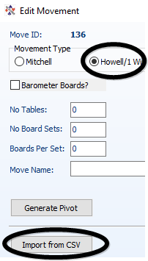
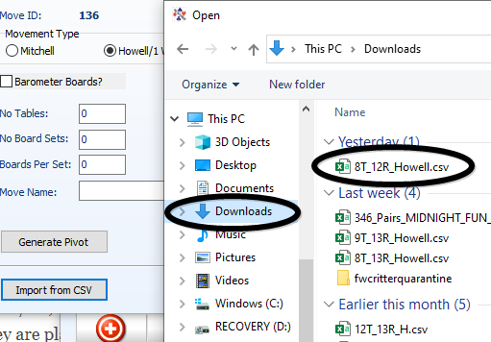
After selecting the correct movement type, click Import from CSV, and select the csv file you need.

When the file is loaded, it will automatically fill out the number of tables and number of boardsets, and you can fill in the number of boards per set, and you must fill in a movement name

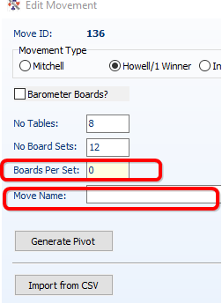
Note that this means that the same csv file can be used to generate, say, an 8 table, 16 board movement for your learners, 8 table 24 board movement for your evening session and 8 table 36 board movement for your daytime players.

THE CSV FILE
The csv files require the following format:
Header line: TableNo,NSPair,EWPair,RoundNo,BoardSet
Remining lines are all numbers separated by commas
e.g.
1,18,1,1,1
2,17,11,13,1 Table 2 has NS 17 and EW 11 in round 13 playing boardset 1
3,6,3,12,1
4,12,7,11,1

There should be no blanks in any of the fields and no empty lines, especially
,,,, at the end of the file is BAD

