Interclub Teams – 3 clubs – 18 teams

Overview
The idea is to compete with each club having 2 x Open grade teams, 2 x Intermediate grade teams and 2 x Junior grade teams.
Each team in each grade from each club will play 2 matches against the same grade teams from the other two clubs.

Seating
Seat the teams from the three clubs in groups thus:
Tables 1-6 Apple Club
Tables 7-12 Banana Club
Tables 13-18 Orange Club
Within these groups seat the teams Open A, Open B, Intermediate A, Intermediate B, Junior A, Junior B. In practise this order is not important, but it makes the construction of the draw much easier.

The Draw
There are six teams in each grade. Taking the OPEN grade teams these are:
1, 2, 7, 8, 13 and 14 [NOTE: 1 never plays 2, 7 never plays 8 and 13 never plays 14]
Example draw for the four rounds:
Round 1 | Round 2 | Round 3 | Round 4
1 v 8 | 1 v 7 | 1 v 14 | 1 v 13
7 v 14 | 2 v 14 | 7 v 13 | 7 v 2
13 v 2 | 13 v 8 | 8 v 2 | 8 v 14
We can now do the draw for the intermediates by adding 2 to each of these numbers
3 v 10 | 3 v 9 | 3 v 16 | 3 v 15
9 v 16 | 4 v 16 | 9 v 15 | 9 v 4
15 v 4 | 15 v 10 | 10 v 4 | 10 v 16
And for the Juniors add another 2 to each
5 v 12 | 5 v 11 | 5 v 18 | 5 v 17
11 v 18 | 6 v 18 | 11 v 17 | 11 v 6
17 v 6 | 17 v 12 | 12 v 6 | 12 v 18

In Scorer

Setting the event in the calendar
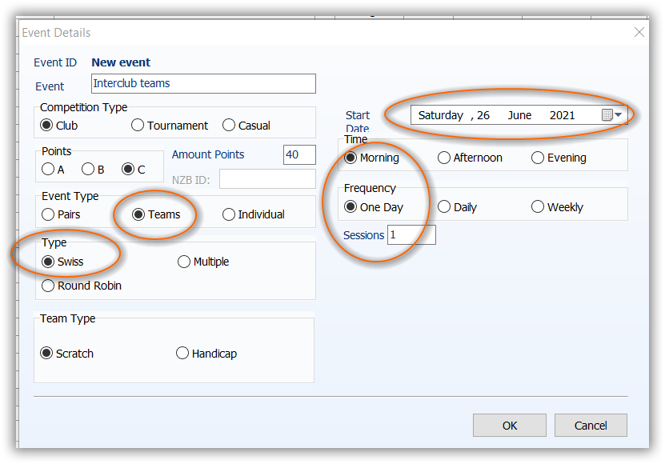
Add the event as
Competition Type: Club
Points: C Amount: 40
(NZB won’t accept masterpoints if you change this from 40C)
Event Type: Teams
Type: Swiss

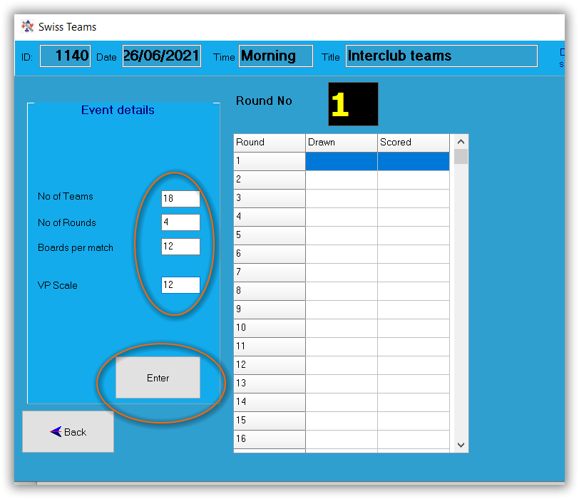
Setting up the Session
In the setup screen set:
No Teams: 18
No Rounds: 4
Boards per Match: 12
VP Scale will default to 12

Now click ENTER

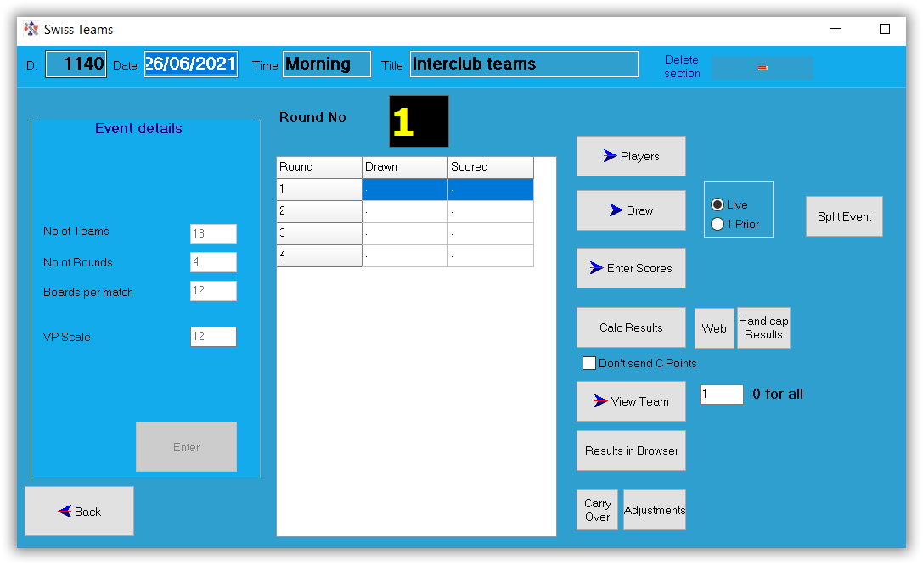
Now the screen looks like this
Go to Players
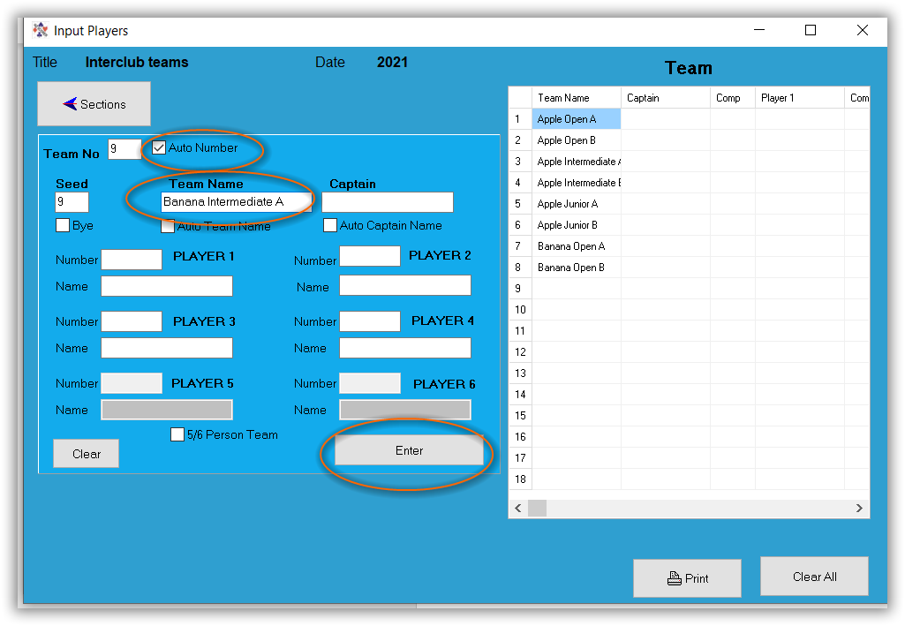
Tick the box “Auto Number”
Start with team 1, just enter the team name, then click Enter.
This will enter the team name and move on to the next team.
Enter all the teams in sequence as discussed above.

When all the teams are in go back to the Sections screen and enter the Draw, starting at round 1.

The Draw
The draws can be copied from the table below and pasted into the draw grid in Scorer.
ROUND 1 Round 2 Round 3 Round 4
1 | 8 |  | 1 | 7 |  | 1 | 14 |  | 1 | 13
7 | 14 |  | 2 | 14 |  | 7 | 13 |  | 7 | 2
13 | 2 |  | 13 | 8 |  | 8 | 2 |  | 8 | 14
3 | 10 |  | 3 | 9 |  | 3 | 16 |  | 3 | 15
9 | 16 |  | 4 | 16 |  | 9 | 15 |  | 9 | 4
15 | 4 |  | 15 | 10 |  | 10 | 4 |  | 10 | 16
5 | 12 |  | 5 | 11 |  | 5 | 18 |  | 5 | 17
11 | 18 |  | 6 | 18 |  | 11 | 17 |  | 11 | 6
17 | 6 |  | 17 | 12 |  | 12 | 6 |  | 12 | 18

For each round, the section is arbitrary, so just use A unless there is a good reason for using another letter.
Rounds 1 and 3 will start with board 1 (unless you have sets of 48 boards) and rounds 2 and 4 will start with board 13.
When the Draw is entered and section and starting board added, create the remote database for each round.
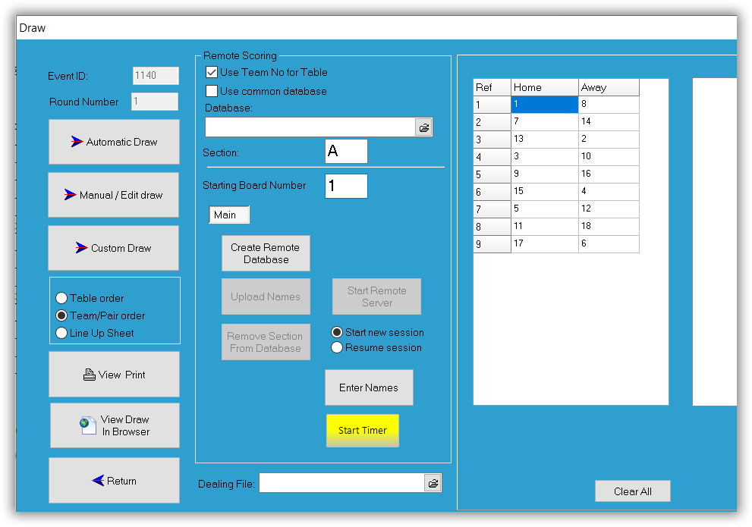

Documentation for team captains
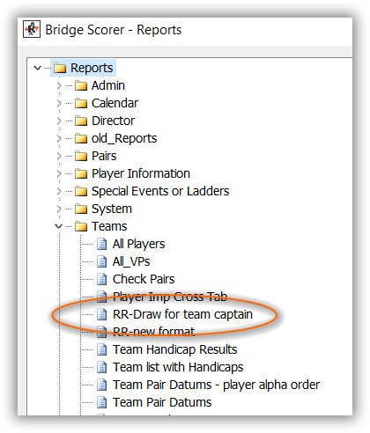
When all the rounds are added to the draw, go to Reports
In the Teams section – choose RR-Draw for team captain
This will ask for the event to be selected. Choose the event you have just entered.

The resulting report will print a page for each team captain telling them which teams they are playing in which round.
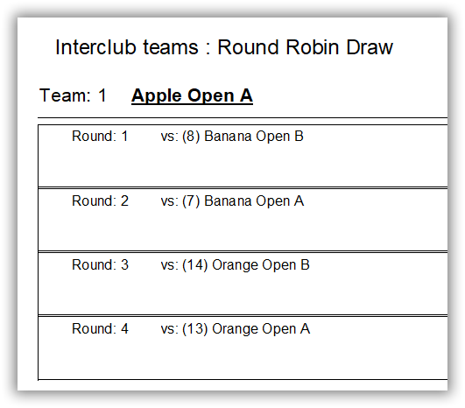
e.g.

The teams may choose to record results here and copy them to the club captain who can check the progress.

Overall Reporting
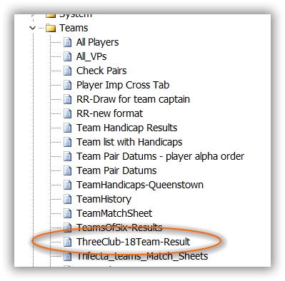
The totals for the clubs is easily obta
ined at the end of each round using another report:
The report will ask for the event, and you will need to manually type the club names (unless you are good at editing reports).
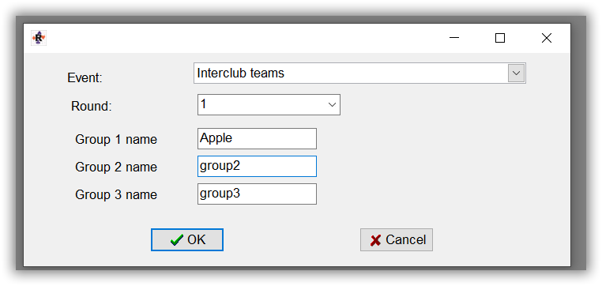
This will generate a page with totals:
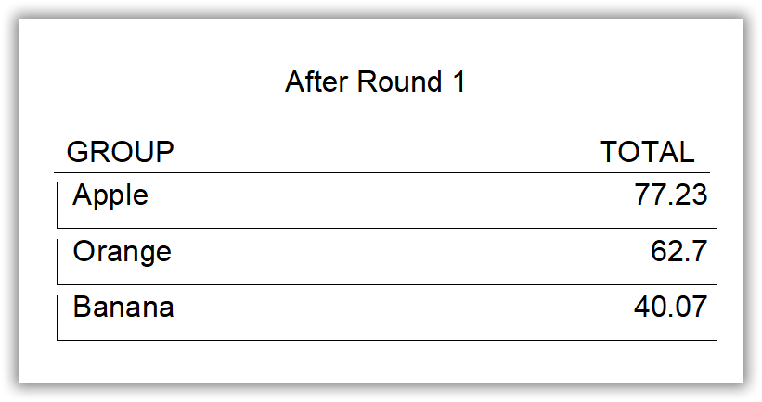
allowing the clubs to see their rankings.

